This guide provides a detailed, step-by-step procedure to build a simulated hospital IT infrastructure using Windows Server 2022 in Oracle VirtualBox. You will configure core services and test the environment to ensure proper functionality.

# Phase 1: Setting Up the Virtual Environment

1.1. Download Necessary Software:

* Oracle VM VirtualBox: Download and install the latest version of VirtualBox and the VirtualBox Extension Pack from the official website.
  + <https://www.virtualbox.org/wiki/Downloads>
* Windows Server ISO: Download the evaluation ISO file for Windows Server 2022 from the Microsoft Evaluation Center.
  + <https://www.microsoft.com/en-us/evalcenter/evaluate-windows-server-2025>
* Windows 10/11 ISO: Download a Windows 10 or 11 evaluation ISO to act as a client machine for testing.

1.2. Configure Virtual Networks in VirtualBox:

1. Open VirtualBox.
2. Go to File > Host Network Manager.
3. Click Create. A new network adapter (e.g., VirtualBox Host-Only Ethernet Adapter) will be created. You can leave the default settings for now. This will be used for the internal network.

1.3. Create the Windows Server 2022 Virtual Machine:

1. In VirtualBox, click New.
2. Name: Hospital-SRV-01
3. Type: Microsoft Windows
4. Version: Windows 2022 (64-bit)
5. Memory size: Allocate at least 4 GB (4096 MB) of RAM.
6. Hard disk: Select Create a virtual hard disk now. Choose VDI, Dynamically allocated, and set the size to at least 60 GB.
7. Click Create.

1.4. Configure the Server VM Settings:

1. Select the Hospital-SRV-01 VM and click Settings.
2. System > Processor: Assign at least 2 CPUs.
3. Storage:
   * Click on the empty CD icon under the "Controller: IDE" section.
   * In the "Attributes" panel on the right, click the small CD icon and choose Choose a disk file....
   * Browse to and select your downloaded Windows Server 2022 ISO file.
4. Network:
   * Adapter 1:
     + Enable Network Adapter.
     + Attached to: Bridged Adapter.
     + Name: Select your primary physical network adapter (e.g., your Wi-Fi or Ethernet card) that is connected to the internet.
   * Adapter 2:
     + Enable Network Adapter.
     + Attached to: Internal Network.
     + Name: Give it a name like hospital-net.

# Phase 2: Installing Windows Server 2022

1. Start the Hospital-SRV-01 VM. It will boot from the ISO file.
2. Follow the on-screen instructions for language, time, and keyboard input.
3. Click Install now.
4. Select Windows Server 2022 Standard (Desktop Experience) or Datacenter (Desktop Experience). The Desktop Experience is crucial for having a graphical user interface.
5. Accept the license terms.
6. Choose Custom: Install Microsoft Server Operating System only (advanced).
7. Select the unallocated drive and click Next.
8. The installation will proceed. The VM will restart a couple of times.
9. After installation, set a strong administrator password.

# Phase 3: Initial Server Configuration

3.1. Configure Network Adapters:

1. Log in to your server. Server Manager will open automatically.
2. Go to Control Panel > Network and Sharing Center > Change adapter settings.
3. You will see two network adapters. Rename them for clarity:
   * Rename the adapter connected to the Bridged network to WAN_Internet.
   * Rename the adapter connected to the Internal Network to LAN_Internal.
4. Configure LAN_Internal:
   * Right-click LAN_Internal and go to Properties.
   * Select Internet Protocol Version 4 (TCP/IPv4) and click Properties.
   * Set a static IP address for your server. This will be the gateway for your internal network.
     + IP address: 192.168.10.1
     + Subnet mask: 255.255.255.0
     + Default gateway: Leave this blank.
     + Preferred DNS server: 127.0.0.1 (This points to the server itself, as it will become the DNS server).
   * Click OK and then Close. The WAN_Internet adapter will get its IP address from your router via DHCP, providing internet access to the server.

3.2. Change Server Name:

1. In Server Manager, click on Local Server.
2. Click on the existing Computer name.
3. In the System Properties window, click Change....
4. Set the computer name to HOSPITAL-SRV-01 and click OK.
5. You will be prompted to restart the server. Do so.

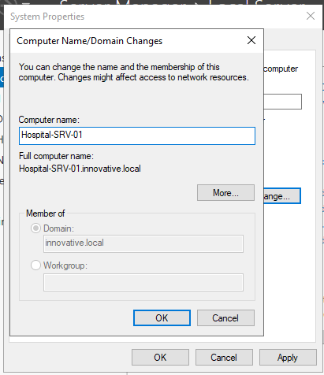

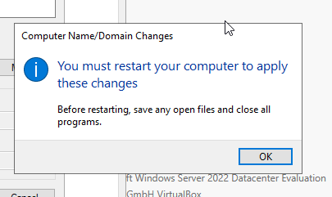

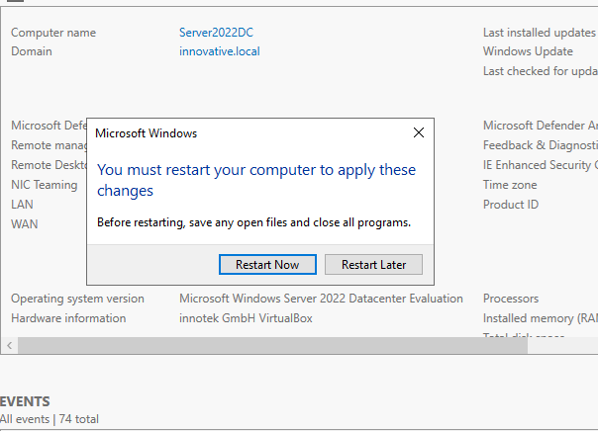

# Phase 4: Installing and Configuring Core Server Roles

4.1. Install Active Directory Domain Services (AD DS) and DNS:

1. Log in after the restart. In Server Manager, click Manage > Add Roles and Features.
2. Click Next through the "Before You Begin," "Installation Type" (select Role-based or feature-based installation), and "Server Selection" pages.
3. In the "Server Roles" list, check Active Directory Domain Services. A pop-up will ask to add required features, including DNS. Click Add Features.
4. Continue clicking Next through the Features and AD DS pages.
5. On the Confirmation page, check Restart the destination server automatically if required, and then click Install.

4.2. Promote Server to a Domain Controller:

1. After the installation completes, you will see a notification flag at the top of Server Manager. Click it and select Promote this server to a domain controller.
2. Select Add a new forest.
3. Root domain name: Enter a domain name, for example, hospital.local.
4. On the next screen, leave the Forest and Domain functional levels as they are. Enter a Directory Services Restore Mode (DSRM) password. This is important for disaster recovery.
5. Click Next on the DNS Options page, ignoring the delegation warning.
6. Confirm the NetBIOS name (it should be HOSPITAL).
7. Leave the paths for the database, log files, and SYSVOL as default.
8. Review your selections and click Next. The system will run a prerequisites check.
9. Click Install. The server will restart automatically.

4.3Of course. Here is a detailed, step-by-step procedure for configuring the DNS and DHCP server roles on your Windows Server 2022 machine after they have been installed.

Prerequisites

Before you begin, ensure you have completed the following:

* Windows Server 2022 is installed.
* The server has two network adapters: one Bridged for internet and one Internal Network for the LAN.
* The LAN_Internal adapter has a static IP address set (e.g., 192.168.10.1).
* The Active Directory Domain Services (AD DS) and DHCP Server roles have been installed.
* The server has been promoted to a Domain Controller for a new forest (e.g., hospital.local). This process automatically installs and performs a basic configuration of DNS.

# Configuring the DNS Server

When you promote a server to a domain controller, the DNS server role is installed and configured with the necessary zones and records for Active Directory to function. However, for your server to resolve external internet addresses (like google.com), you must configure DNS Forwarders.

Step 1.1: Open the DNS Manager

1. Open Server Manager.
2. Click on Tools in the top-right corner and select DNS.

Step 1.2: Review Existing DNS Zones

In the DNS Manager console, you will see two primary zones created during the AD promotion:

* Forward Lookup Zones:
  + _msdcs.hospital.local: This zone stores service location (SRV) records that clients use to find domain controllers and other services.
  + hospital.local: This is the primary zone for your domain. It contains the Host (A) record for your server, mapping its name (HOSPITAL-SRV-01) to its IP address (192.168.10.1).

This setup handles all name resolution *within* your hospital.local domain.

Step 1.3: Configure DNS Forwarders

A forwarder is a DNS server that your internal DNS server will "ask" if it cannot resolve a name query itself. This is how you provide internet name resolution to your entire internal network.

1. In the DNS Manager, right-click on your server name (HOSPITAL-SRV-01) in the left-hand pane and select Properties.
2. Go to the Forwarders tab.
3. Click the Edit button.
4. You will see a field that says <Click here to add an IP address or DNS name>. Enter the IP address of a public DNS server. Press Enter after each one. It's best practice to add at least two for redundancy.
   * 8.8.8.8 (Google's Public DNS)
   * 1.1.1.1 (Cloudflare's Public DNS)
5. After adding the addresses, the system will validate them. You should see their server names appear.
6. Click OK, and then Apply and OK on the Properties window.
7. 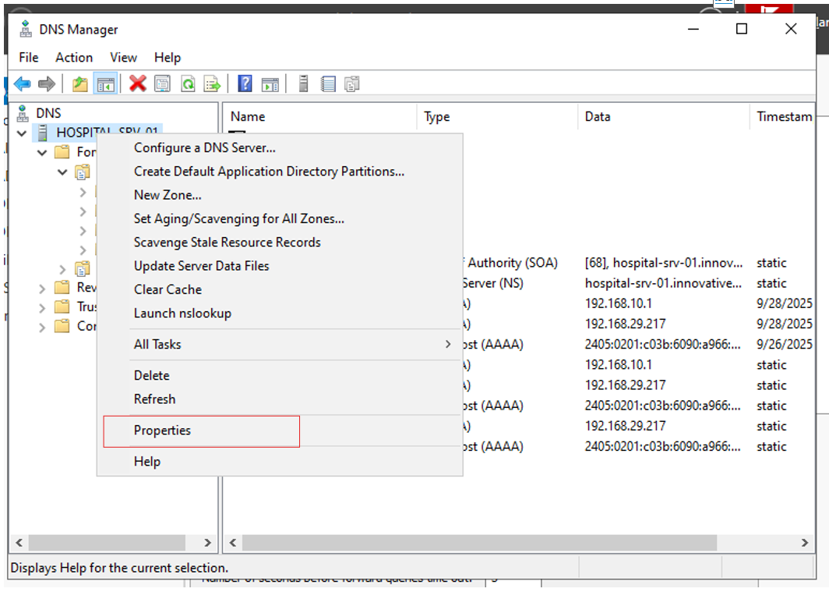
8. 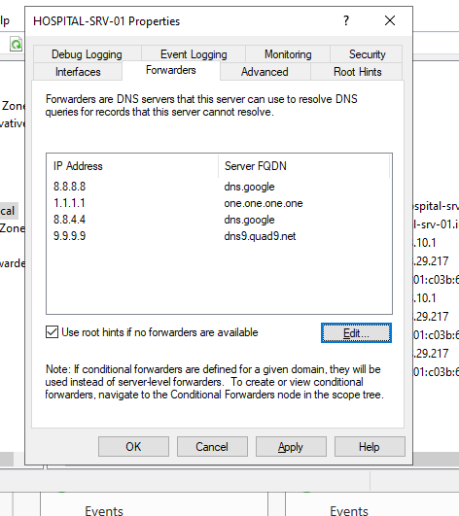
9. 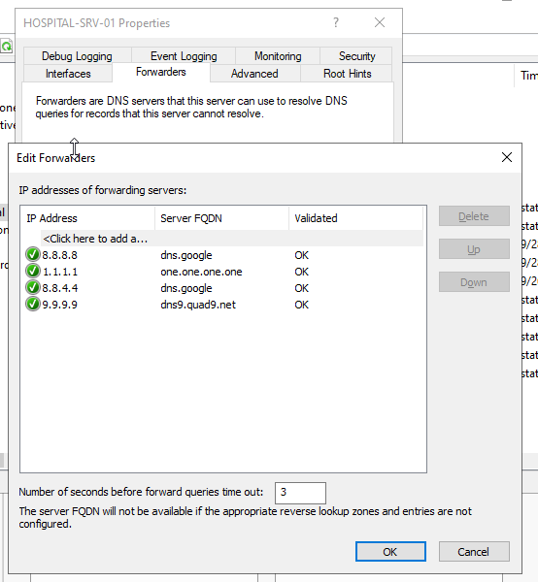

Step 1.4: (Recommended) Create a Reverse Lookup Zone

A reverse lookup zone maps an IP address back to a hostname (e.g., 192.168.10.1 -> HOSPITAL-SRV-01.hospital.local). This is good practice and required by some applications.

1. In the DNS Manager, right-click on Reverse Lookup Zones and select New Zone....
2. Click Next on the welcome screen.
3. Zone Type: Select Primary zone and ensure Store the zone in Active Directory is checked. Click Next.
4. Active Directory Zone Replication Scope: Select To all DNS servers running on domain controllers in this domain. Click Next.
5. Reverse Lookup Zone Name: Select IPv4 Reverse Lookup Zone. Click Next.
6. Network ID: Enter the network portion of your IP address range. For the 192.168.10.x network, you would enter 192.168.10.
7. Click Next.
8. Dynamic Update: Select Allow only secure dynamic updates (recommended for Active Directory). This allows domain-joined computers to automatically create their own reverse lookup records (PTR records).
9. Click Next, and then Finish.

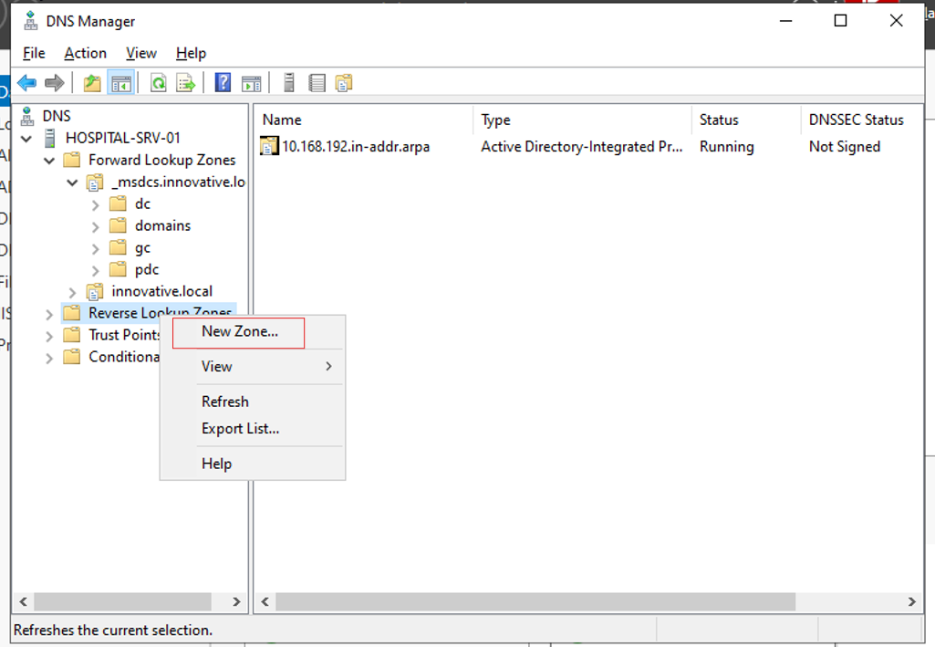

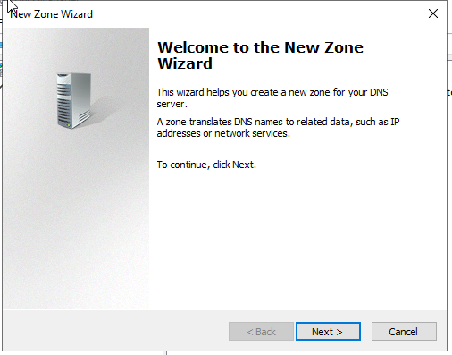

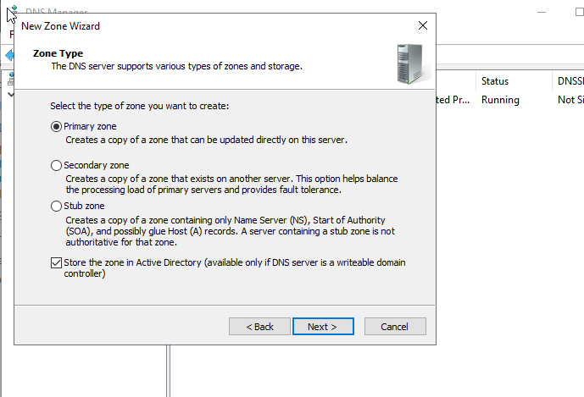

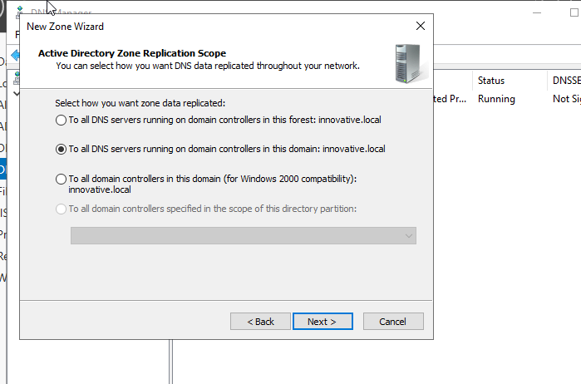

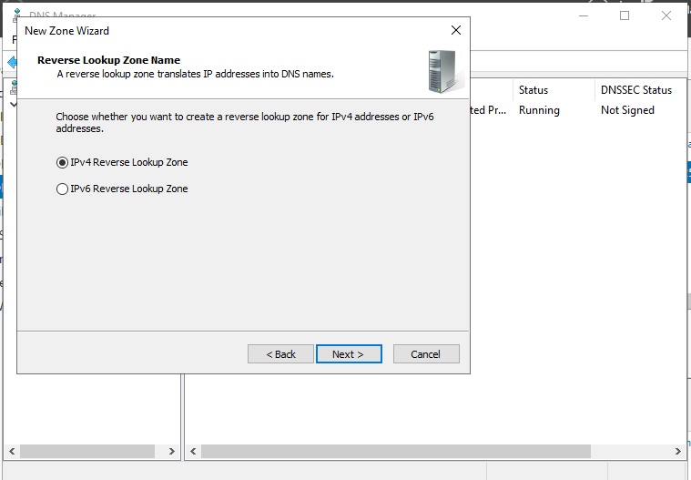

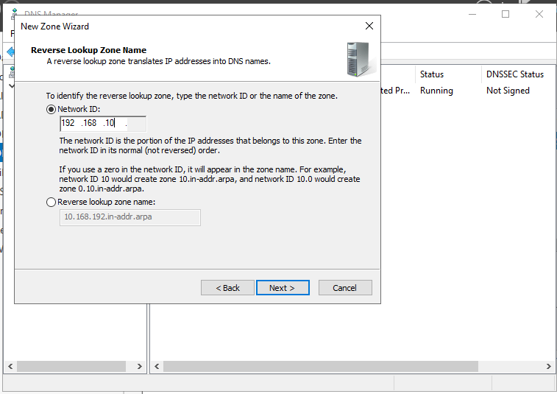

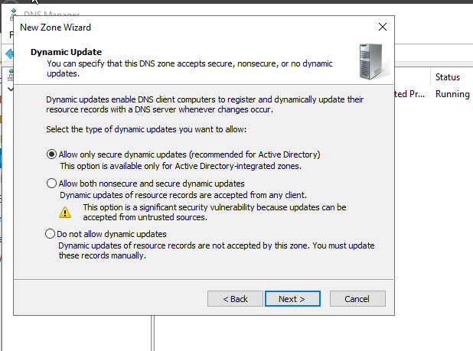

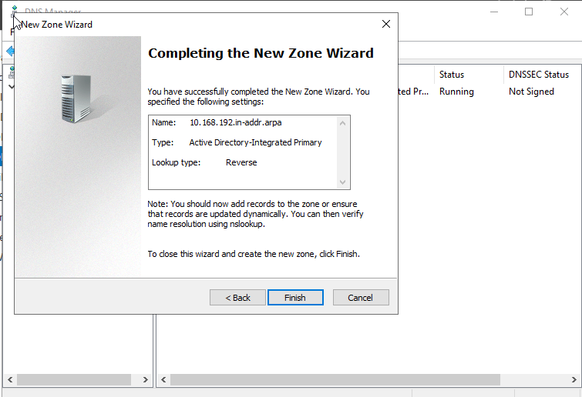

Step 1.5: Test DNS Configuration from the Server

1. Open Command Prompt or PowerShell on your server.
2. Use the nslookup utility to test resolution.
   * Test Internal Resolution: Type nslookup hospital-srv-01.hospital.local. You should get a response from your own server (192.168.10.1) with the correct IP address.
   * Test External Resolution (Forwarding): Type nslookup www.google.com. You should get a response showing the IP address(es) for Google, confirming your forwarders are working.

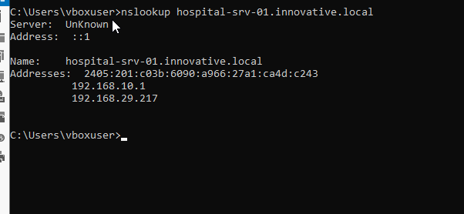

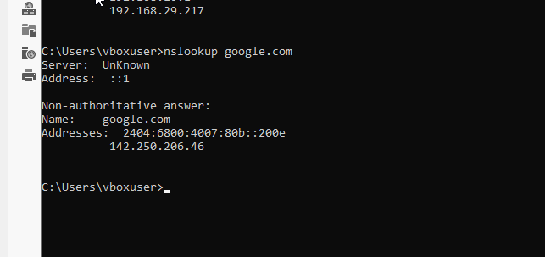

# Configuring the DHCP Server

Now that DNS is fully configured, you can set up DHCP to automatically assign IP addresses and network settings (including your new DNS server) to client machines.

Step 2.1: Authorize the DHCP Server in Active Directory

This is a security step to prevent unauthorized DHCP servers on the network. If you haven't done this already via the post-installation wizard:

1. Open the DHCP console from Server Manager > Tools.
2. If you see a red down-arrow on the server name, right-click the server name (hospital-srv-01.hospital.local) and select Authorize.
3. Right-click the server name again and select Refresh. The arrow should turn green.

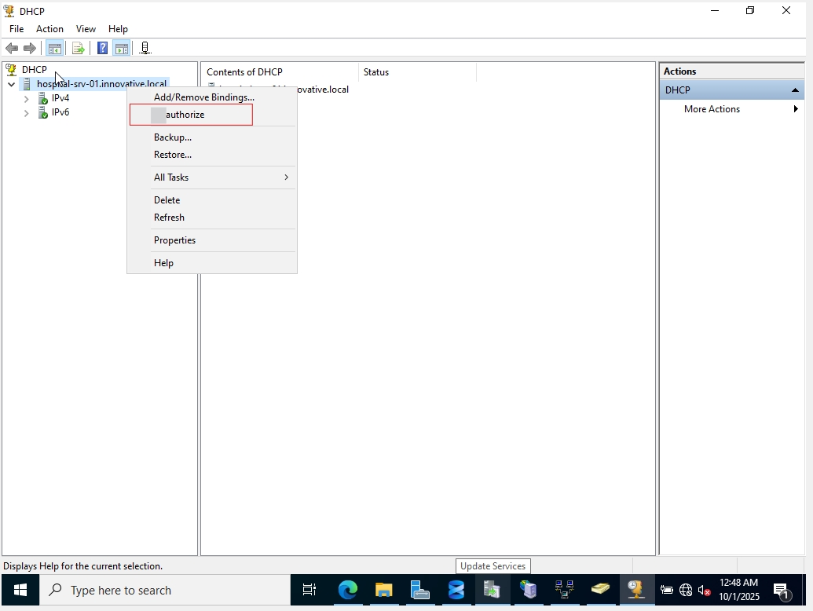

Step 2.2: Create a New DHCP Scope

A "scope" is a range of IP addresses you want to make available for clients to lease.

1. In the DHCP console, expand your server name.
2. Right-click on IPv4 and select New Scope....
3. The New Scope Wizard will open. Click Next.
4. Scope Name: Give it a descriptive name and description.
   * Name: Hospital Client Computers
   * Description: IP address range for doctor, nurse, and admin workstations
5. Click Next.
6. IP Address Range: Define the pool of addresses to be handed out.
   * Start IP address: 192.168.10.100
   * End IP address: 192.168.10.200
   * Subnet mask: 255.255.255.0
7. Click Next.
8. Add Exclusions and Delay: You can exclude specific IP addresses from being assigned (e.g., for printers or other servers). We will skip this for now. Click Next.
9. Lease Duration: Leave the default of 8 days. This is how long a client can use an IP address before needing to renew it. Click Next.

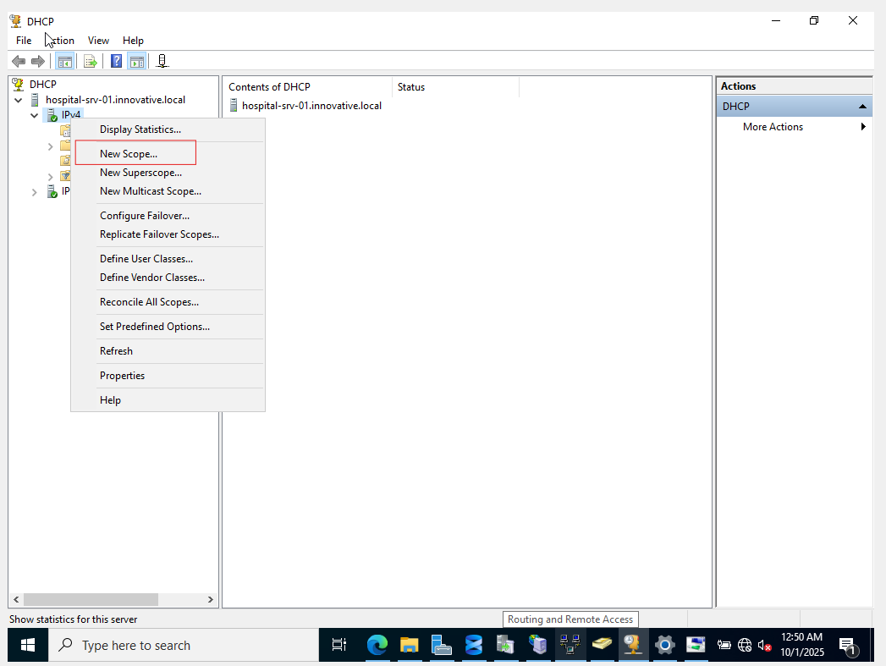

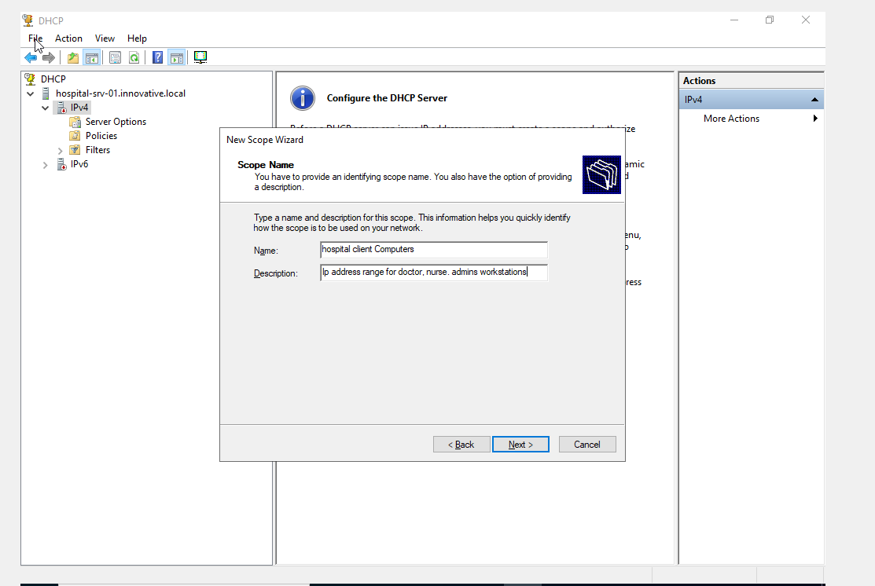

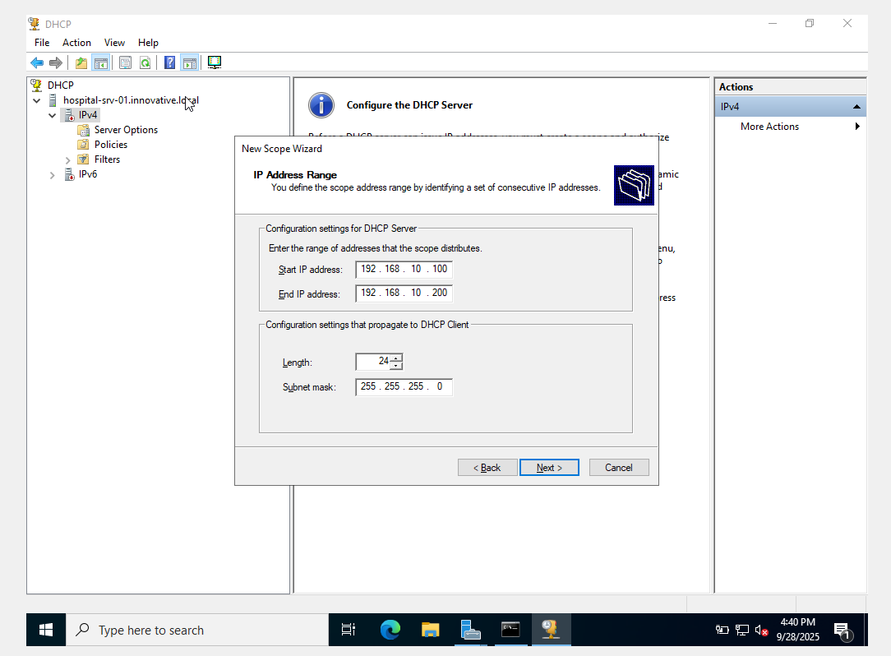

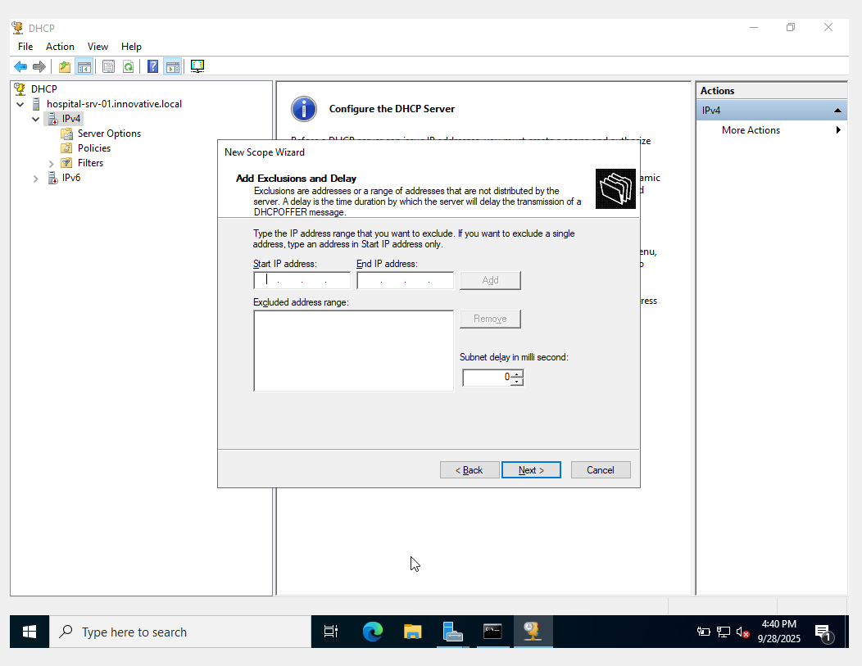

Step 2.3: Configure DHCP Scope Options

This is the most critical part, where you tell clients which gateway and DNS server to use.

1. On the "Configure DHCP Options" screen, select Yes, I want to configure these options now. Click Next.
2. Router (Default Gateway): This is the IP address clients will use to reach other networks.
   * Enter your server's internal IP address: 192.168.10.1.
   * Click Add, then Next.
3. Domain Name and DNS Servers:
   * The Parent domain should be correctly populated as hospital.local.
   * Your server's name (HOSPITAL-SRV-01) and IP address (192.168.10.1) should be listed as the DNS server. This is correct.
4. Click Next.
5. WINS Servers: This is an older technology for name resolution. Leave it blank and click Next.

Step 2.4: Activate the Scope

1. On the final screen, select Yes, I want to activate this scope now.
2. Click Next, and then Finish.

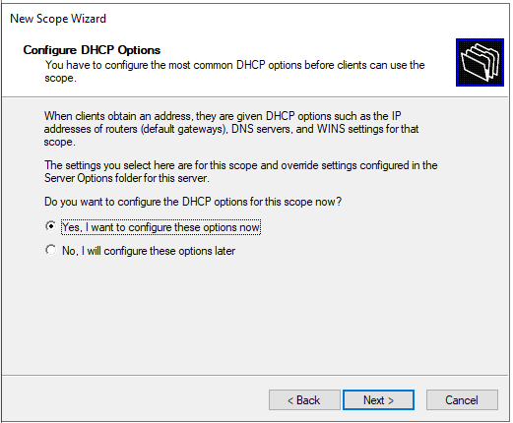

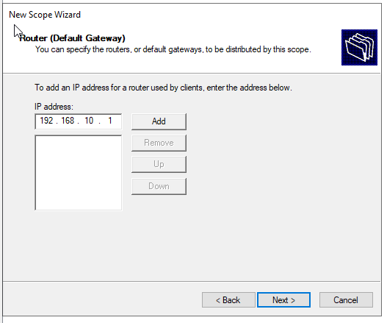

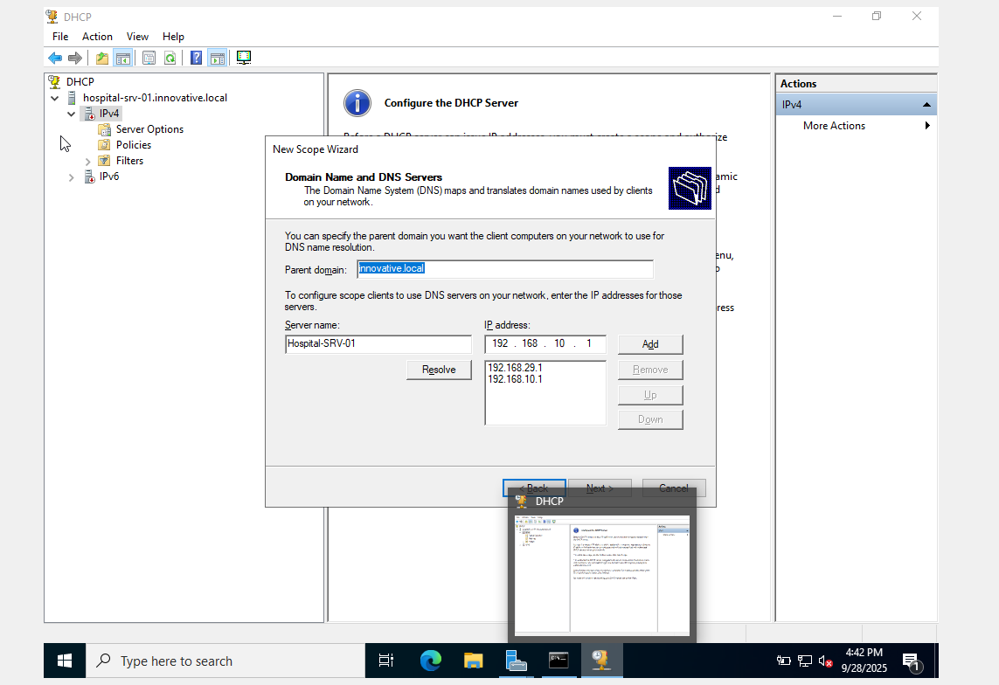

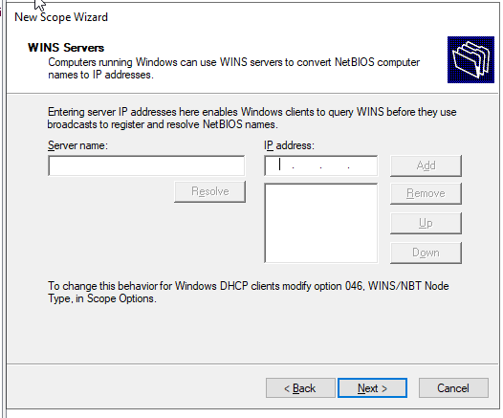

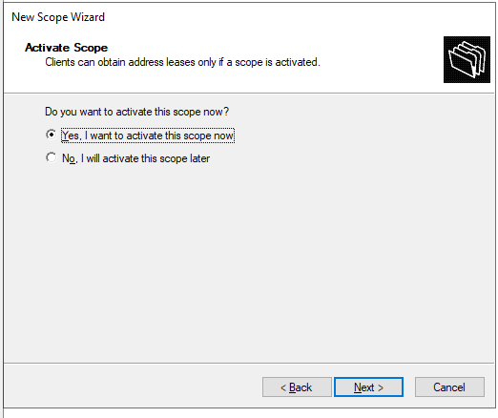

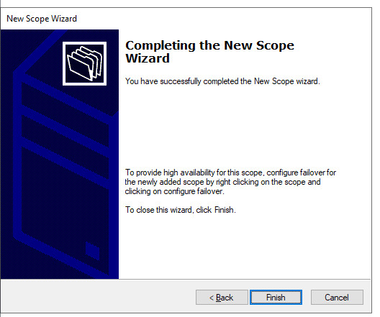

Step 2.5: Verify DHCP Configuration

1. In the DHCP console, under your new scope, click on the Address Pool folder. You should see the IP address range you defined.
2. Click on the Scope Options folder. You should see entries for 003 Router, 006 DNS Servers, and 015 DNS Domain Name with the values you configured.
3. Now, start your Windows 10/11 client VM or ubuntu. It will boot up, search for a DHCP server on the hospital-net internal network, and receive an IP address and configuration from your server.
4. On the client machine, open Command Prompt and type ipconfig /all to confirm it received the correct settings.

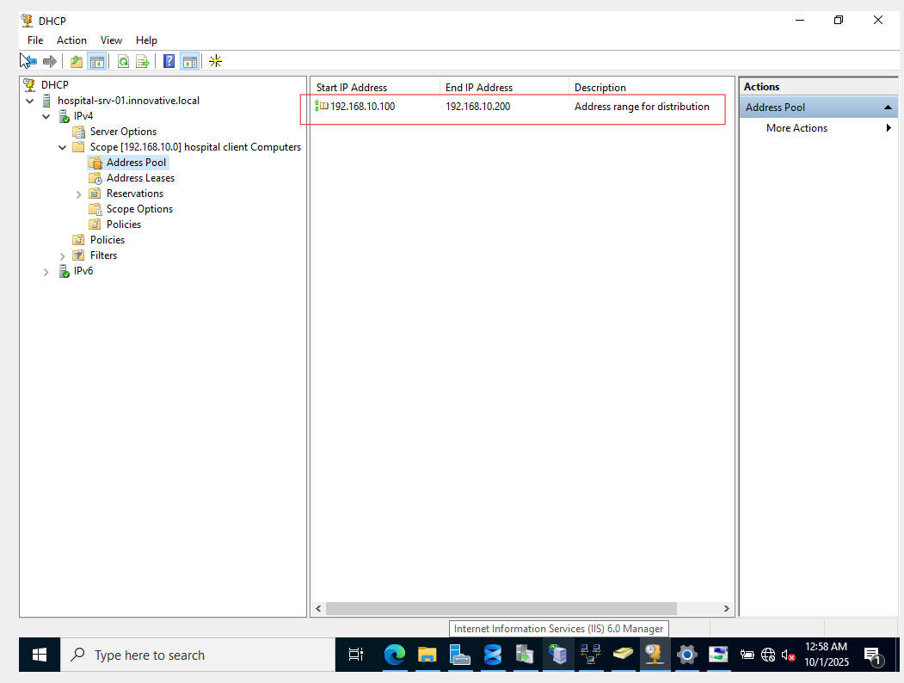

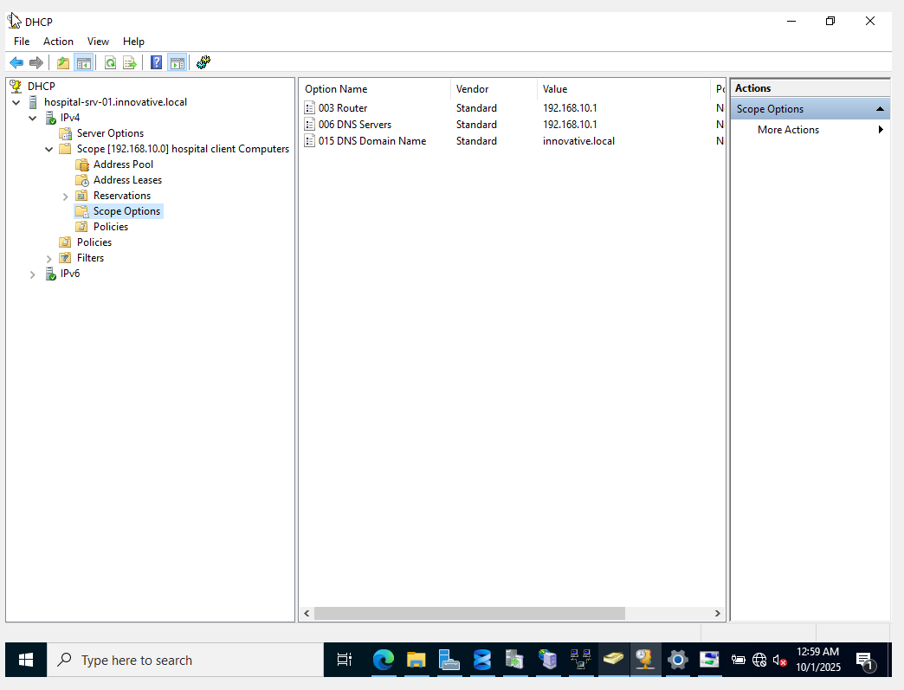

**Detailed Steps to Fix the DHCP Authorization Error**

Follow these steps precisely to resolve the issue.

**Step 1: Re-run the Post-Installation Wizard**

1. Close the wizard that showed the "Failed" status.
2. In **Server Manager**, you should still see a yellow notification flag at the top. Click it.
3. Click on **Complete DHCP configuration** to start the wizard again.

**Step 2: Provide the Correct Credentials for Authorization**

1. Click **Next** on the **Description** screen.
2. You are now at the **Authorization** screen. This is the most important step.
   * Do NOT use the default selection ("Use the following user's credentials").
   * Select the second option: **Use alternate credentials**.
   * Click the **Specify...** button.
3. In the credential window that pops up:
   * **User name:** INNOVATIVE\Administrator (or simply Administrator)
   * **Password:** The password you set for the domain Administrator account when you promoted the server to a domain controller.
   * Click **OK**.
4. The wizard will now show that you are using the INNOVATIVE\Administrator credentials. Click the **Commit** button.

**Step 3: Verify Success**

1. The **Summary** screen should now appear, and this time, both steps should show **Done**.
   * Creating security groups ........................ Done
   * Authorizing DHCP server ......................... Done
2. Click **Close**.

**Step 4: Final Confirmation in the DHCP Console**

1. From Server Manager, go to **Tools > DHCP**.
2. In the DHCP console, expand your server name.
3. Initially, you may have seen a small red "down" arrow next to "IPv4" and "IPv6". After successful authorization, right-click on your server name (hospital-srv-01.innovative.local) and select **Refresh**.
4. The red arrows will turn into green "play" icons, confirming that the DHCP server is now authorized and running correctly on the network.

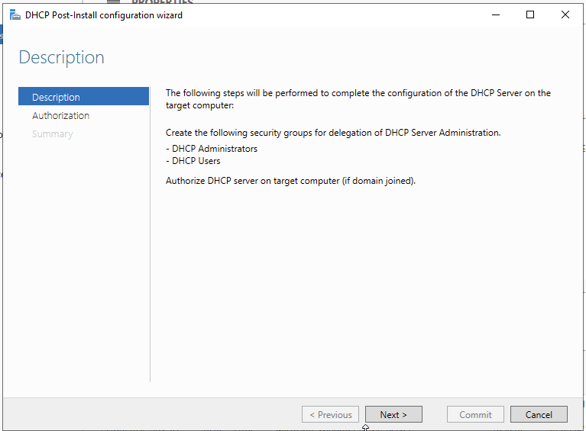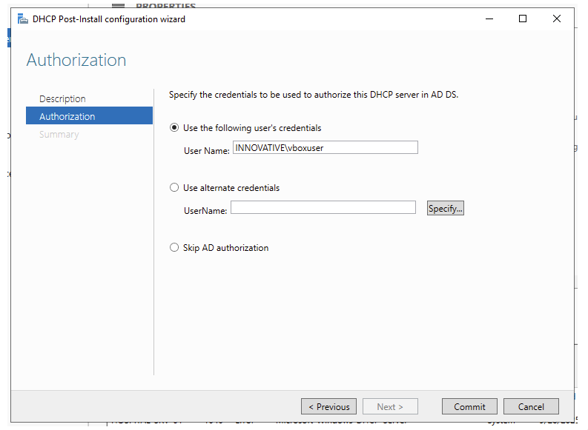

Check Use alternative credentials and provide the INNOVATIVE\Administrator and ur password

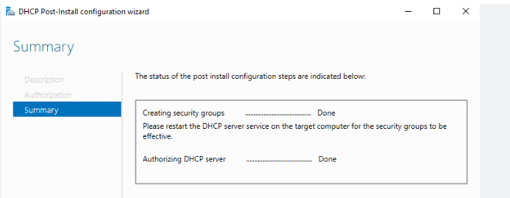

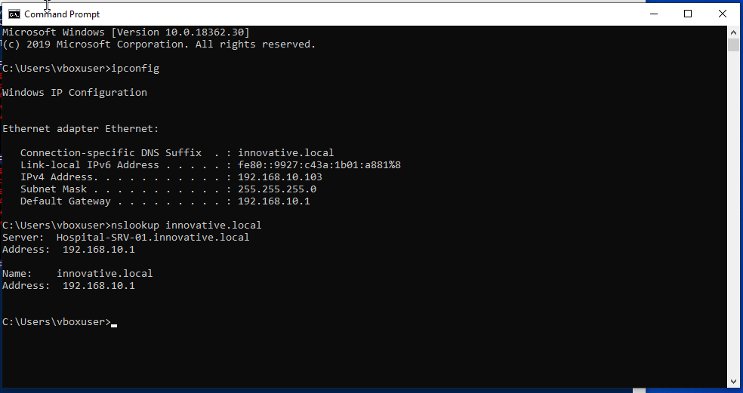

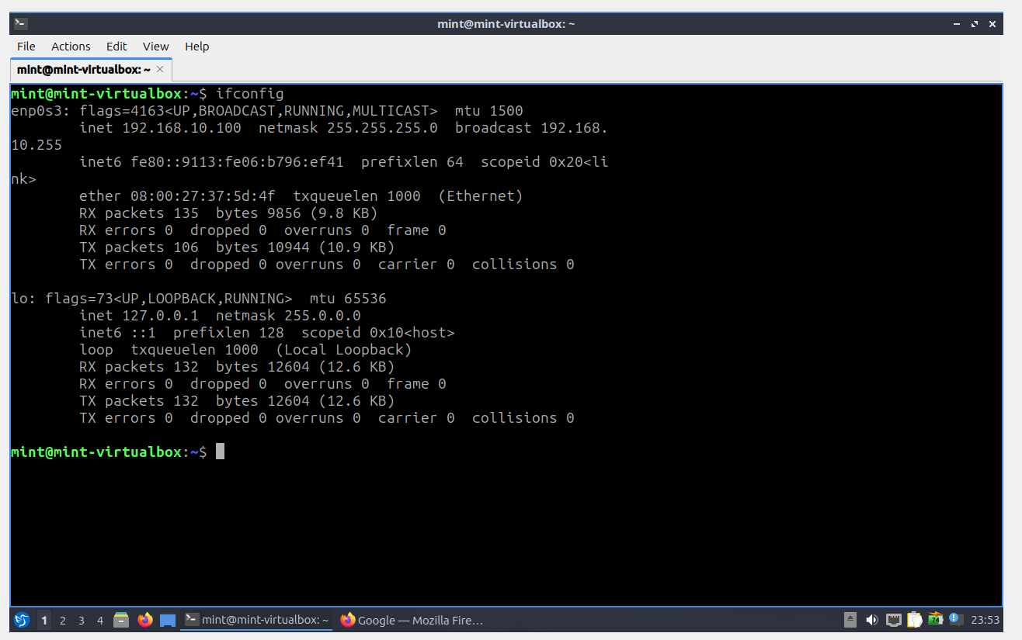

This is the screenshot after the Lubuntu is connected to the innovative.local domain DHCP server.

# Part 3: Active Directory Organizational Unit (OU) Structure

We'll create a minimal, but logical, OU structure.

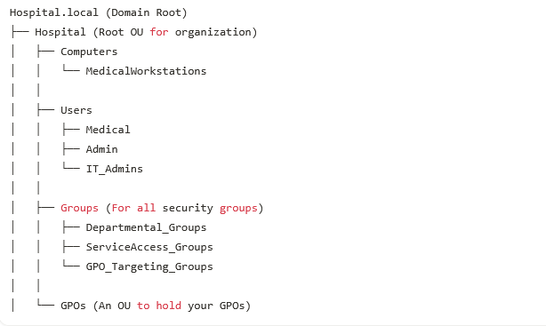

**Step 1: Create the OU Structure**

1. On your **Windows Server 2022**, open **Active Directory Users and Computers (ADUC)**.
2. Right-click on your domain (Hospital.local) and select **New > Organizational Unit**.
3. Create the Hospital OU.
4. Within Hospital, create Computers, Users, Groups, and GPOs.
5. Populate Computers with MedicalWorkstations.
6. Populate Users with Medical, Admin, and IT_Admins.
7. Populate Groups with Departmental_Groups, ServiceAccess_Groups, and GPO_Targeting_Groups.
8. Populate GPOs (we won't create sub-OUs for policies here, just store them directly).

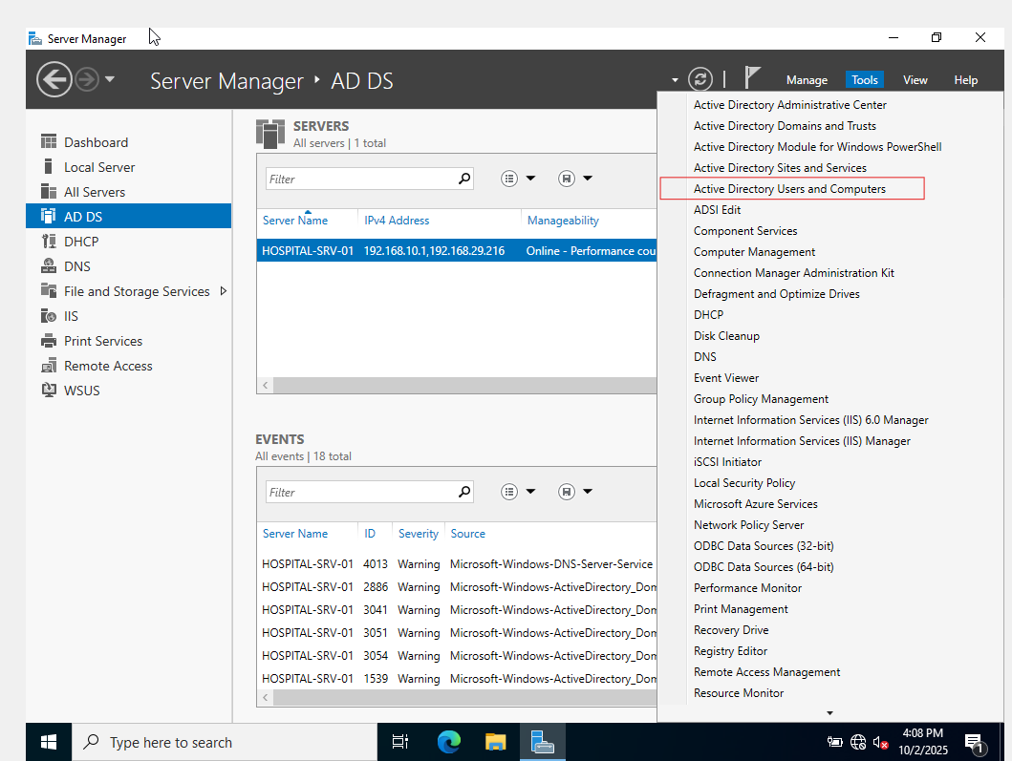

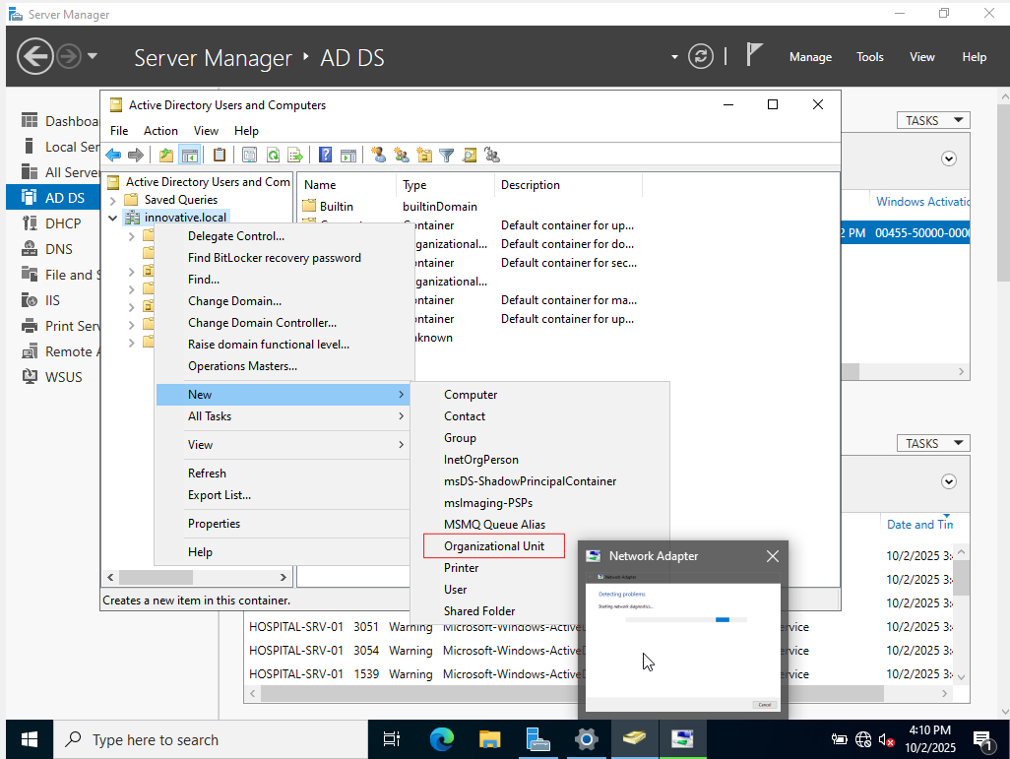

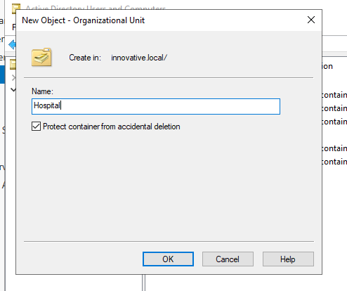

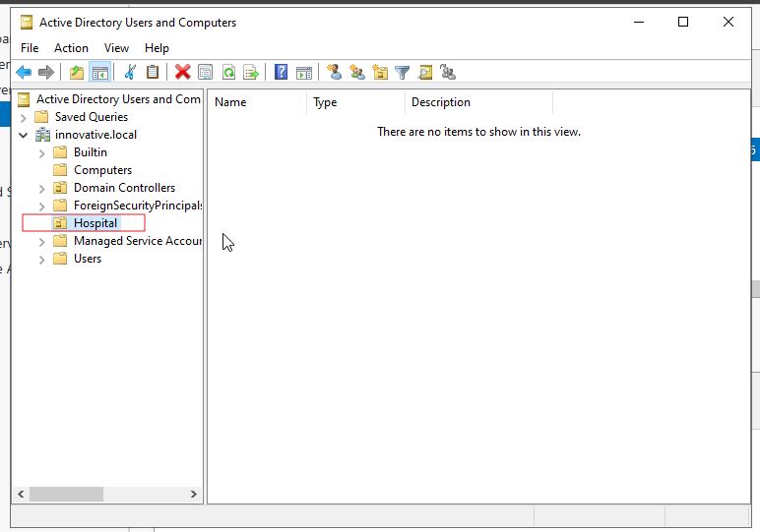

Follow the creation of OU steps to create GPO OU, Computer OU, Users OU, Groups OU resulting the below screen shot

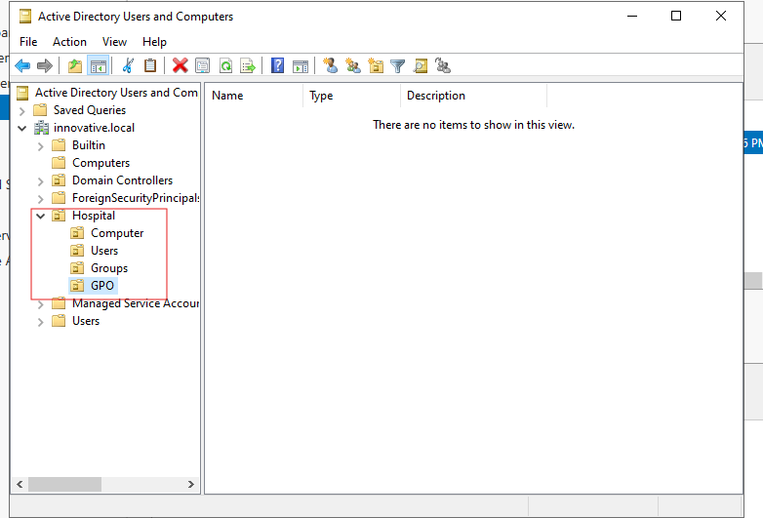

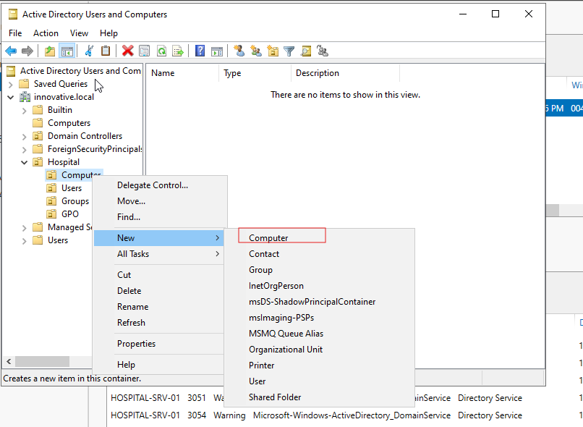

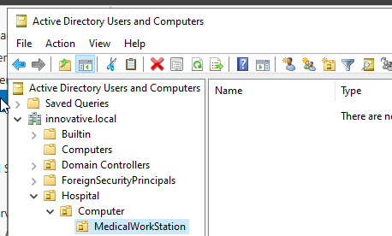

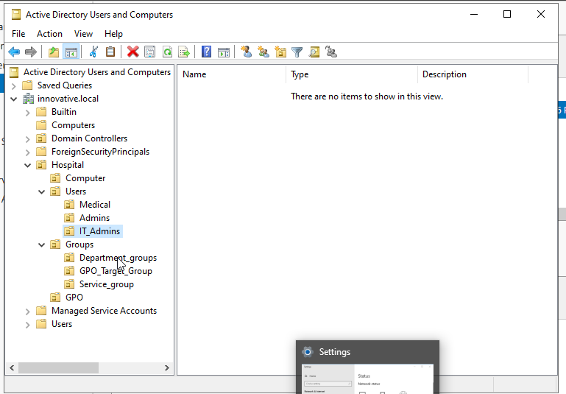

# Create Security Groups

We'll create essential groups for user roles and GPO applications.

**Step 2: Create Security Groups**

1. In **ADUC**, navigate to Hospital/Groups.

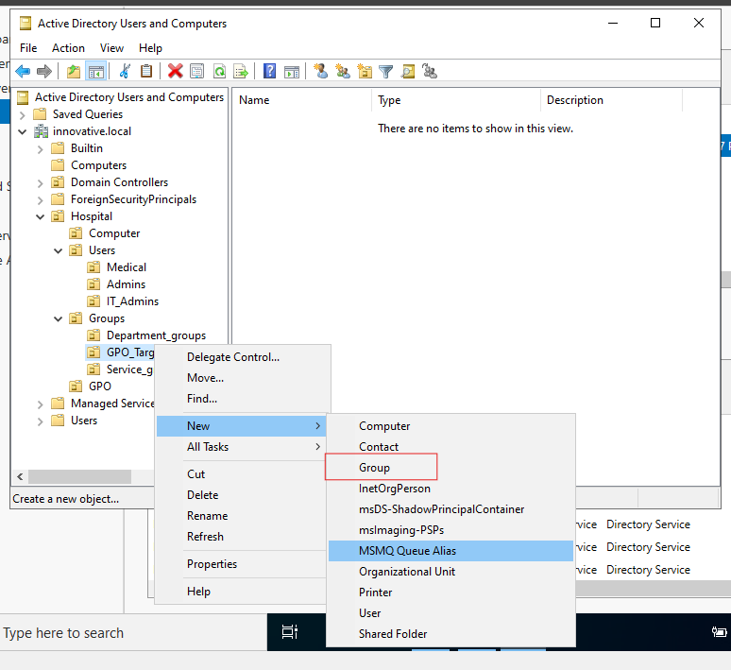

1. **Departmental Groups (Global Security):**
   * Right-click Departmental_Groups > **New > Group**.
   * SG_Medical_Doctors
   * SG_Admin_Staff
   * SG_IT_Admins

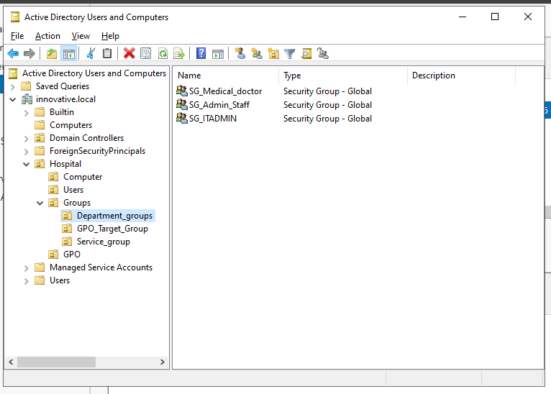

1. **Service Access Groups (Domain Local Security):**
   * Right-click ServiceAccess_Groups > **New > Group**.
   * DL_Access_EMR_Read (Simulate access to a patient database/shared folder)
   * DL_Access_FTP_Users
   * DL_Access_IIS_Web_App
   * DL_Access_Printer_Medical

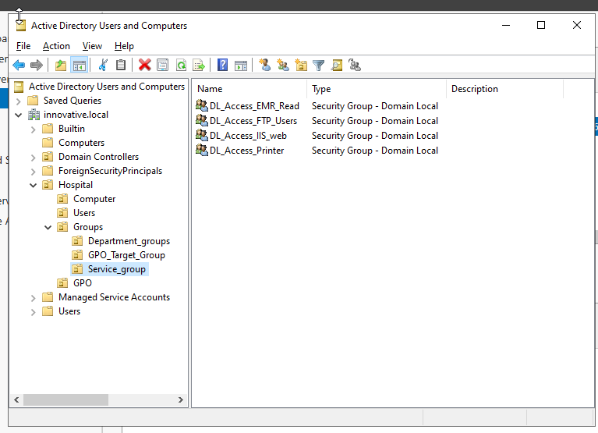

1. **GPO Targeting Groups (Global Security):**
   * Right-click GPO_Targeting_Groups > **New > Group**.
   * SG_GPO_MedicalWorkstations (For your Win10 client)
   * SG_GPO_MedicalUsers
   * SG_GPO_AdminUsers
   * SG_GPO_ITUsers

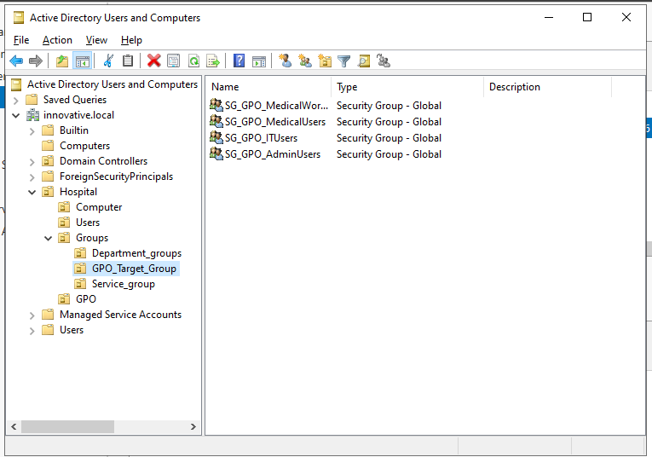

# Create Users and Join Client

**Step 3: Create User Accounts**

1. In **ADUC**, navigate to Hospital/Users.

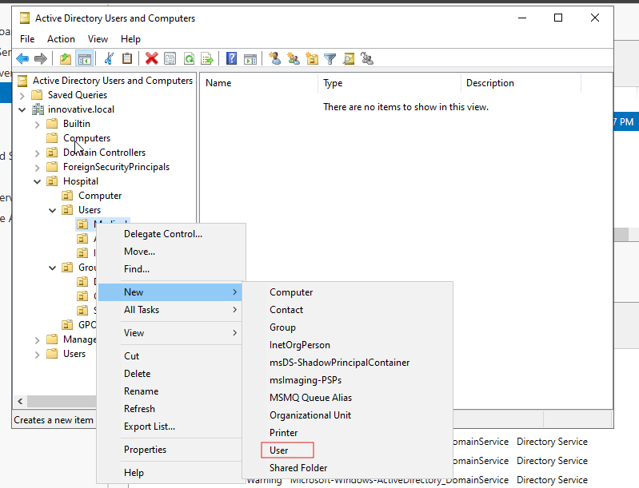

1. 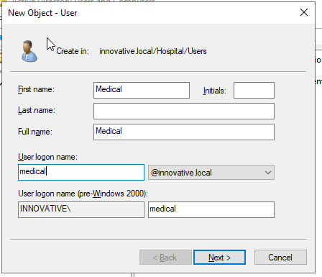
2. 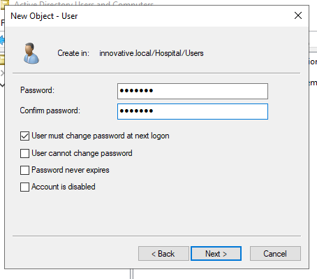
3. 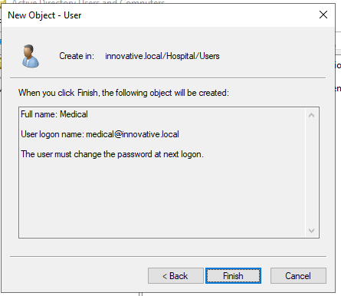
4. **IT Admin:**
   * Right-click IT_Admins > **New > User**.
   * First Name: IT, Last Name: Admin, Logon: itadmin
   * Set password (e.g., P@ssw0rd!), uncheck "User must change password...", check "Password never expires" (for lab convenience). Add to Domain Admins (for server management demos).

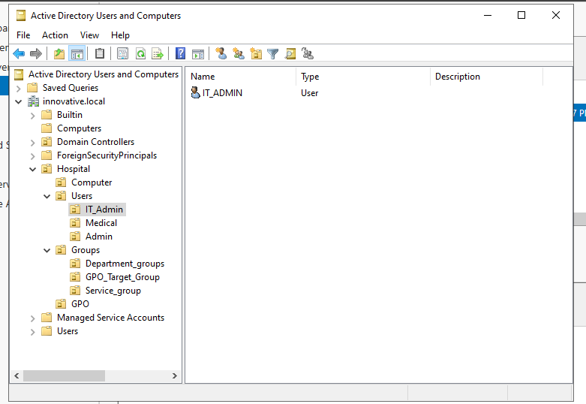

1. **Doctor User:**
   * Right-click Medical > **New > User**.
   * First Name: John, Last Name: Doctor, Logon: jdoctor
   * Set password (e.g., P@ssw0rd!), check "User must change password at next logon".

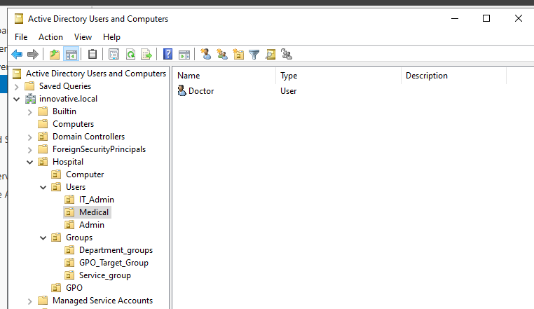

1. **Admin User:**
   * Right-click Admin > **New > User**.
   * First Name: Jane, Last Name: Admin, Logon: jadmin
   * Set password (e.g., P@ssw0rd!), check "User must change password at next logon".

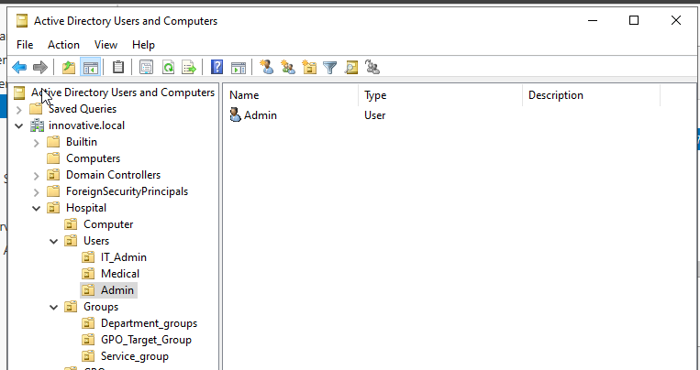

**Step 4: Add Users to Groups**

1. Open jdoctor properties > **Member Of** tab. Add SG_Medical_Doctors and SG_GPO_MedicalUsers.
2. Open jadmin properties > **Member Of** tab. Add SG_Admin_Staff and SG_GPO_AdminUsers.
3. Open itadmin properties > **Member Of** tab. Add SG_IT_Admins and SG_GPO_ITUsers (also Domain Admins if not already done).

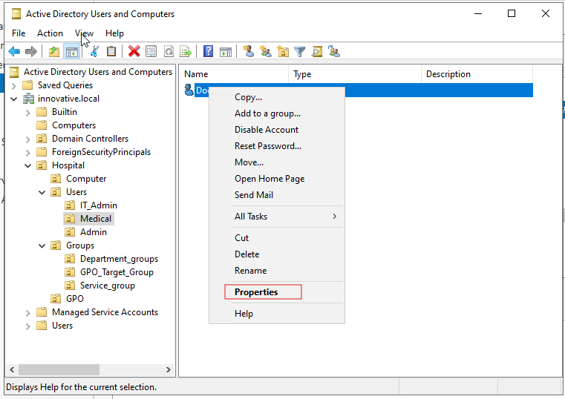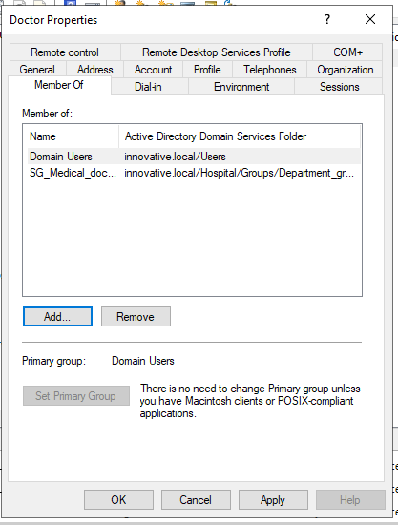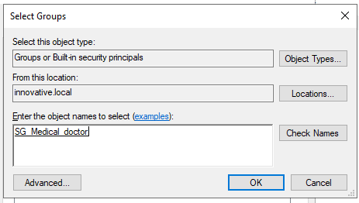

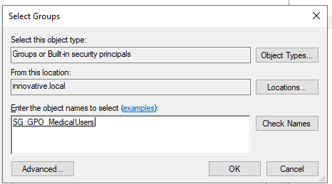

Follow the same for the other users and they should look as in the screenshot

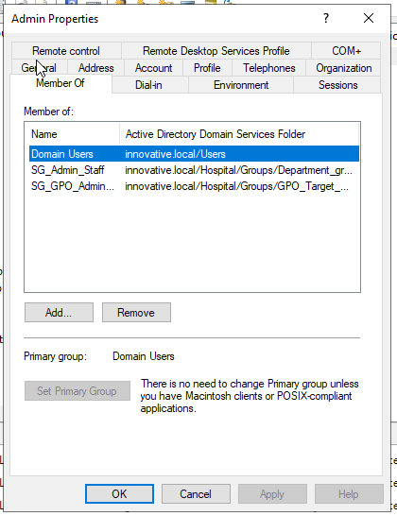

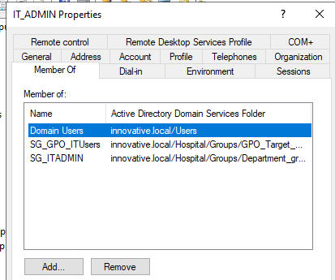

# Setting Up and Testing a Client Machine

**5.1. Create and Configure the Windows 10PRO VM:**

1. Create a new VM in VirtualBox for your client machine (e.g., Client-PC-01).
2. Assign at least 2 GB of RAM and a 40 GB hard disk.
3. In the VM's **Settings > Storage**, attach the Windows 10/11 ISO.
4. In **Settings > Network**, set **Adapter 1** to be attached to the **Internal Network** named hospital-net.

**5.2. Install Windows 10/11:**

1. Start the client VM and install Windows.
2. During the setup, you may not have internet access. This is expected. Complete the installation with a local account for now.

**5.3. Join the Client to the Domain:**

1. Once Windows is installed and you are logged in, open **Settings > System > About**.
2. Click on **Rename this PC (advanced)** or **Advanced system settings**.
3. Go to the **Computer Name** tab and click **Change...**.
4. Under "Member of," select **Domain** and type hospital.local.
5. Click **OK**. A window will pop up asking for credentials.
6. Enter the credentials for your domain administrator (HOSPITAL\Administrator) and the password you set.
7. You should see a "Welcome to the hospital.local domain" message.
8. Restart the client PC.

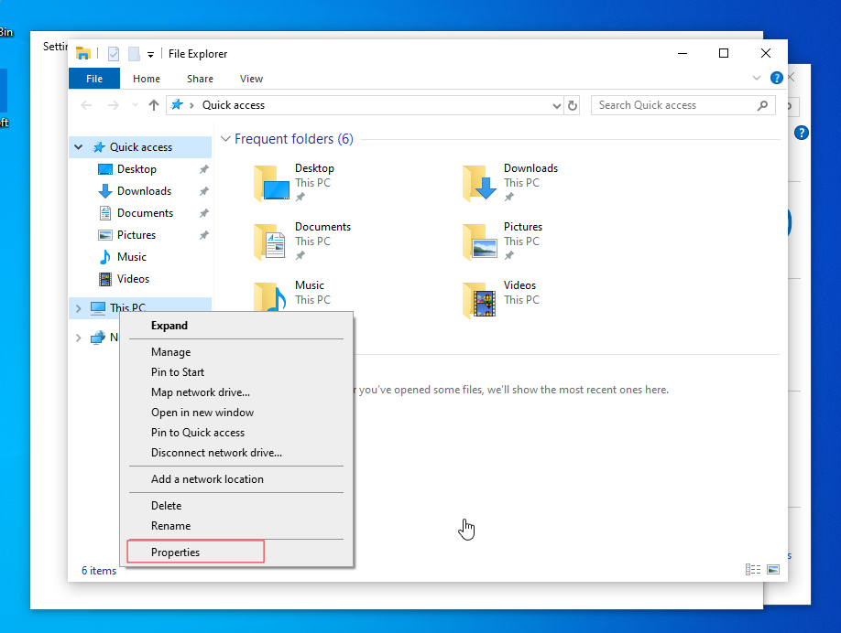

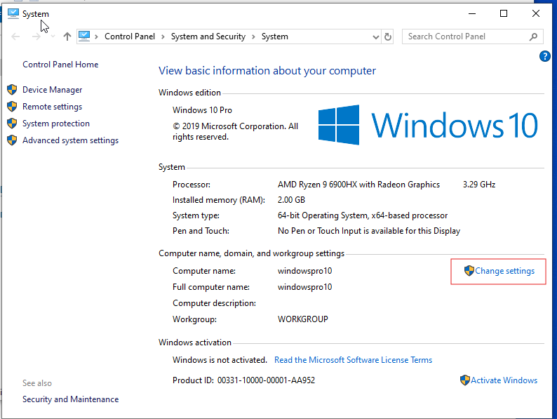

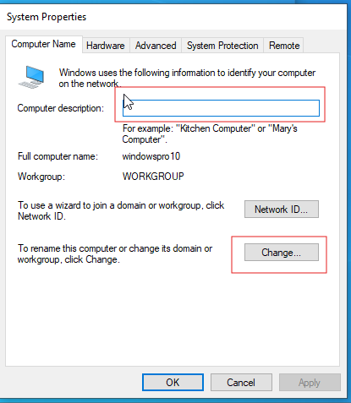

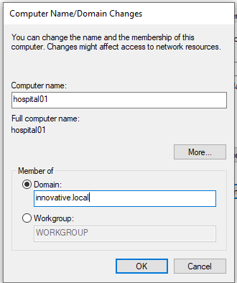

Provide the administrator credentials while authenticating window pop’s up

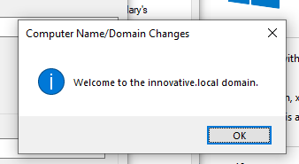

**Step 6: Add Computer Object to GPO Targeting Group**

1. In **ADUC**, navigate to Hospital/Groups/GPO_Targeting_Groups.
2. Open properties of SG_GPO_MedicalWorkstations > **Members** tab.
3. Click **Add...** and add Hospital01.

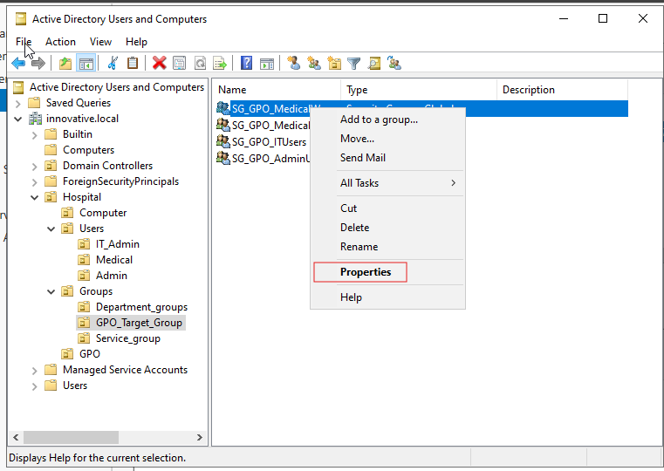

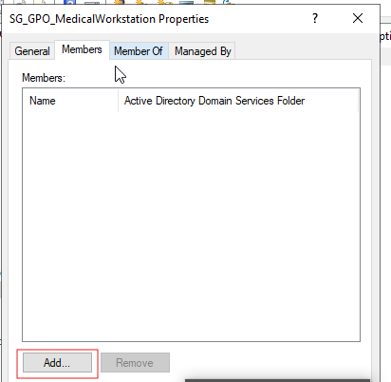

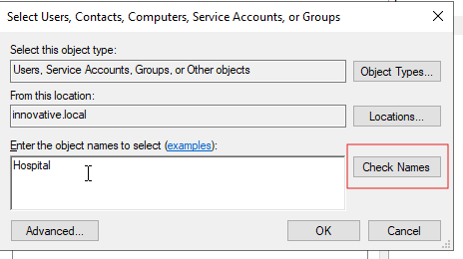

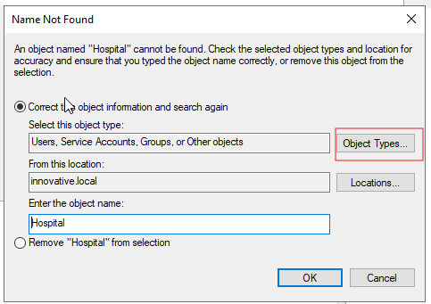

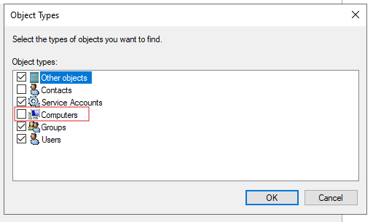

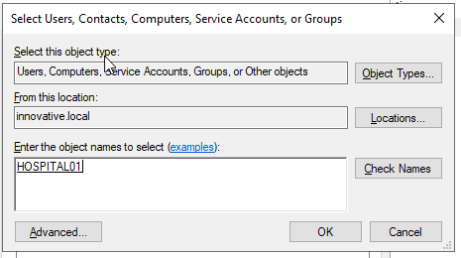

When logging into the other user from the client system

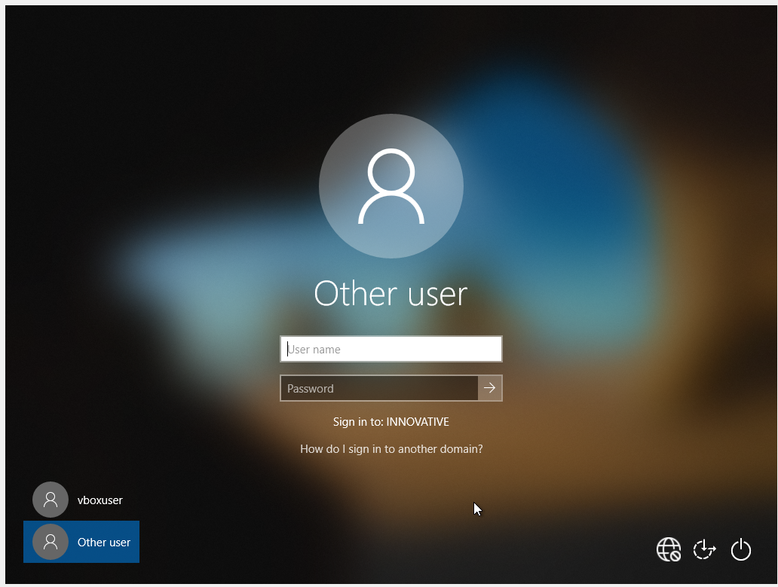

Configured GPO are being forcefully implemented on to the user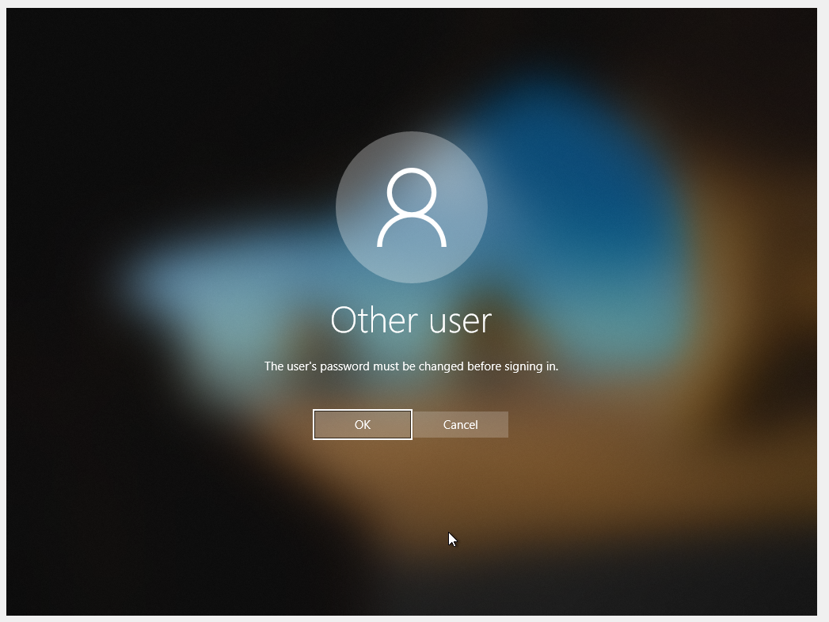

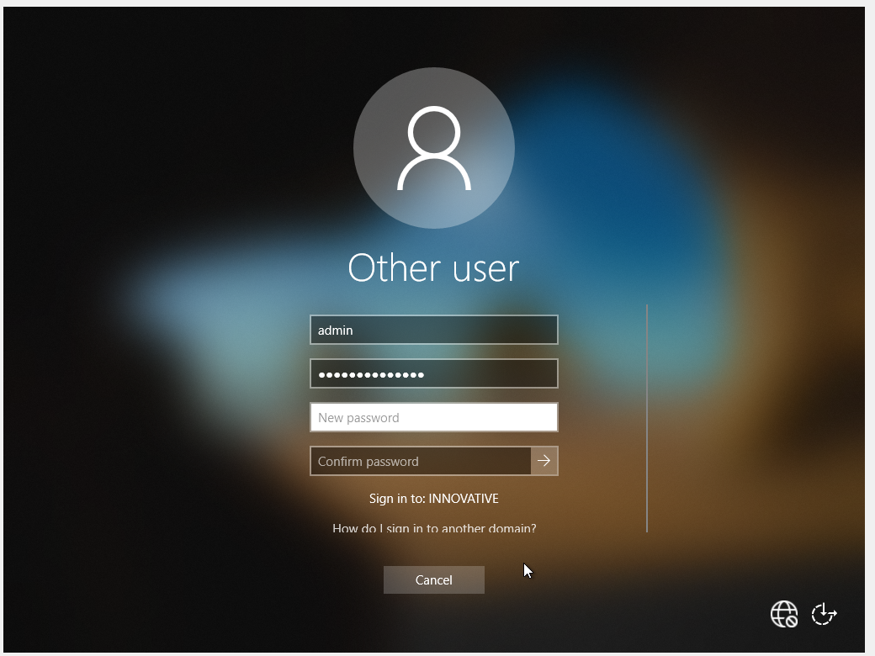

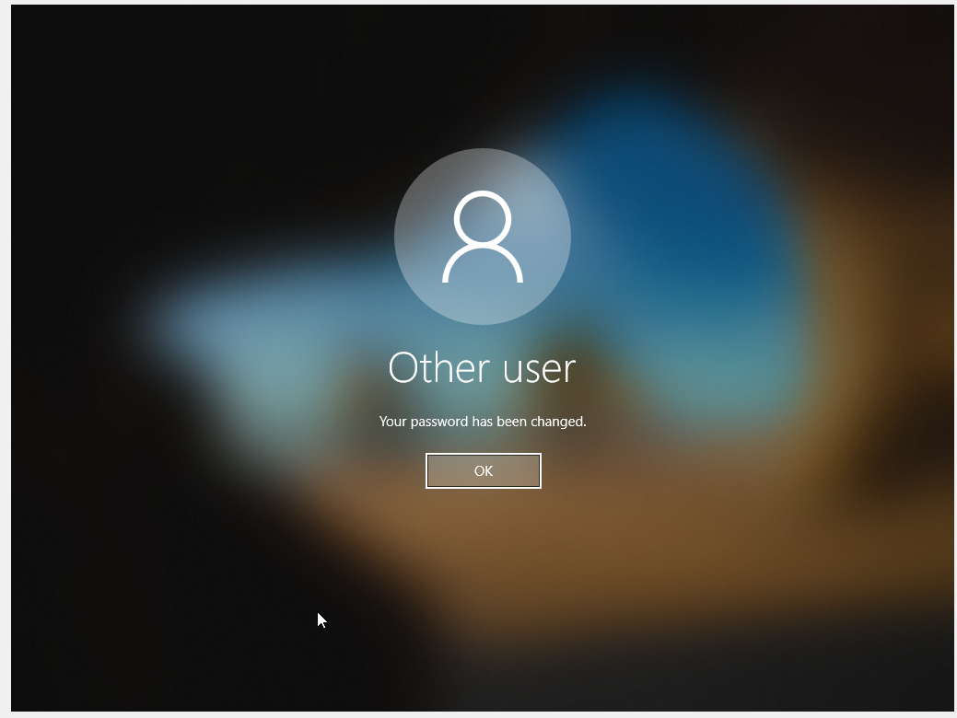

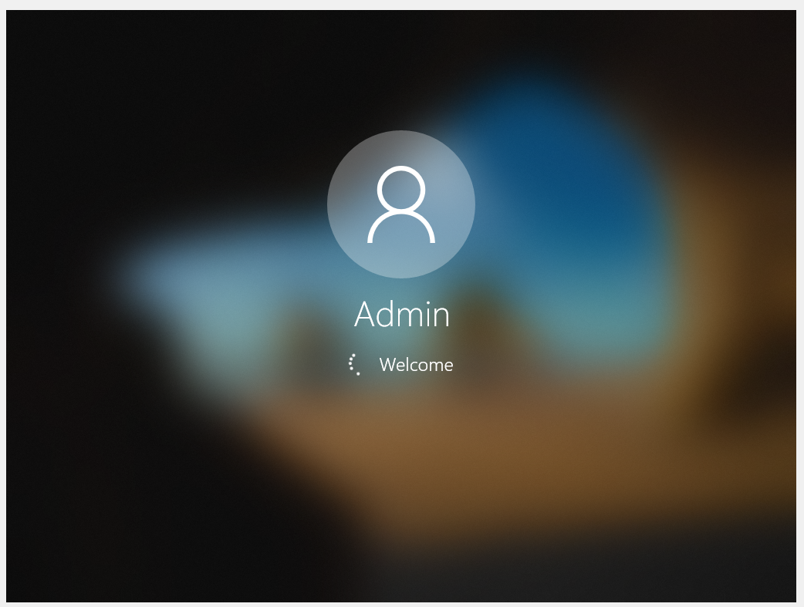

# Group Policy Object (GPO) Creation and Linking

**We'll create essential GPOs to showcase functionality.**

**Step 7: Create Core GPOs in GPMC**

1. **On Windows Server 2022, open Group Policy Management Console (GPMC).**
2. **Navigate to Hospital/GPOs. Right-click and select Create a GPO in this domain, and Link it here... (or create unlinked and drag it here).**

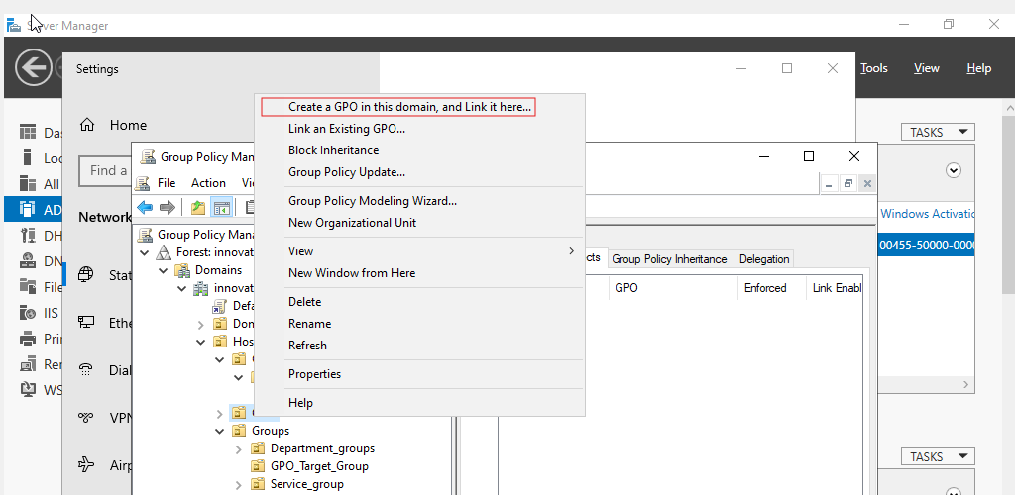

**A. Computer Configuration GPOs (Linked to MedicalWorkstations OU, filtered to SG_GPO_MedicalWorkstations)**

1. **GPO_Computer_Security_Base_Medical**
   * **Purpose: Enforce essential security on the client.**

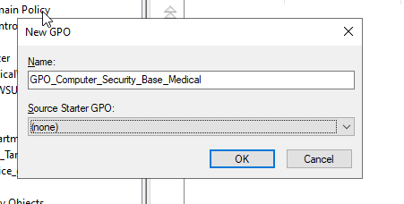

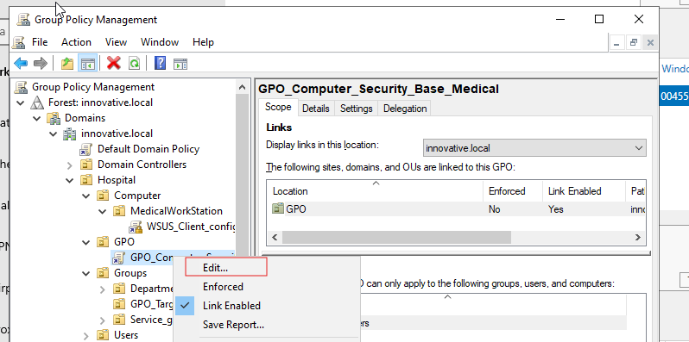

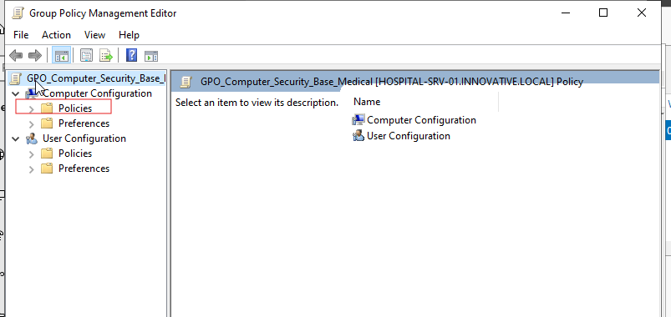

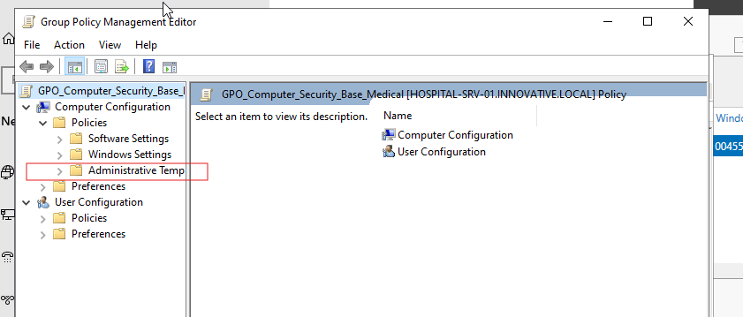

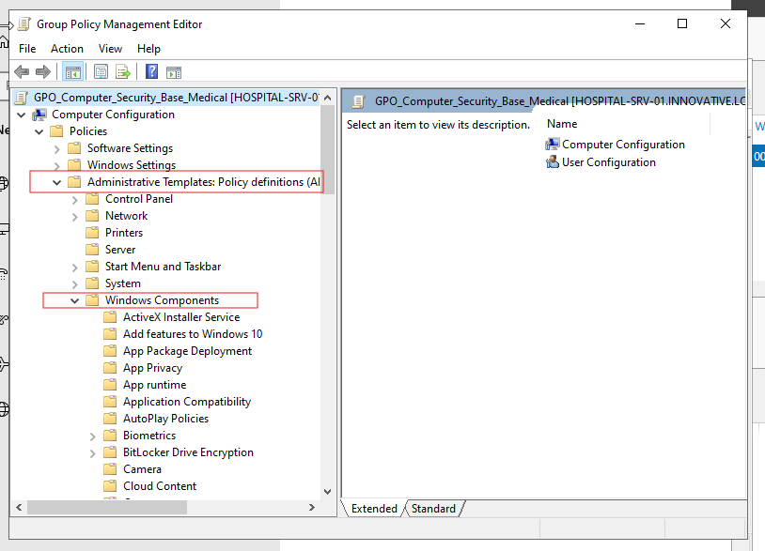

* + **Settings:**
    - **Computer Configuration\Policies\Administrative Templates\Windows Components\Windows Defender Antivirus: Enable real-time protection.**

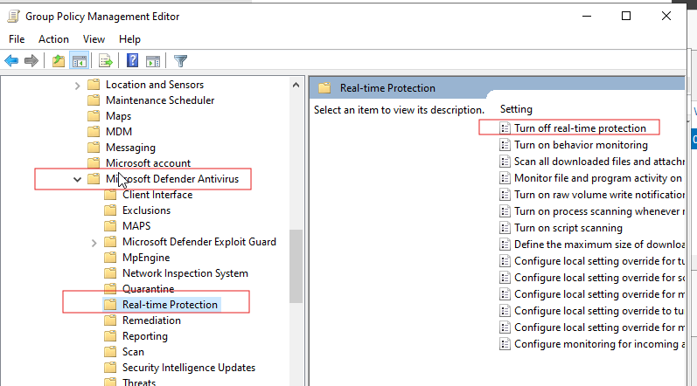

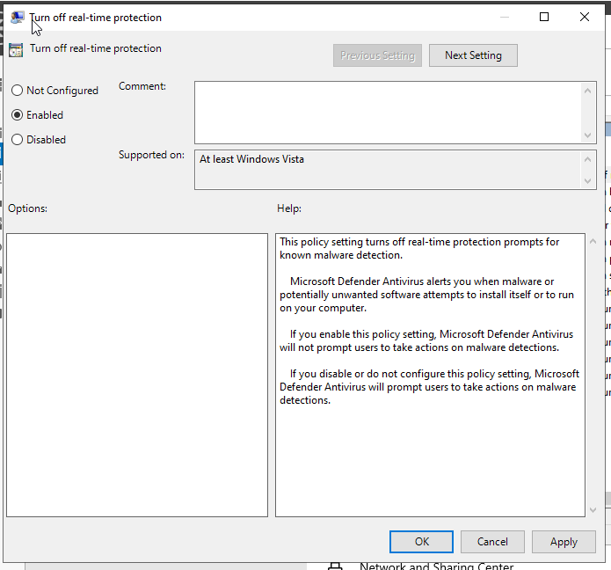

**Follow the above similar steps to create and save the GPO final output screen shot will be added at the end**

**B. User Configuration GPOs (Linked to Medical OU, filtered to SG_GPO_MedicalUsers)**

1. **GPO_User_Desktop_MedicalUsers**
   * **Purpose: Standardize medical user desktop, deploy resources.**
   * **Settings:**
     + **User Configuration\Policies\Administrative Templates\Control Panel\Prohibit access to Control Panel and PC settings: Enabled.**
     + **User Configuration\Policies\Administrative Templates\Desktop\Desktop\Hide and disable all items on the desktop: Enabled (Simulate a locked-down medical workstation).**
     + **User Configuration\Preferences\Windows Settings\Drive Maps:**
       - **Create a New Drive Map (Update action): Z:, to \\your_server_ip\EMR_Data (Create this share on the server with DL_Access_EMR_Read permissions).**
     + **User Configuration\Preferences\Control Panel Settings\Printers:**
       - **Create a New Shared Printer (Update action): Path \\your_server_ip\MedicalPrinter (Share a printer from the server).**
     + **User Configuration\Preferences\Control Panel Settings\Internet Settings:**
       - **Create a New Internet Explorer 10 preference: Set Homepage to http://your_server_ip/EMR_Web_App (or a simple IIS test page).**
   * **Linking: Link to Hospital/Users/Medical.**
   * **Security Filtering: Remove Authenticated Users, add SG_GPO_MedicalUsers. Also add Domain Users for Read access on the Delegation tab.**

**C. Other GPOs (Conceptual/Demonstrative)**

* **You can create a GPO_User_Desktop_AdminUsers linked to Hospital/Users/Admin with different drive mappings or homepages to show variation.**
* **You can create a GPO_IT_Admin_RDP_Access (User Configuration) linked to Hospital/Users/IT_Admins to grant them specific RDP permissions (though Domain Admins already have it).**

**This is how the GPO’s are created and enforced on to the computers and users**

# Application and Data Services(IIS)

In this phase, you will install and configure the platforms necessary to run web-based applications and manage the hospital's data.

**1. Internet Information Services (IIS) Installation and Configuration**

IIS will serve as the web server for internal applications, such as an intranet portal.

**Step 3.1: Install the IIS Role**

1. On HOSPITAL-SRV-01, open **Server Manager**.
2. Go to **Manage > Add Roles and Features**.
3. Click **Next** until you reach the **Server Roles** page.
4. Check the box for **Web Server (IIS)**. Click **Add Features** in the pop-up window.
5. Click **Next** through the rest of the wizard, accepting the default settings.
6. On the **Confirmation** screen, click **Install**.

**Step 3.2: Test the Default IIS Installation**

1. Once the installation is complete, open a web browser **on the server** and navigate to http://localhost.
2. You should see the default blue IIS welcome page. This confirms the service is running.

**Step 3.3: Create a Simple Intranet Website**

1. Open **File Explorer** and create a new folder C:\inetpub\intranet.
2. Inside this new folder, create a simple HTML file.
   * Right-click inside the folder, select **New > Text Document**.
   * Name it index.html (be sure to change the .txt extension).
   * Right-click index.html and choose **Edit** (or open with Notepad).
   * Paste the following code into the file and save it:

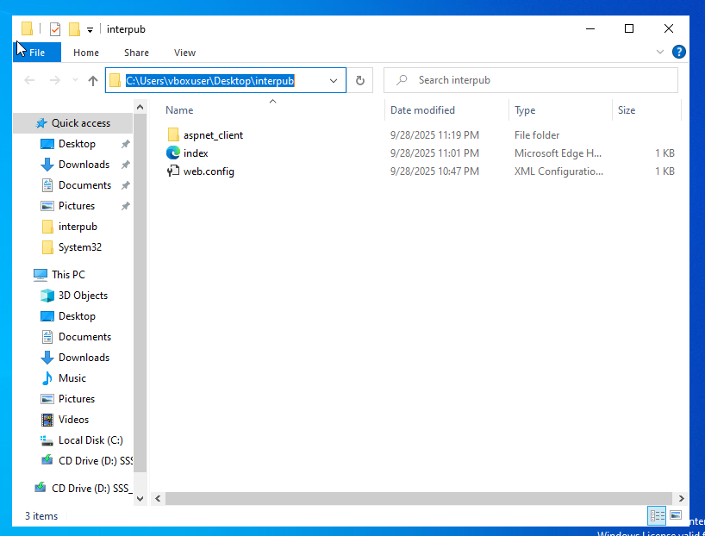

code Html

* + <!DOCTYPE html>
  + <html>
  + <head>
  + <title>Hospital Intranet</title>
  + </head>
  + <body style="font-family: sans-serif; text-align: center;">
  + <h1>Welcome to the Hospital Intranet Portal</h1>
  + <p>This is the central hub for hospital staff.</p>
  + </body>
  + </html>

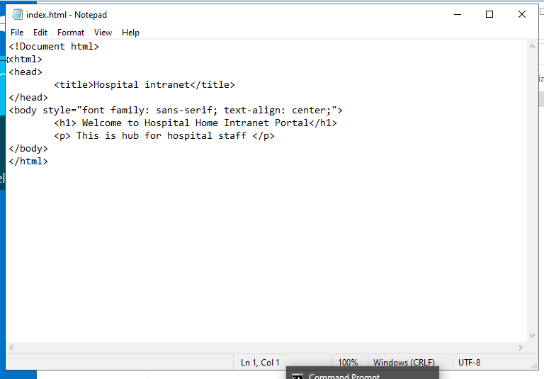

1. Now, configure IIS to serve this site.
   * From Server Manager, go to **Tools > Internet Information Services (IIS) Manager**.
   * In the IIS Manager, expand your server name in the left pane.
   * Right-click on the **Sites** folder and select **Add Website**.
   * **Site name:** Intranet
   * **Physical path:** Browse to C:\inetpub\intranet.
   * **Binding > Host name:** intranet.hospital.local (or intranet.innovative.local depending on your domain name).
   * Click **OK**.

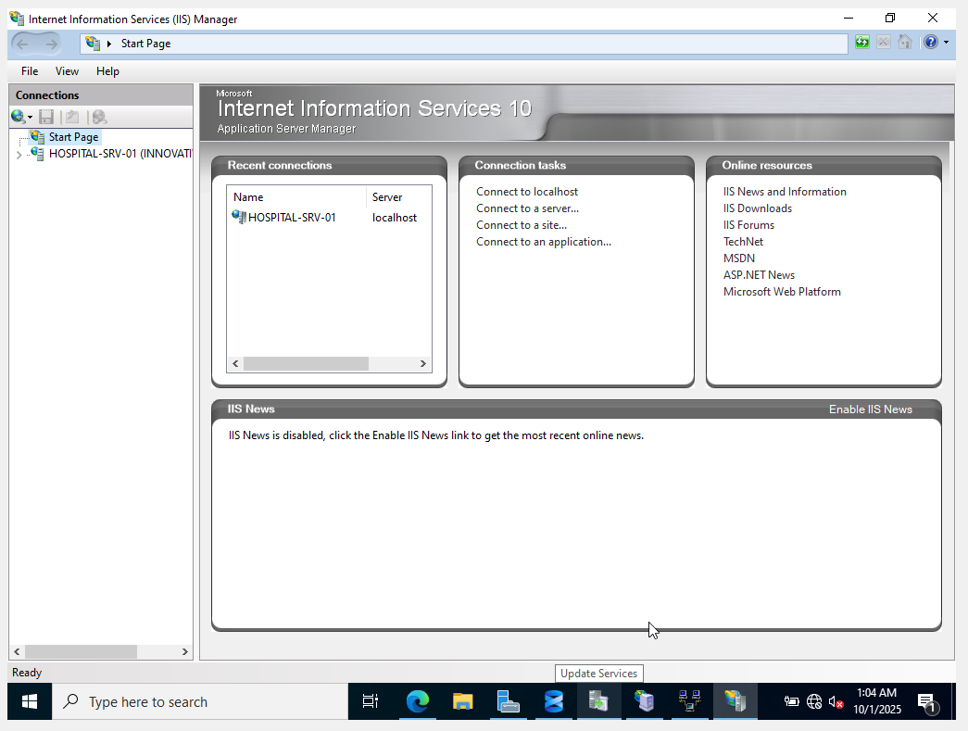

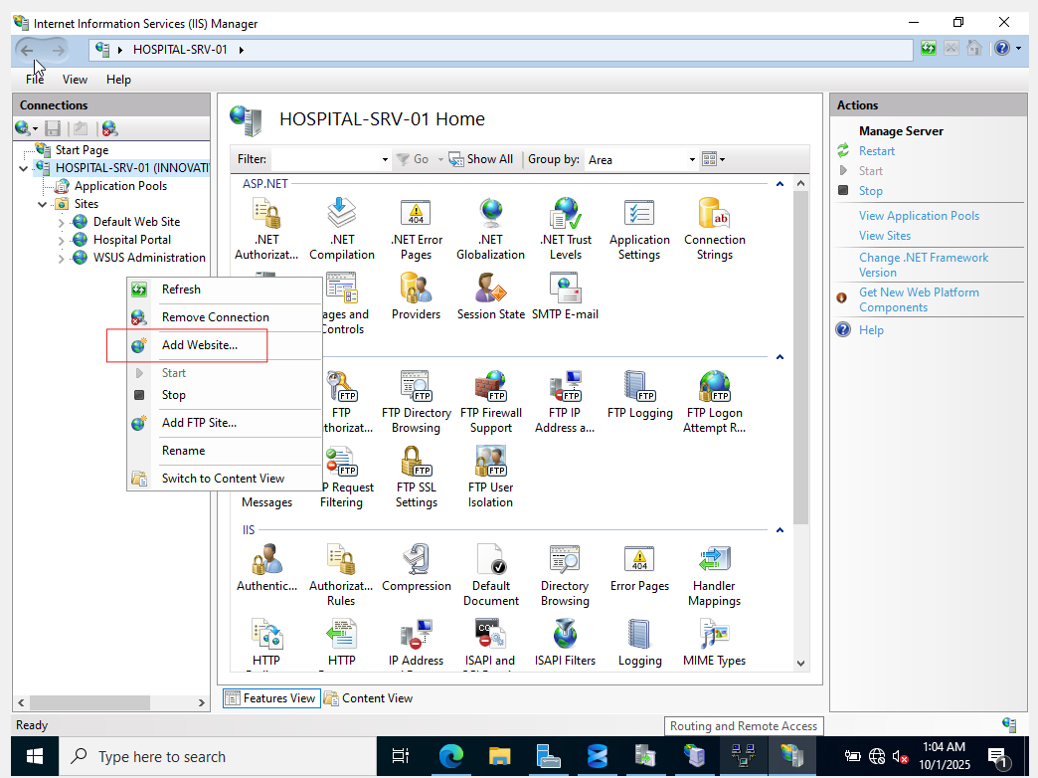

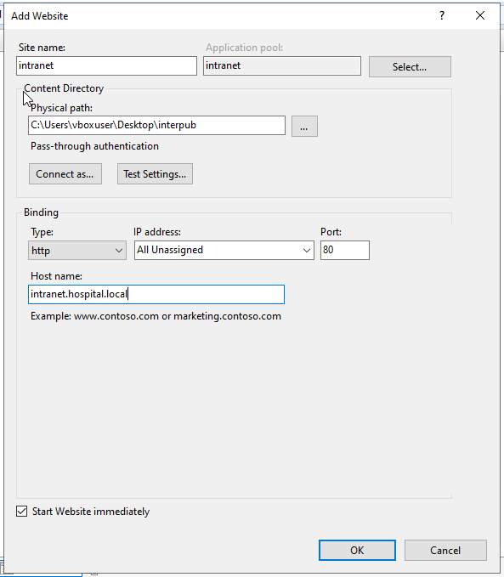

**Step 3.4: Create a DNS record for the Intranet Site**

1. From Server Manager, go to **Tools > DNS**.
2. Expand your server, expand **Forward Lookup Zones**, and click on your domain (hospital.local or innovative.local).
3. Right-click in the empty space and select **New Host (A or AAAA)...**.
   * **Name:** intranet (the domain part will be filled in automatically).
   * **IP address:** 192.168.10.1 (the IP of your server).
   * Click **Add Host**.

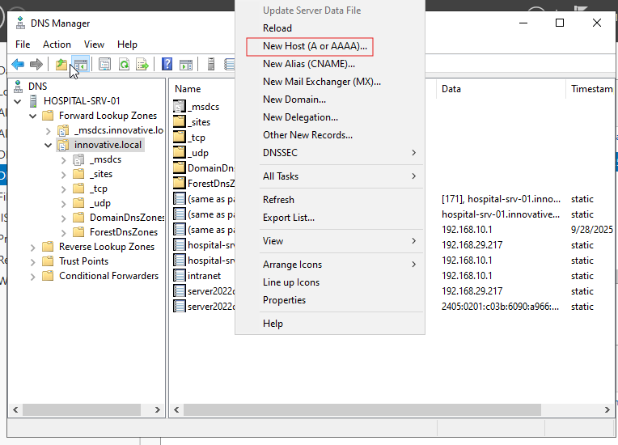

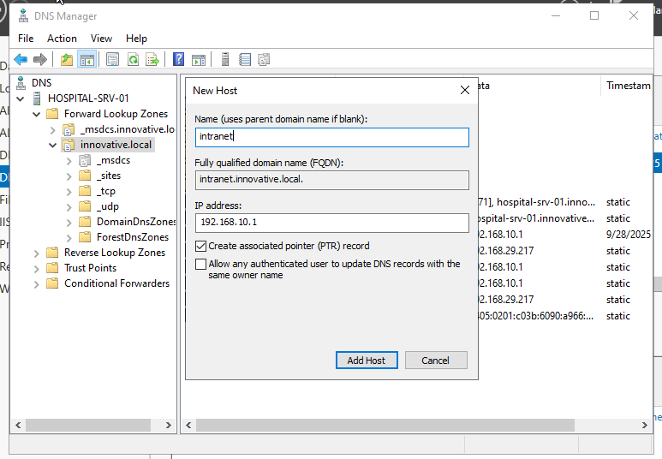

**Step 3.5: Test the Intranet from a Client PC**

1. Log in to your domain-joined Windows 10/11 client machine (Client-PC-01).
2. Open a web browser and navigate to http://intranet.hospital.local (or your equivalent domain).
3. You should see the "Welcome to the Hospital Intranet Portal" page you created.

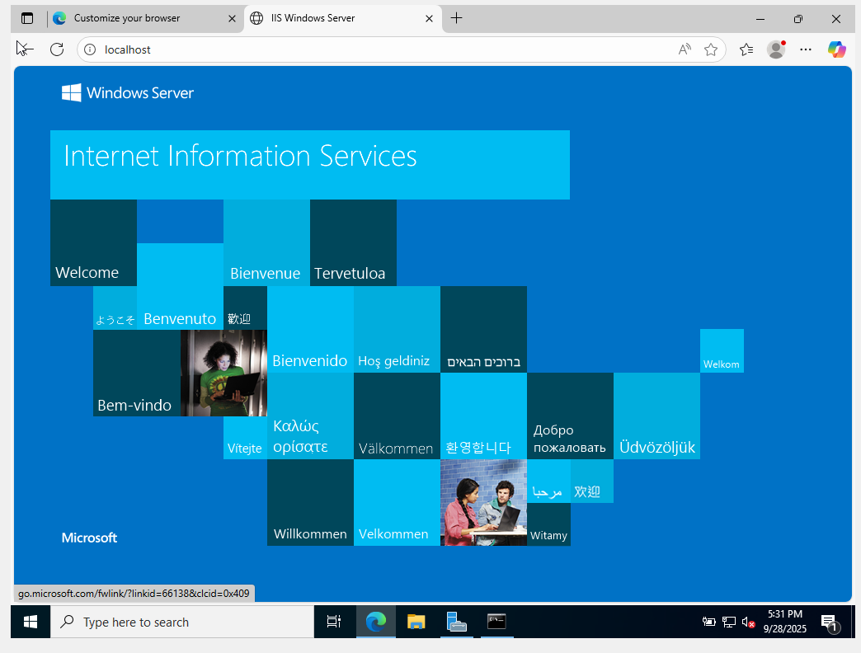

If any authentication or authorization error occurs Here's how you can configure the security settings to resolve this:

**Option 1: Allow Anonymous Authentication (Simplest for a basic Intranet without specific user authentication)**

This is often sufficient for a simple internal intranet where you just want users to view content without logging in.

1. **Open IIS Manager:** On HOSPITAL-SRV-01, go to Server Manager > Tools > Internet Information Services (IIS) Manager.
2. **Navigate to your Intranet Site:** In the left pane, expand your server, then Sites, and click on your Intranet site.
3. **Open Authentication:** In the central pane, double-click on Authentication under the "IIS" section.
4. **Enable Anonymous Authentication:**
   * Ensure Anonymous Authentication is Enabled.
   * If Windows Authentication is Enabled, you might want to Disable it for a basic intranet unless you specifically intend for users to authenticate with their domain credentials.
   * If you enable both, IIS might try Windows Authentication first, and if it fails (e.g., due to client browser settings or configuration), it will then fall back to Anonymous. For simplicity, just enabling Anonymous is often best.
5. **Test Again:** From your client PC, try accessing http://intranet.hospital.local again.

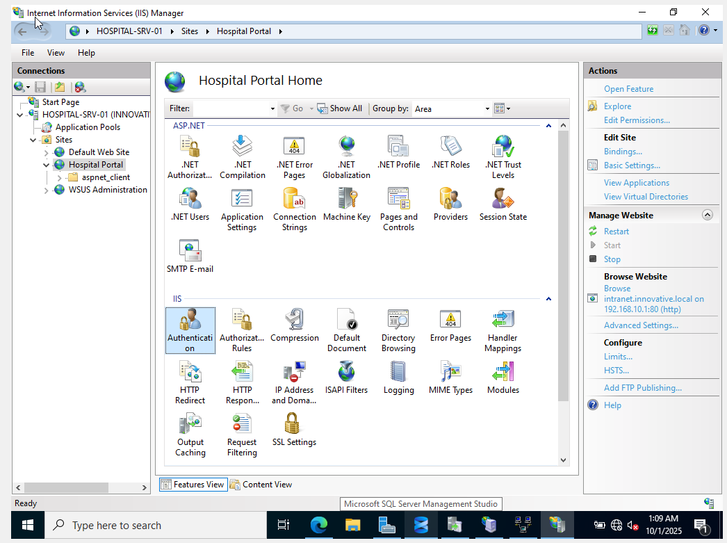

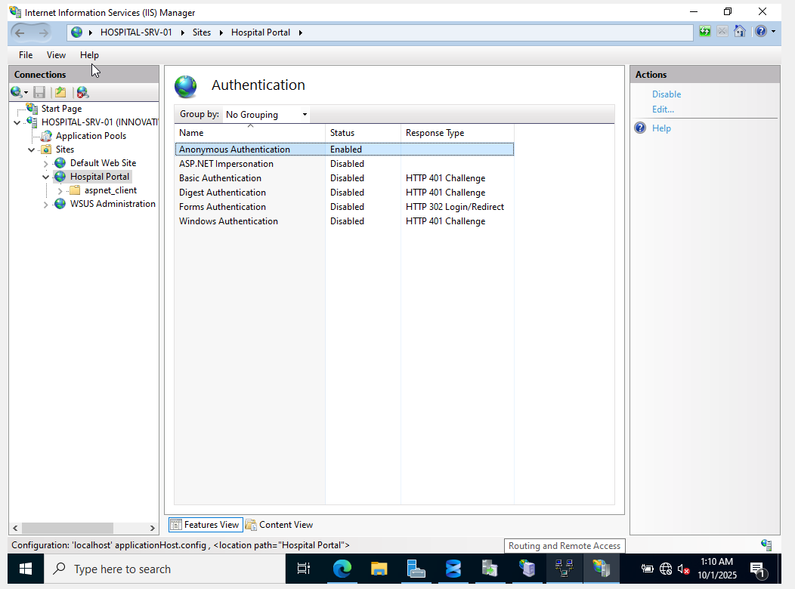

**Option 2: Check File System Permissions (Crucial if Anonymous Authentication doesn't fix it or if you want more control)**

Even with Anonymous Authentication enabled, the IIS worker process (which runs as a specific user, typically IUSR or IIS_IUSRS) needs read access to your website's files.

1. **Open File Explorer:** On HOSPITAL-SRV-01, navigate to C:\inetpub\intranet.
2. **Access Security Settings:** Right-click on the intranet folder and select Properties. Go to the Security tab.
3. **Check Permissions for IIS Users:**
   * Click Edit... to change permissions.
   * Click Add....
   * In the "Enter the object names to select" field, type IIS_IUSRS and click Check Names. It should resolve to "IIS_IUSRS" (this is a built-in group for IIS application pool identities). Click OK.
   * With IIS_IUSRS selected, ensure that Read & execute, List folder contents, and Read permissions are checked under "Allow".
   * Click OK on both windows to apply the changes.
   * Alternatively, you can try adding IUSR (the default anonymous user account) with Read permissions, but IIS_IUSRS is generally preferred as it covers all application pool identities.
4. **Test Again:** From your client PC, try accessing http://intranet.hospital.local again.

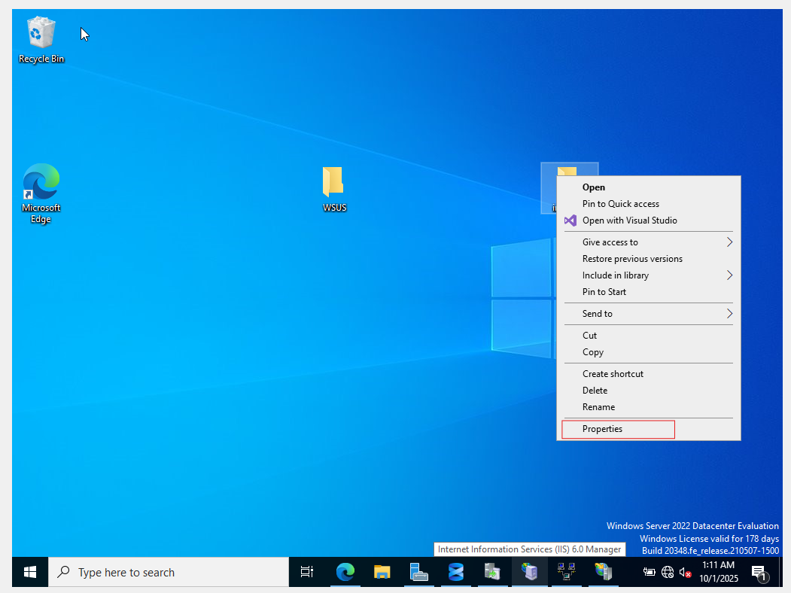

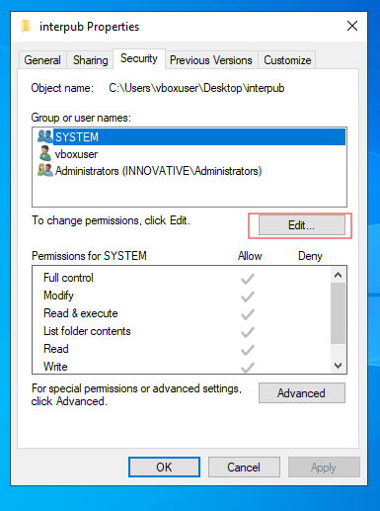

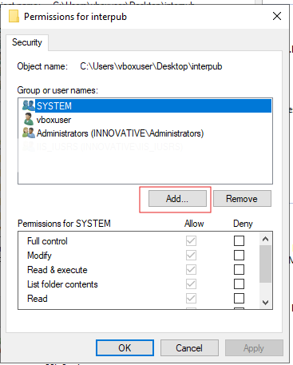

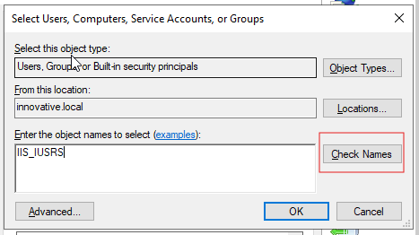

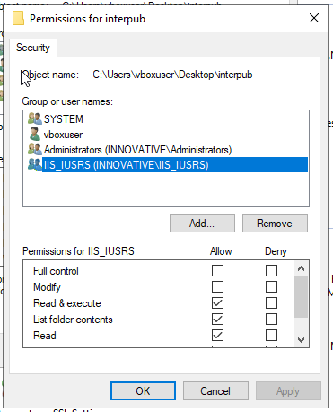

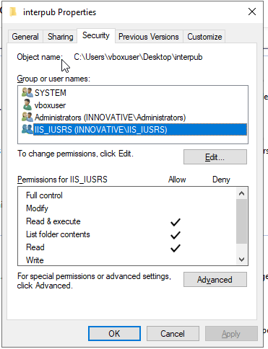

Here's what the IIS Authentication settings typically look like:

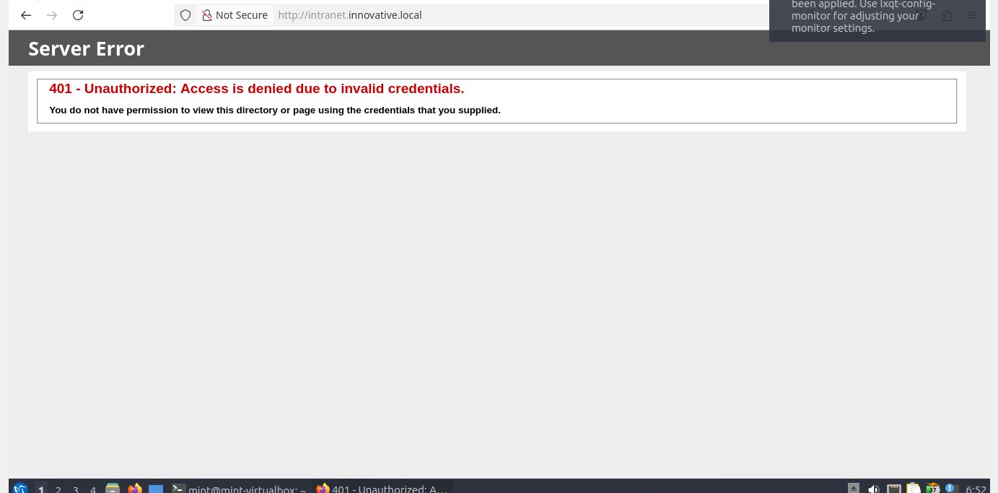

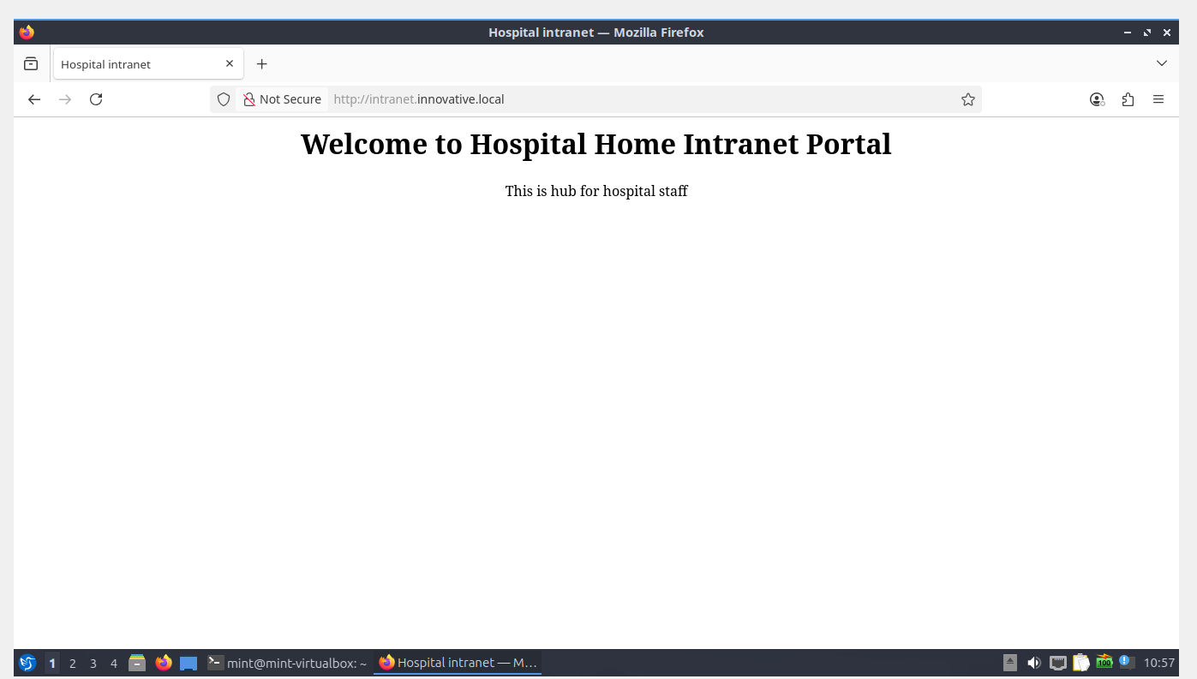

# Phase 4: Management and Support Services (printer)

Here you will centralize the management of updates and printers.

**1. Print Server**

**Step 4.1: Install the Print Server Role**

1. In Server Manager, go to **Manage > Add Roles and Features**.
2. In the **Server Roles** list, check **Print and Document Services**.
3. Click **Next**. On the Role Services page, ensure **Print Server** is checked. Click **Next** and then **Install**.

**Step 4.2: Add and Share a Virtual Printer for Testing**

1. From Server Manager, go to **Tools > Print Management**.
2. Expand **Print Servers > [Your Server Name] > Printers**.
3. Right-click on **Printers** and select **Add Printer...**.
4. Choose **Add a new printer using an existing port**. Select **LPT1: (Printer Port)** from the list and click **Next**.
5. Choose **Install a new driver** and click **Next**.
6. Select **Microsoft** as the manufacturer and **Microsoft PCL6 Class Driver** as the printer. Click **Next**.
7. **Printer Name:** Hospital_FrontDesk_Printer.
8. **Share this printer:**
   * **Share name:** FrontDeskPrinter
   * Check the box for **List in the directory**. This makes it easy for users to find.
9. Click **Next** twice, then **Finish**.

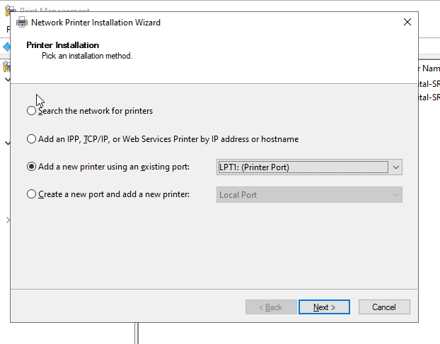

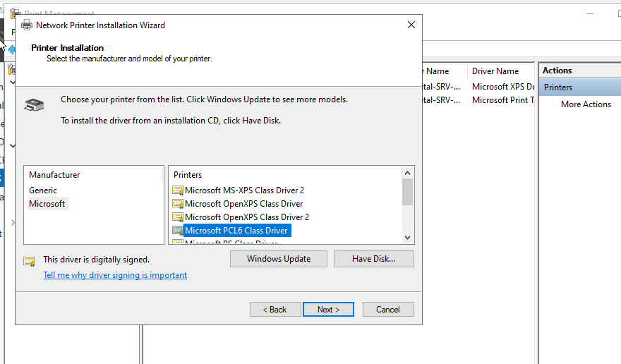

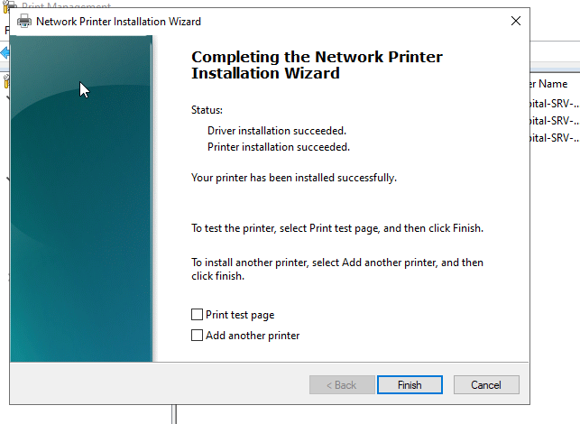

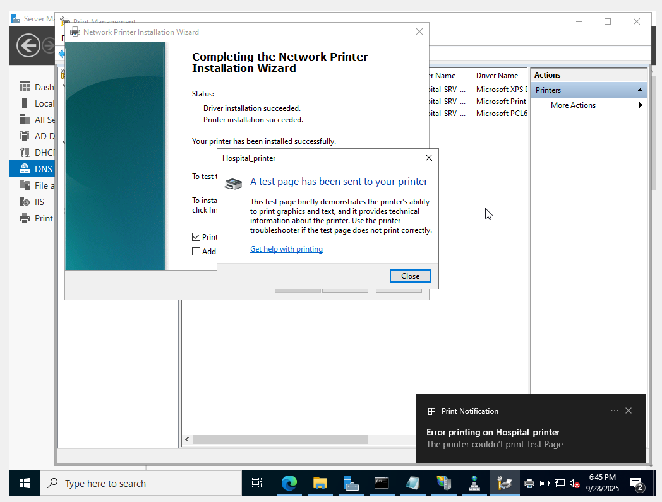

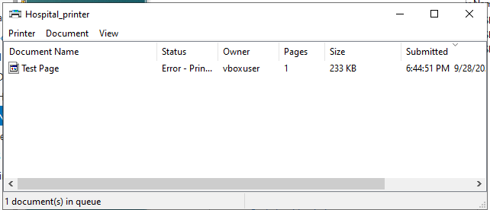

**Steps to Verify Network Printing (The Actual Goal):**

1. **Clear the Current Erroring Job:**
   * In the "Hospital_printer" queue window, right-click on the "Test Page" job with "Error - Printing" status and select Cancel.
   * You might need to restart the Print Spooler service on the server if it's stuck. Go to Services.msc, find "Print Spooler", right-click and choose Restart.
2. **Connect from a Client PC:**
   * **On your client machine (e.g., Client-PC-01):**
     + Open Settings (Windows Key + I) > Bluetooth & devices > Printers & scanners.
     + Click Add a printer or scanner.
     + After it searches, click "The printer that I want isn't listed".
     + Choose "Select a shared printer by name" and type in the path: \\HOSPITAL-SRV-01\FrontDeskPrinter (or \\<Your_Server_Name>\FrontDeskPrinter).
     + Click Next. The client should find the printer and install the necessary driver from the server.
     + Once installed, it will ask if you want to print a test page. **You can try this, but it will likely end up in the server's queue with the same error.** The important thing is that the client *successfully connects* and *installs* the printer.
3. **Confirm Client Connection (The Real Success Metric):**
   * Once the client adds the printer, open WordPad or Notepad on the client.
   * Type some text.
   * Go to File > Print, select FrontDeskPrinter on HOSPITAL-SRV-01.
   * Click Print.
   * **Crucially, go back to the Print Management on your HOSPITAL-SRV-01 server.**
   * Expand Print Servers > [Your Server Name] > Printers.
   * Double-click Hospital_FrontDesk_Printer.
   * You should see the print job from the client machine appear in the queue. It will likely still show an "Error - Printing" status **on the server's queue**, because the server still has nowhere to physically send the output on LPT1:.
   * **However, the success here is that the client was able to *send* the job to the server.** This confirms the network share and basic printing setup is working from the client's perspective.

**In essence, the error you're seeing on the server's test page is a non-issue for the functionality of sharing the printer to network clients.** The "printer" you set up on LPT1 is a placeholder for network sharing.

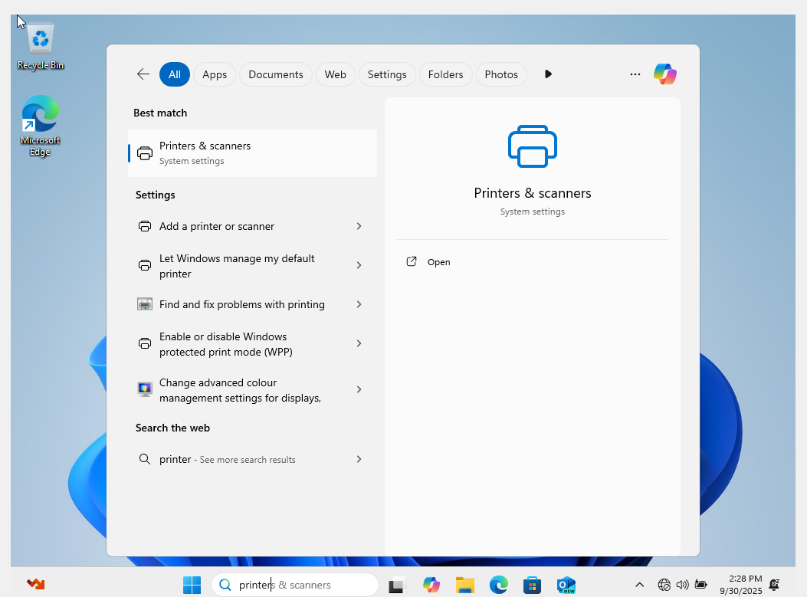

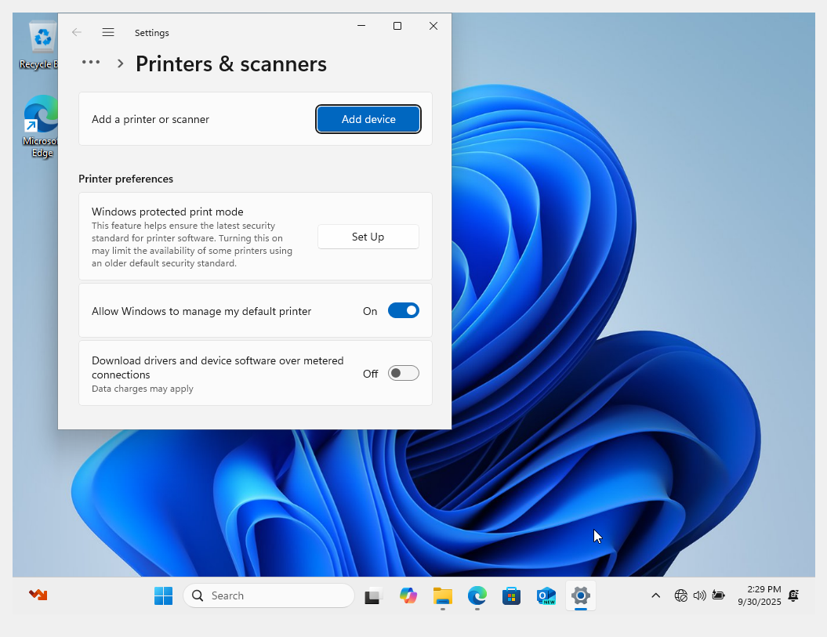

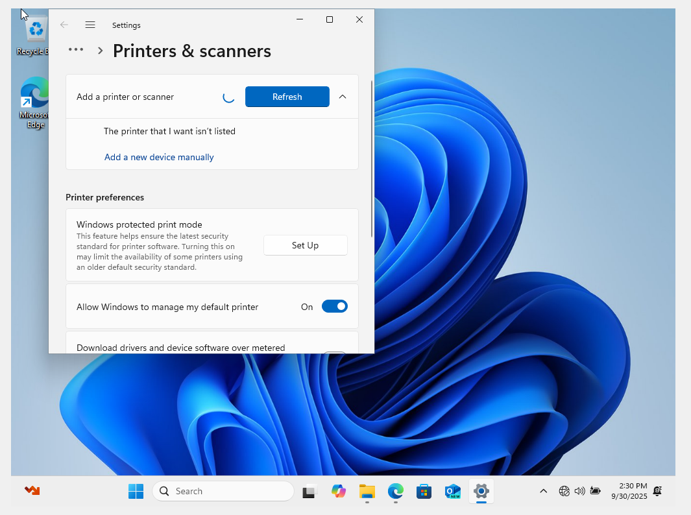

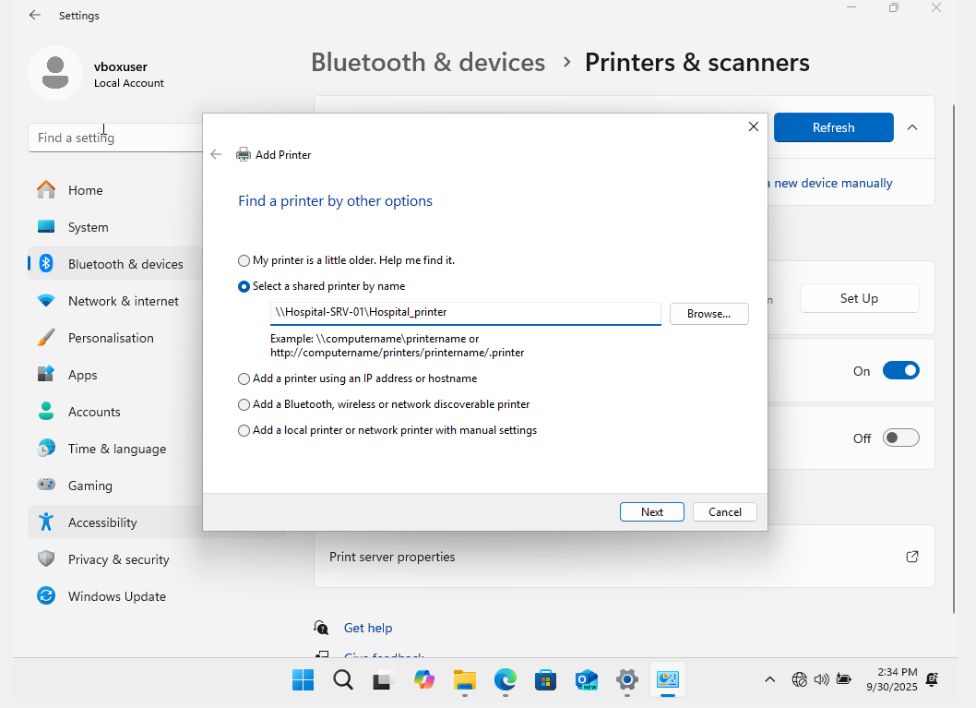

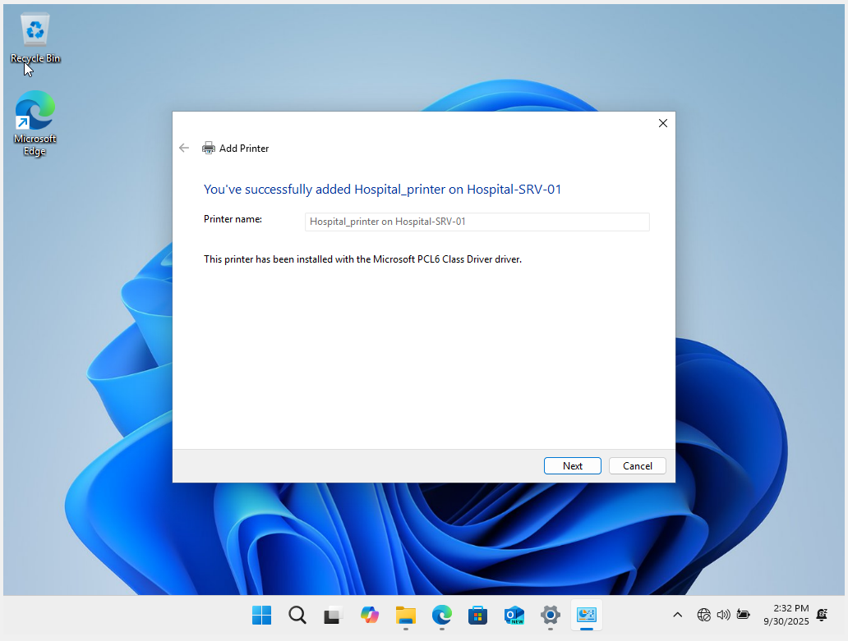

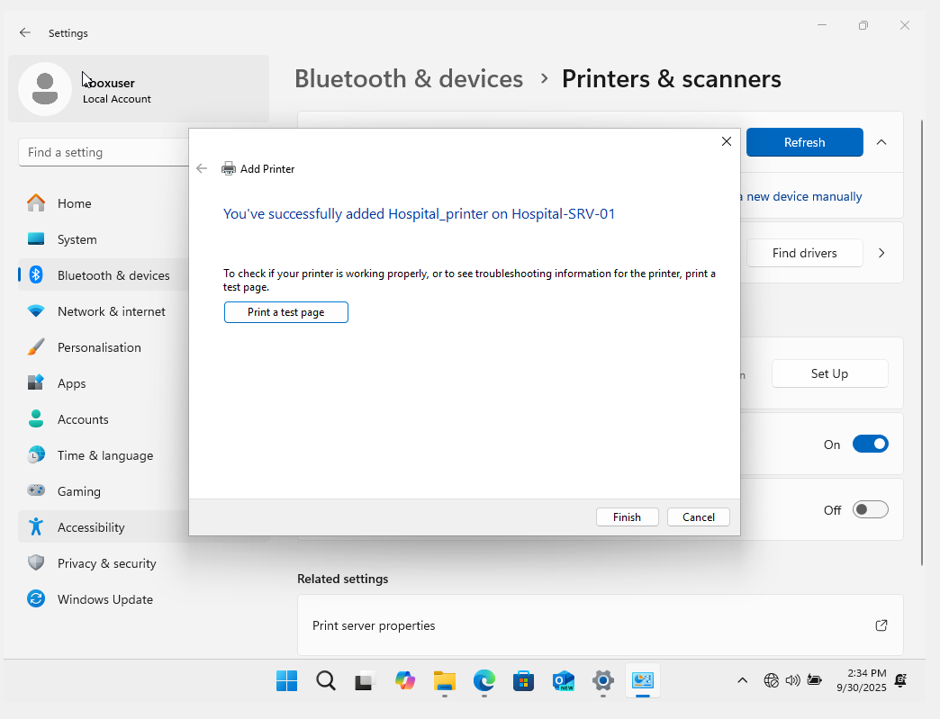

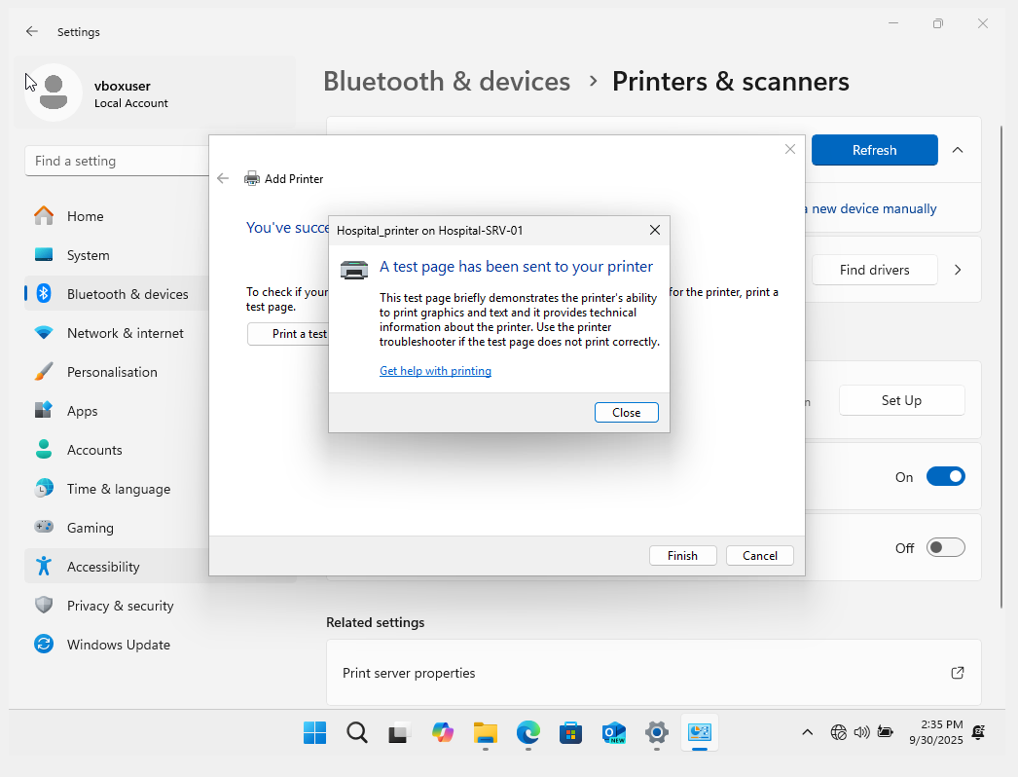

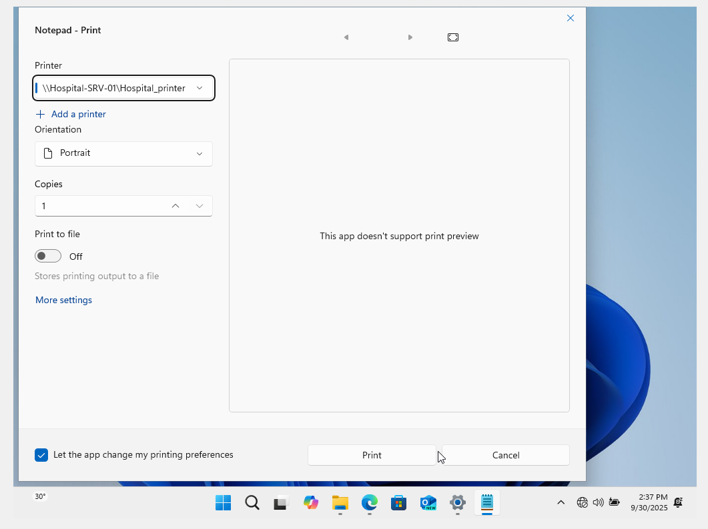

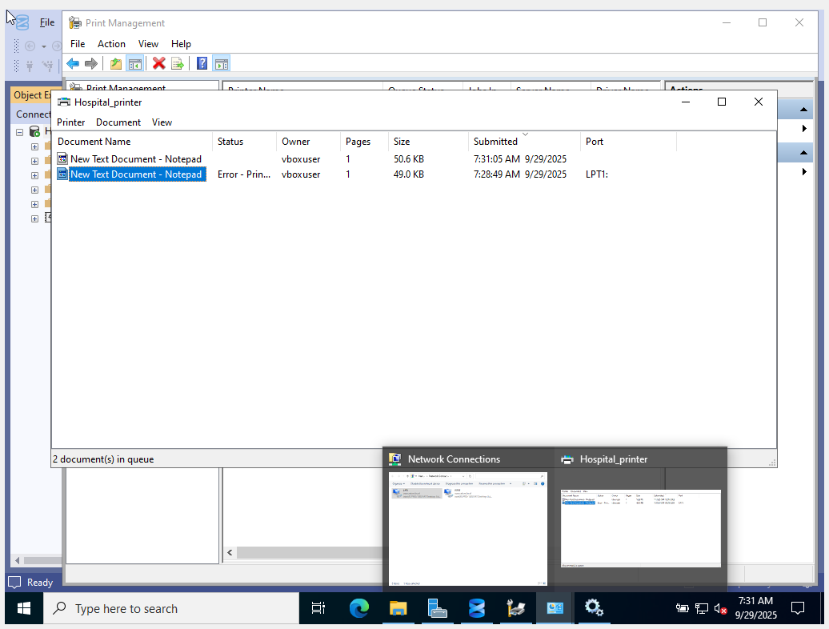

We see the print queues

**Windows Server Update Services (WSUS)**

**Step 4.3: Prepare for and Install the WSUS Role**

1. In **File Explorer**, create a folder to store the updates, for example, C:\WSUS.
2. In Server Manager, launch the **Add Roles and Features** wizard.
3. Select **Windows Server Update Services** from the Server Roles list. Click **Add Features** in the pop-up.
4. On the **Role Services** page, uncheck **WID Connectivity** and check **WSUS Services** and **SQL Server Connectivity**. (While we could use the Windows Internal Database, pointing it to the full SQL Server we just installed is better practice).
5. On the next page, enter the path to the folder you created: C:\WSUS.
6. On the Database Instance Selection page, enter your server name, HOSPITAL-SRV-01, and click **Check connection**. It should say "Successfully connected to server".
7. Click **Next** and then **Install**.
8. 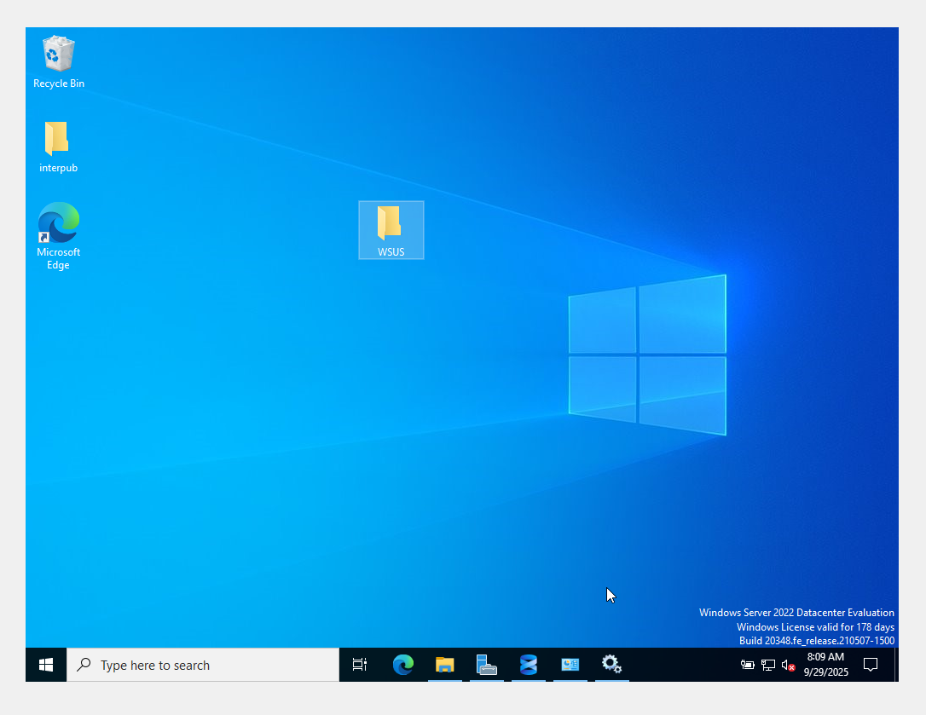
9. 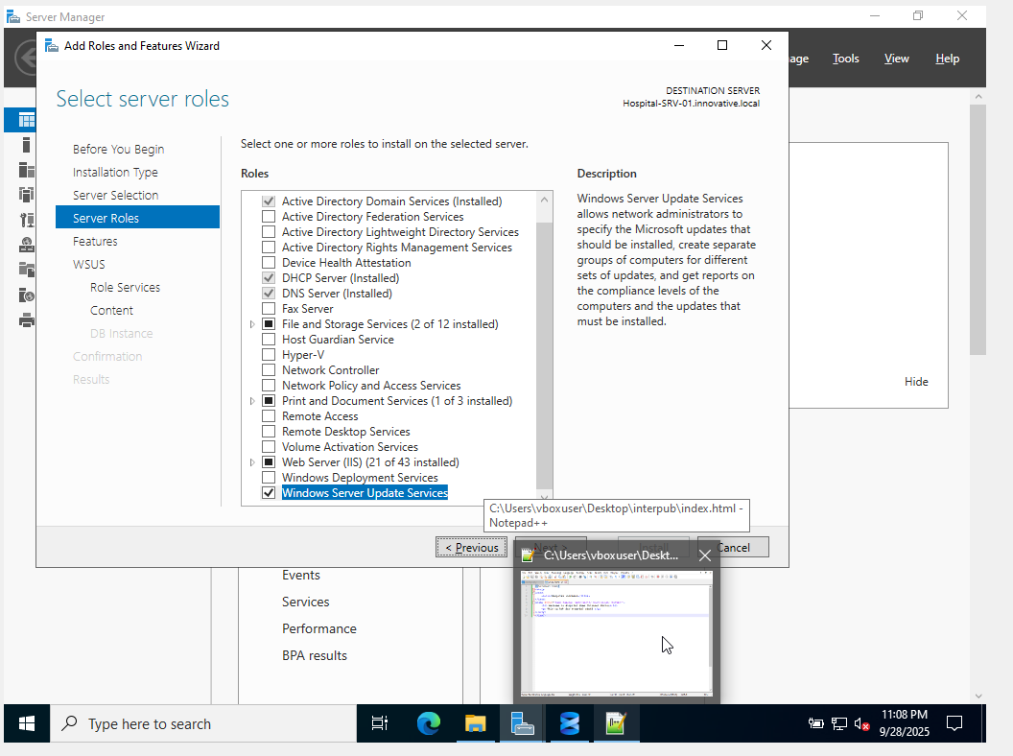
10. 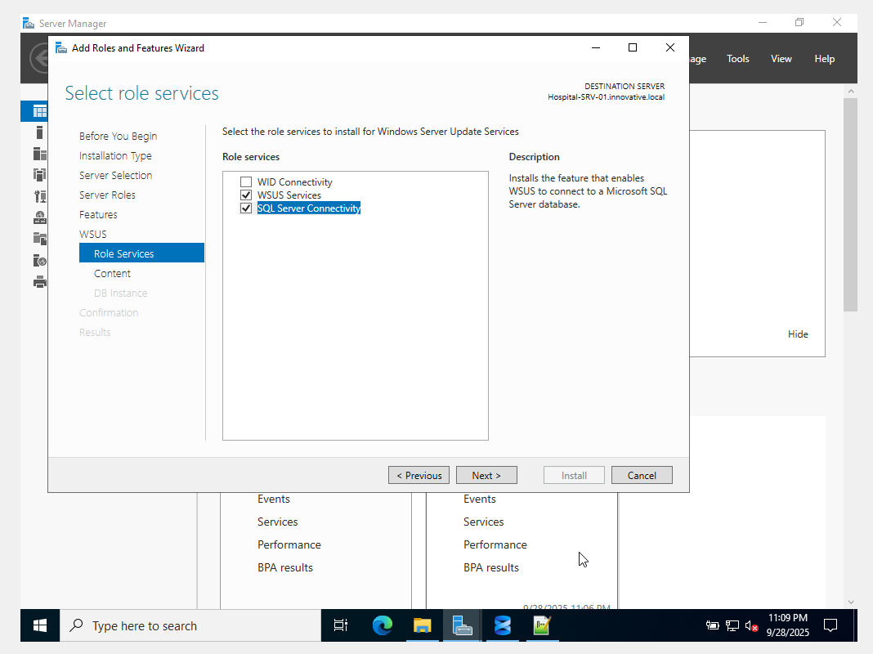
11. 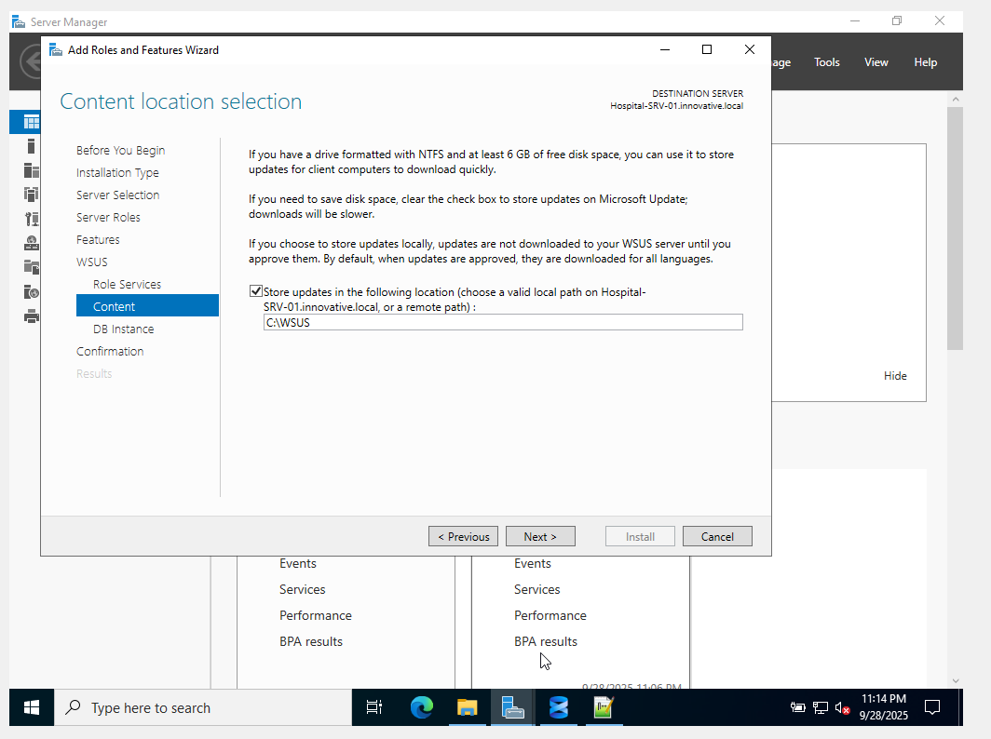
12. 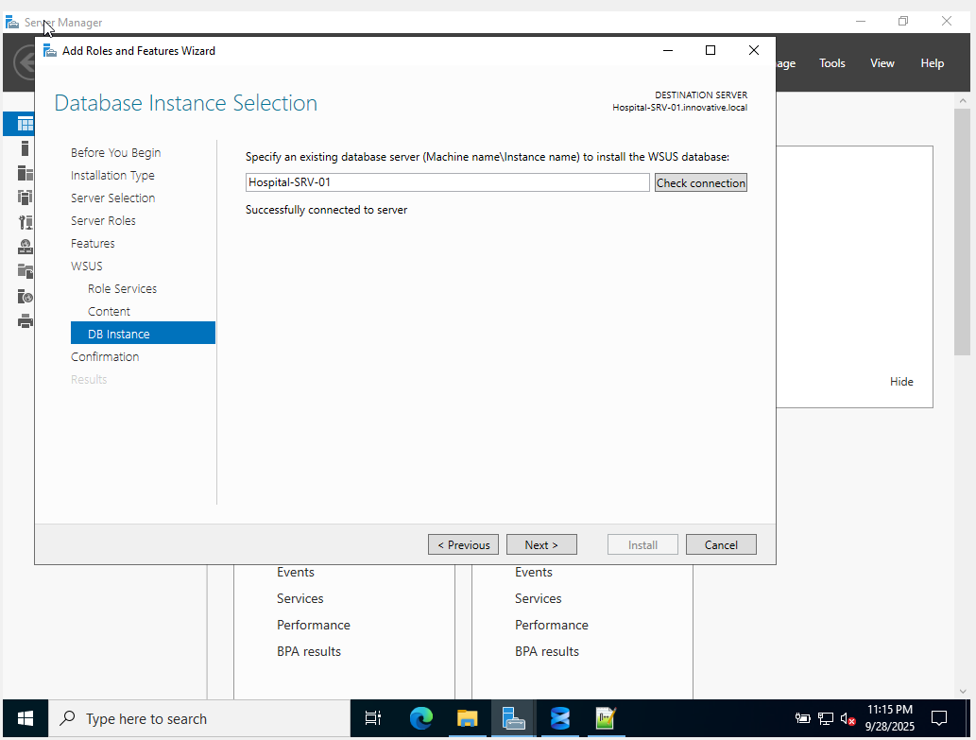
13. 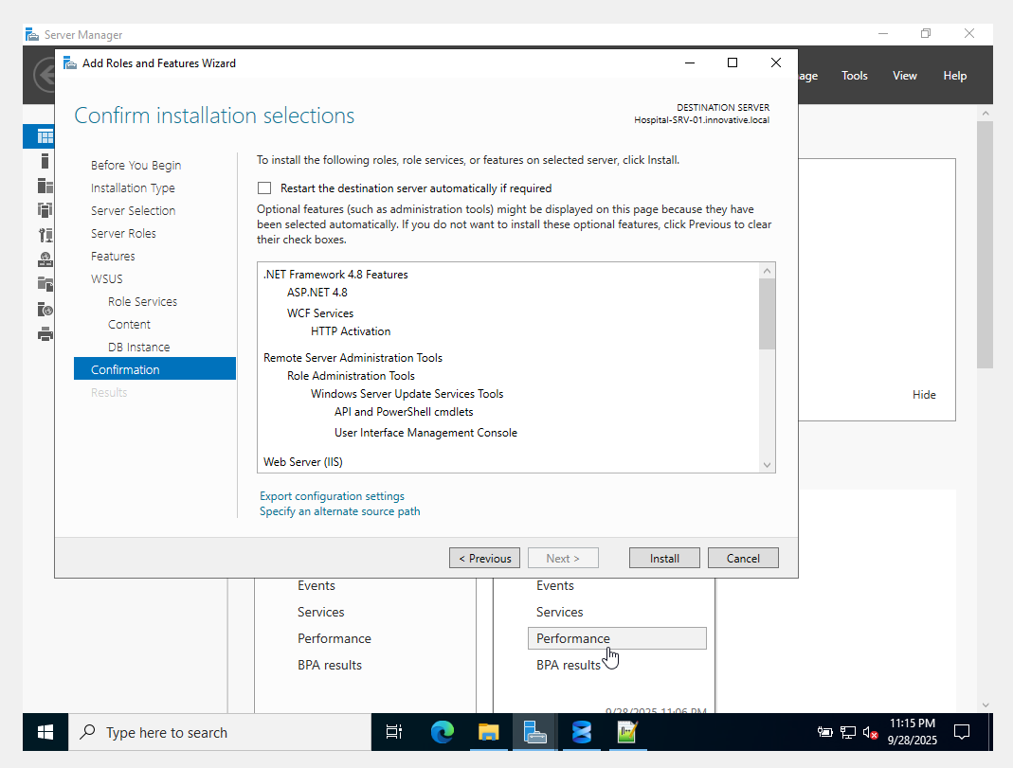
14. 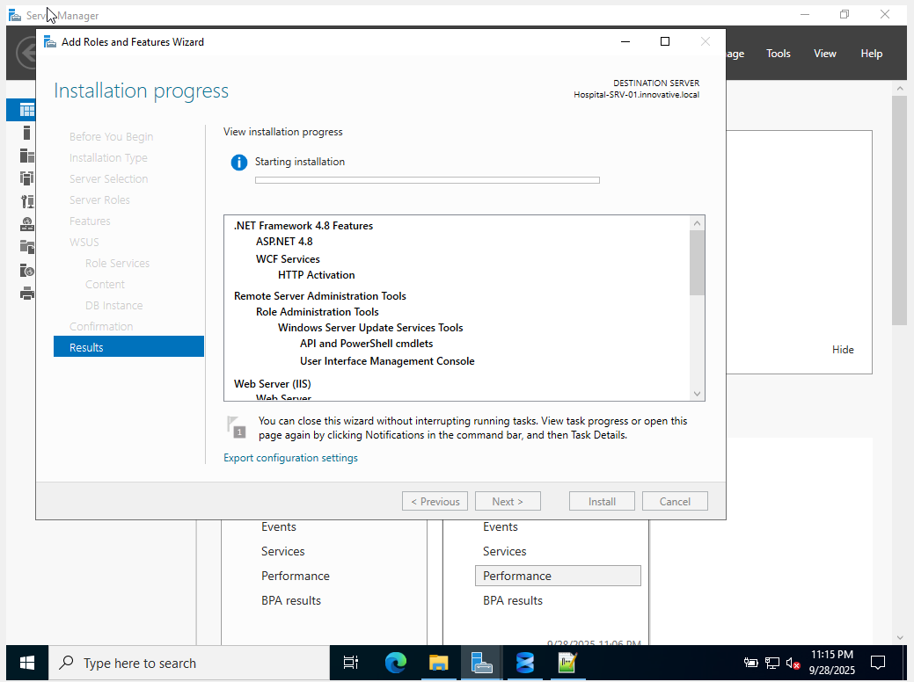

**Step 4.4: Configure WSUS**

1. After installation, a message will appear in Server Manager. Click **Launch Post-Installation tasks**. Wait for it to complete.
2. In Server Manager, go to **Tools > Windows Server Update Services**.
3. The **WSUS Configuration Wizard** will launch.
   * Click **Next** on the first few informational screens.
   * **Choose Upstream Server:** Select **Synchronize from Microsoft Update**.
   * **Specify Proxy Server:** Leave this blank unless you use a proxy.
   * Click **Start Connecting**. This can take several minutes.
   * **Choose Languages:** Select **English** only (or languages you need).
   * **Choose Products:** For this lab, select **Windows 10** and/or **Windows 11**.
   * **Choose Classifications:** Select **Critical Updates** and **Security Updates**.
   * **Configure Sync Schedule:** Select **Synchronize automatically** and set a time (e.g., daily at 2:00 AM).
   * Check **Begin initial synchronization** and click **Next**, then **Finish**.
   * The initial sync can take a very long time (hours) and consume significant bandwidth and disk space.

**Step 4.5: Create Computer Groups in WSUS**

1. In the WSUS console, expand your server, and right-click on **All Computers**. Select **Add Computer Group...**.
2. Create a group named Hospital_Workstations.

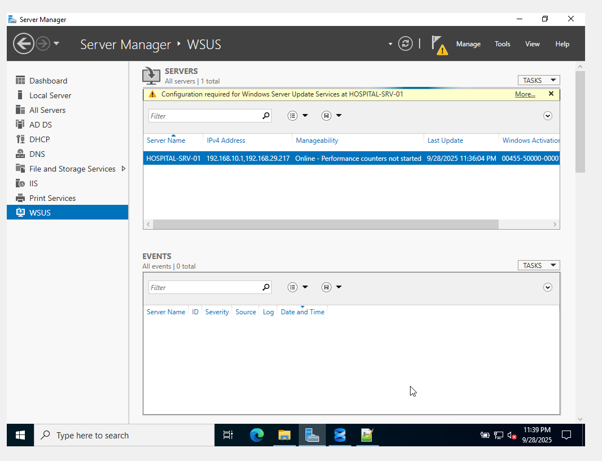

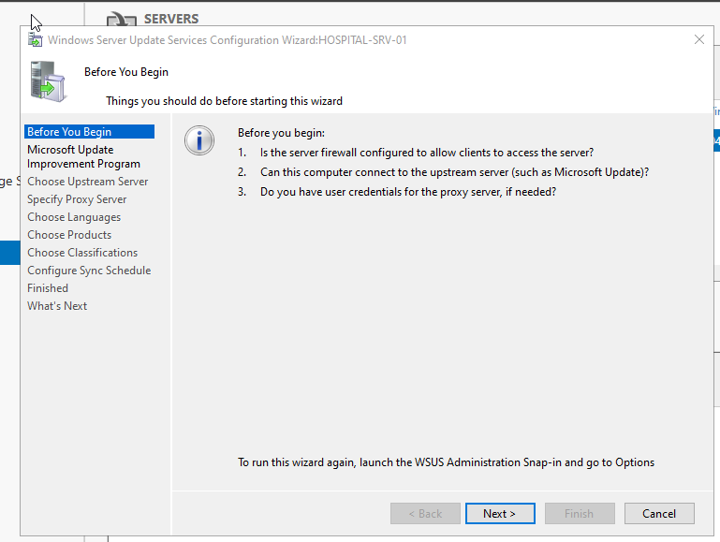

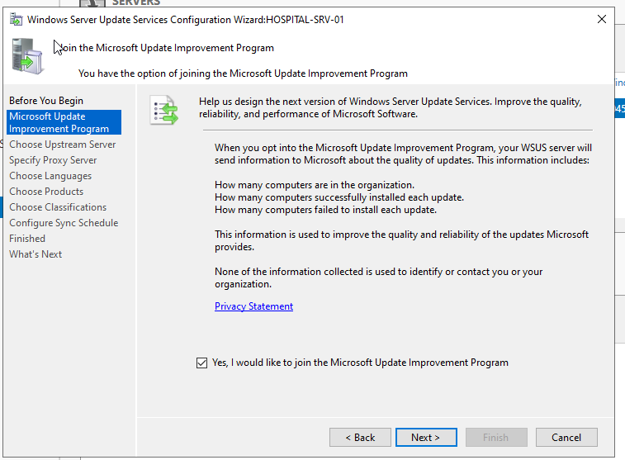

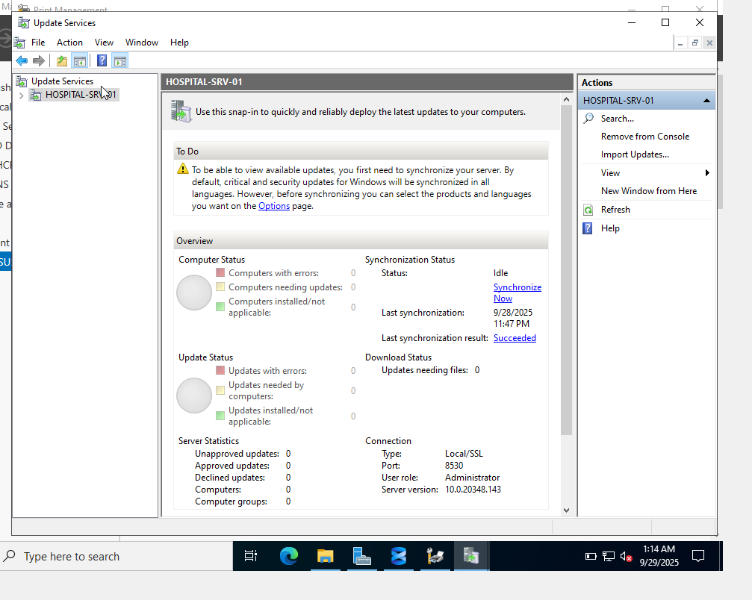

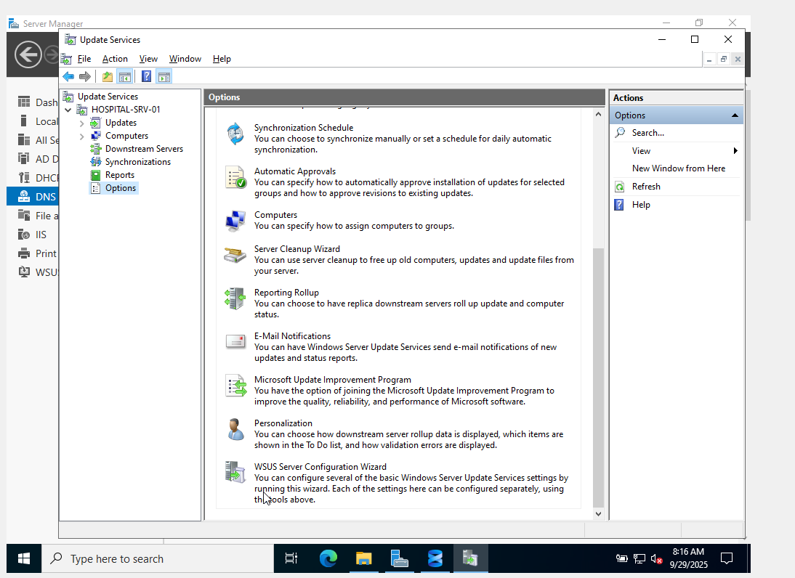

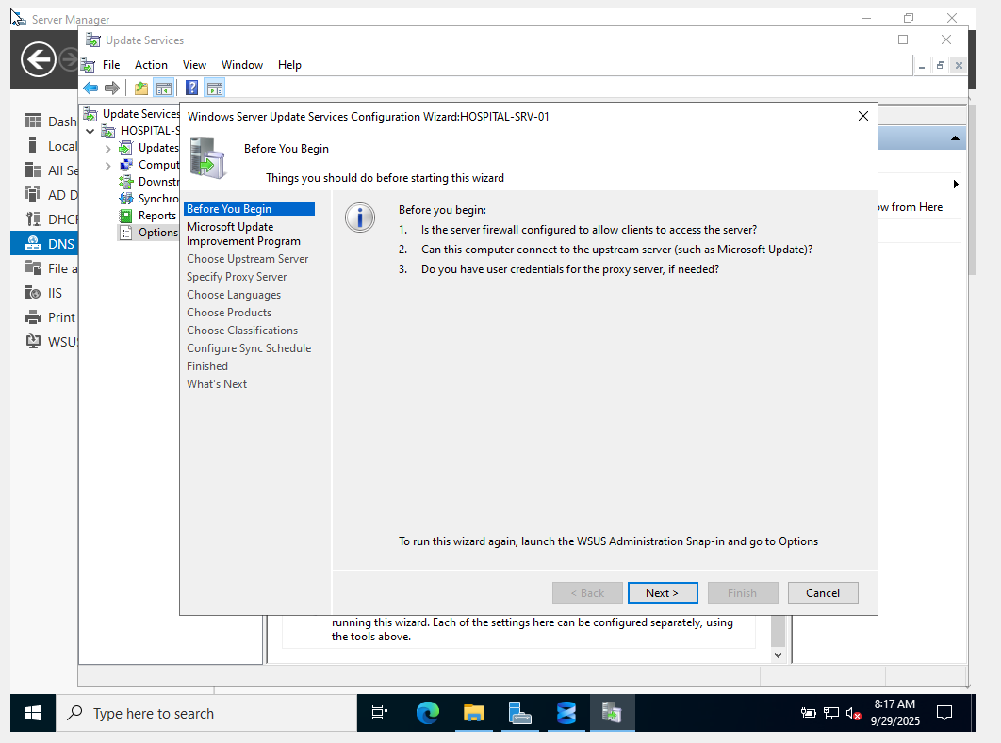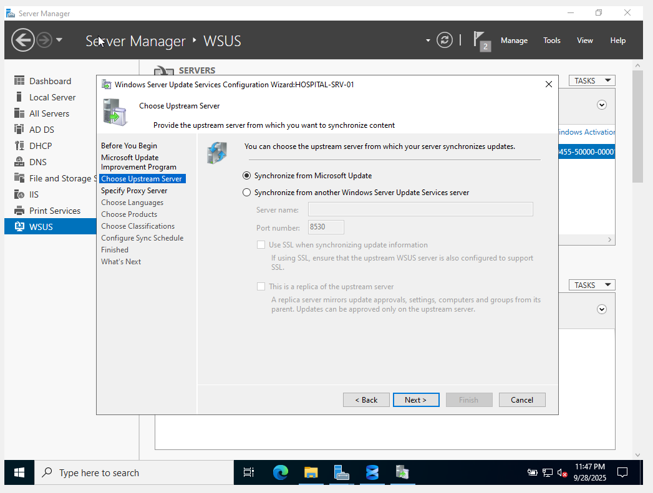

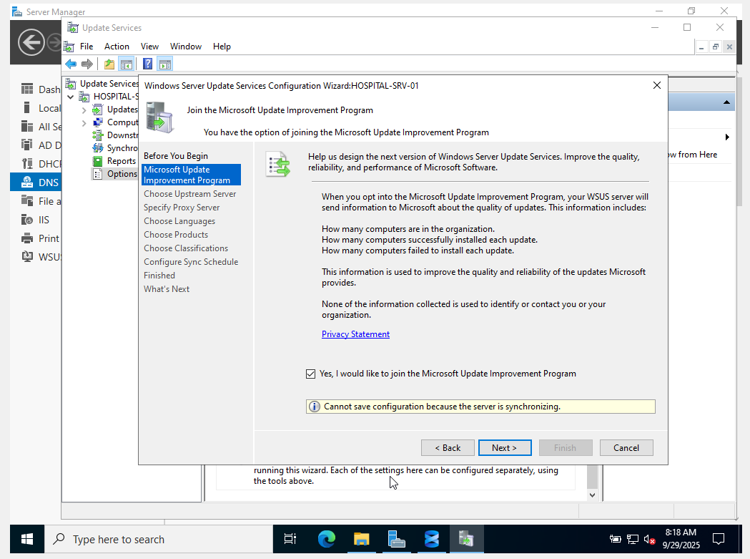

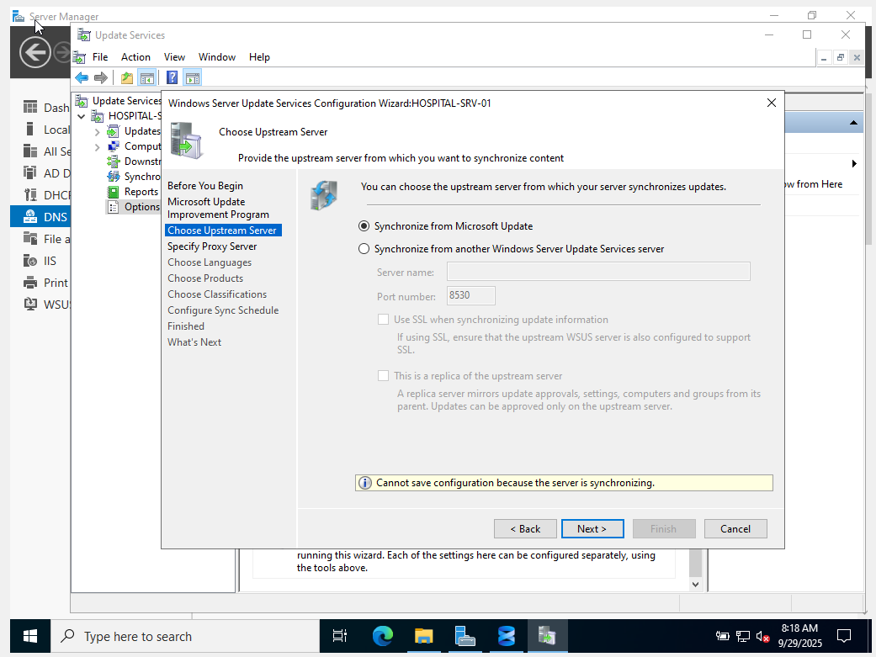

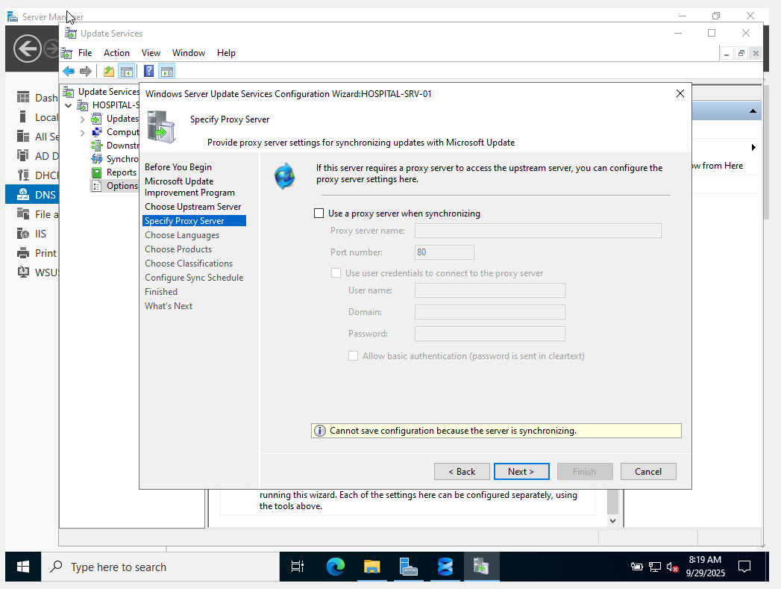

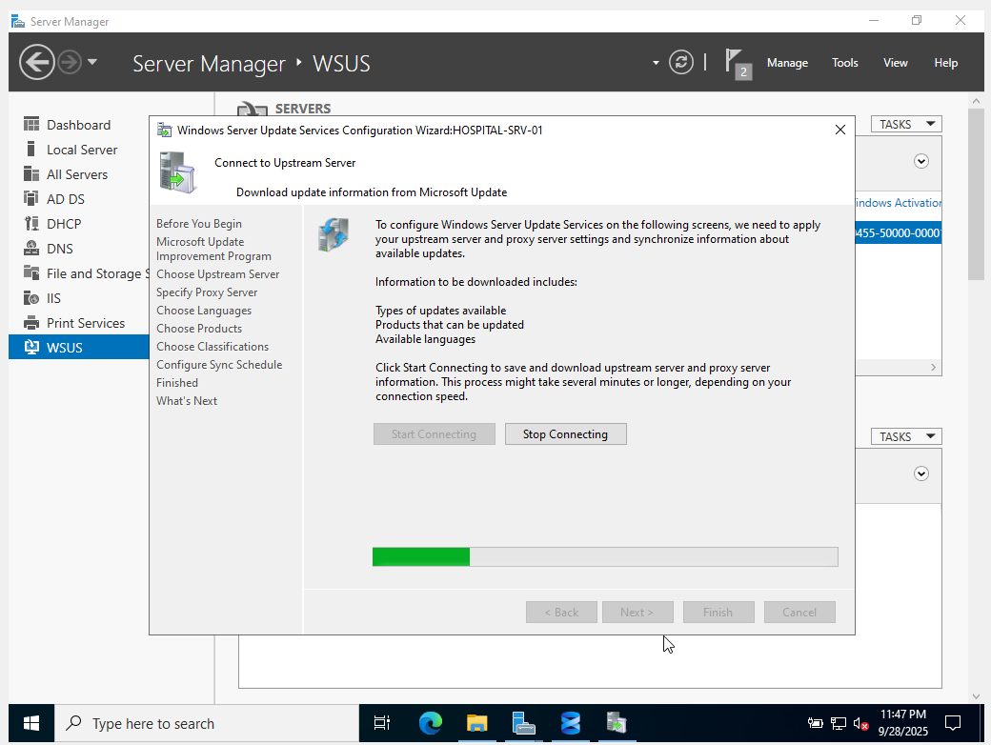

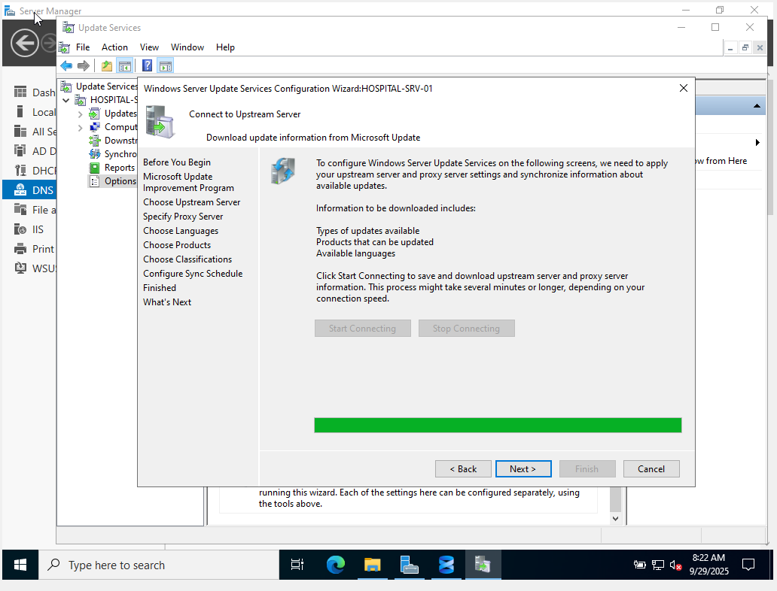

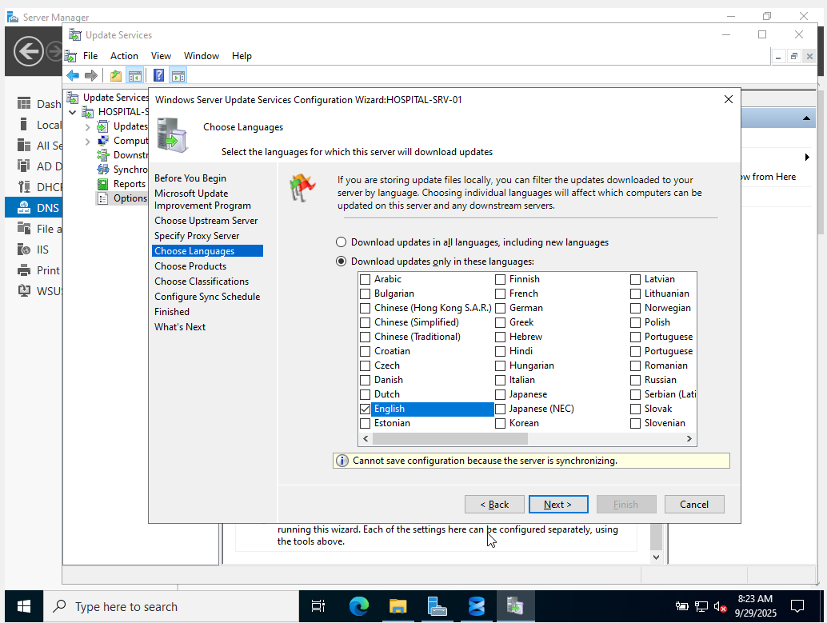

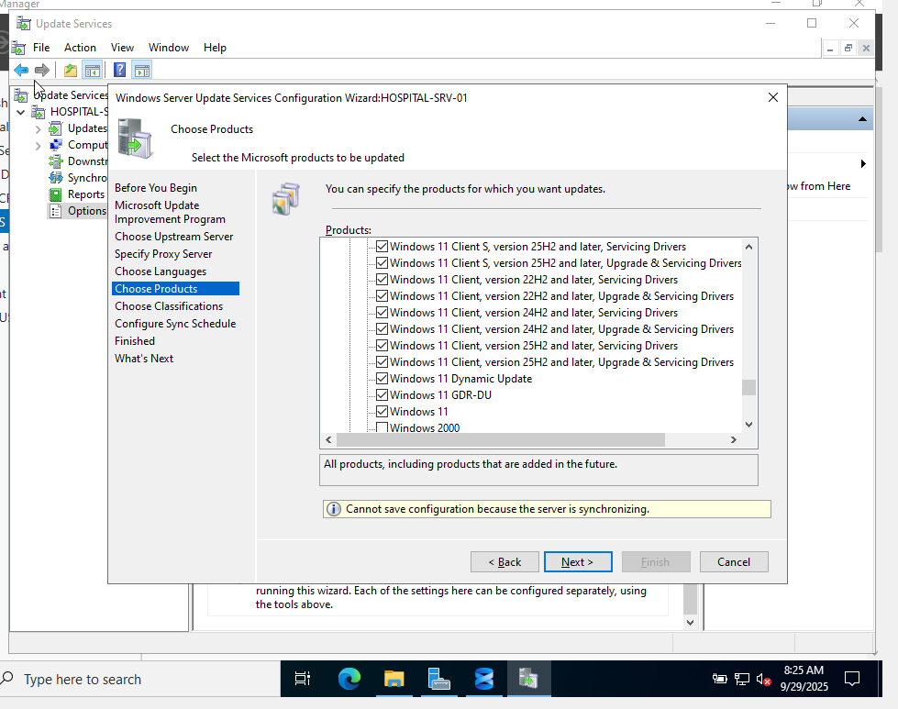

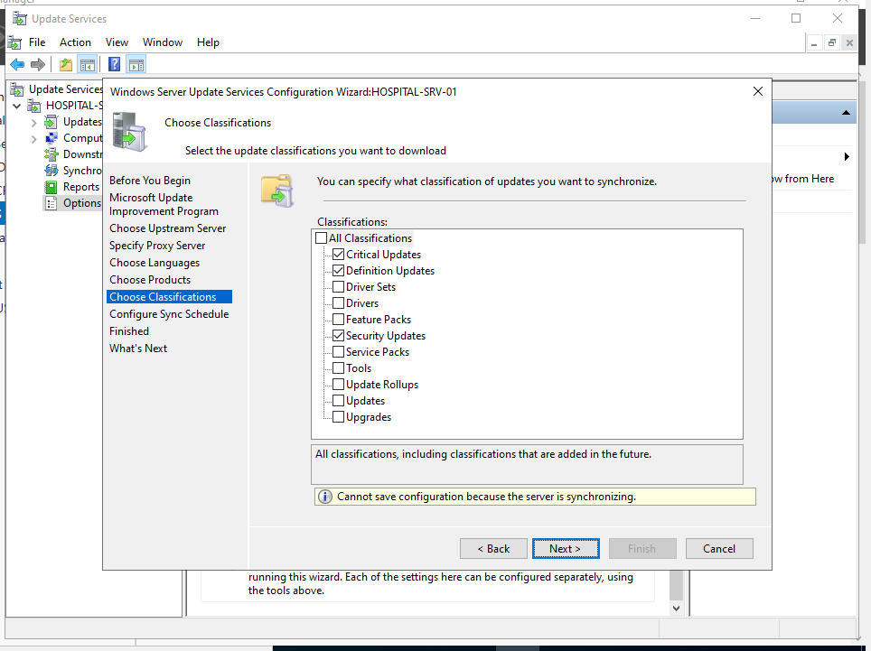

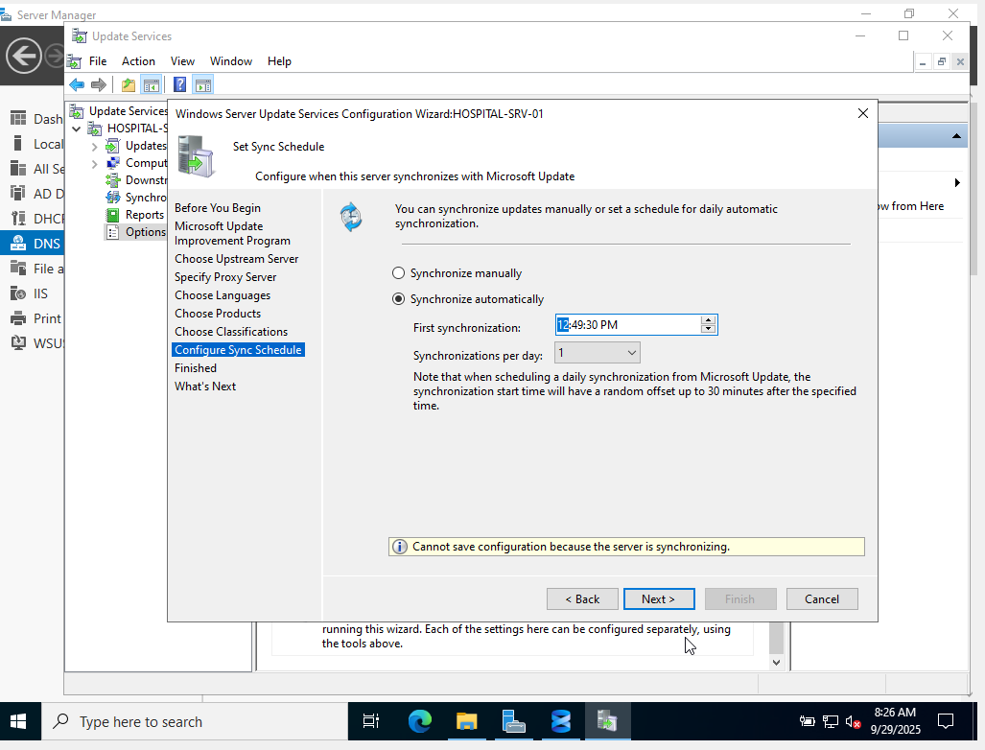

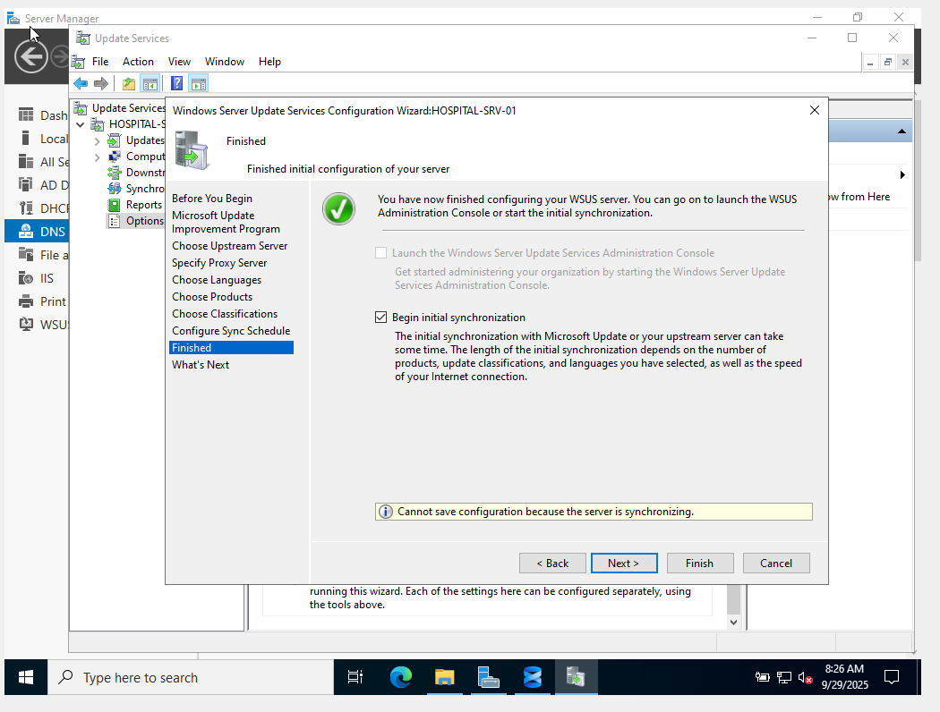

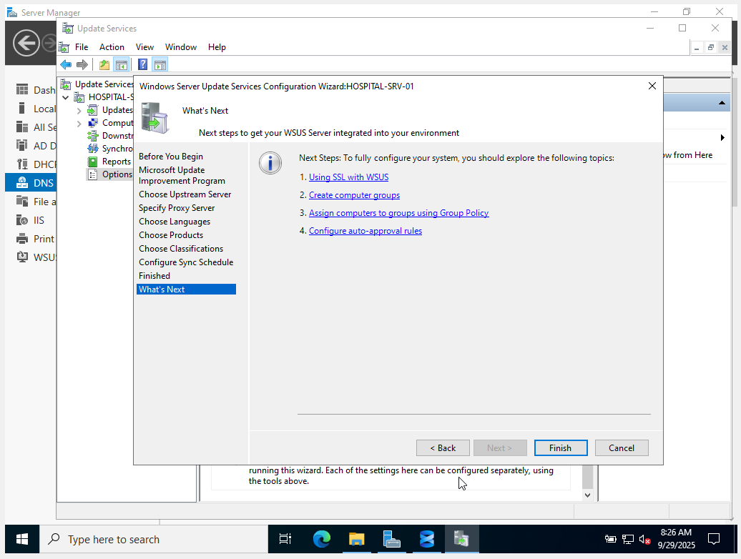

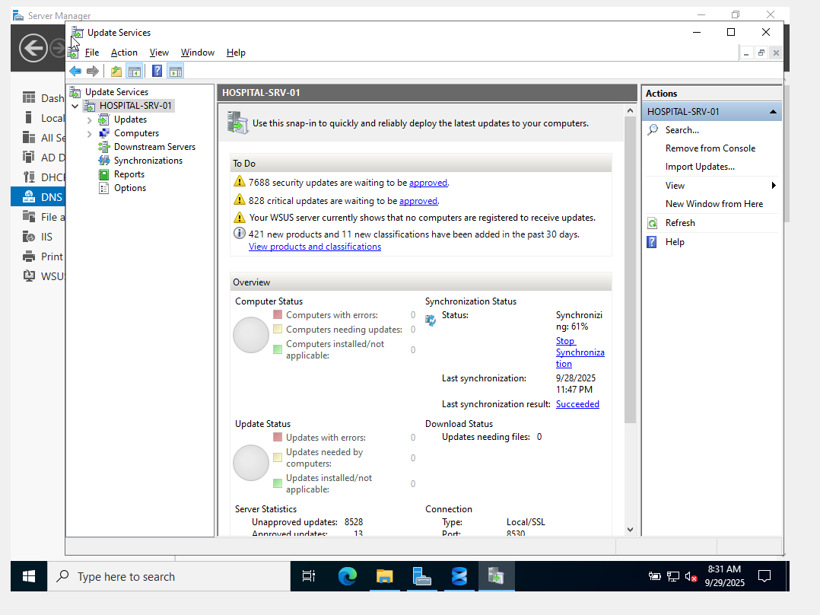

**Testing with a Windows Client (Detailed Steps)**

**This assumes your WSUS server (HOSPITAL-SRV-01) has completed its initial synchronization and you have a Windows client machine (e.g., Windows 10 or 11) that you want to manage.**

**Step 1: On Your Domain Controller (or the Windows Client Itself for Local Policy)**

This step configures how the client will behave regarding updates. We'll use Group Policy.

1. **Log in to your Domain Controller (DC)** with an administrator account. If you don't have a DC and are testing with a standalone Windows client, log in to that client with an administrator account and skip to step 1.4 (using gpedit.msc).
2. **Open Group Policy Management:**
   * Press Win + R to open the Run dialog.
   * Type gpmc.msc and press Enter. The Group Policy Management console will open.
3. **Navigate to and Select an Organizational Unit (OU):**
   * In the left-hand pane, expand Forest: [YourDomainName] -> Domains -> [YourDomainName].
   * Locate the OU where your Windows client computer account resides. For example, if your client is in an OU called "Workstations" or "Computers". If not, you can link it to the root of your domain for testing, but in a production environment, you'd target a specific OU.
   * **Right-click** on the chosen OU (e.g., "Workstations") and select "Create a GPO in this domain, and Link it here...".
   * Give your new GPO a descriptive name, like WSUS_Client_Configuration. Click OK.
   * Now, **right-click** on the newly created WSUS_Client_Configuration GPO and select Edit.... This will open the Group Policy Management Editor.
   * **Alternative for Standalone Client (Local Group Policy):** If you're using a standalone Windows client not joined to a domain, press Win + R, type gpedit.msc, and press Enter. This opens the Local Group Policy Editor directly. The navigation paths within gpedit.msc are the same as described below.
4. **Configure WSUS Settings in the GPO:**
   * In the Group Policy Management Editor (or Local Group Policy Editor), navigate through the tree:  
     Computer Configuration -> Policies -> Administrative Templates -> Windows Components -> Windows Update
   * You will see a list of policies in the right-hand pane. Double-click on each of the following policies and configure them as described:
     + **Policy 1: "Specify intranet Microsoft update service location"**
       - **Description:** This is the most crucial setting. It tells the client *where* to look for updates.
       - **Action:** Double-click this policy.
       - Select Enabled.
       - In the "Set the intranet update service for detecting updates" field, enter your WSUS server's URL. The default port for WSUS over HTTP is 8530.
         * **Example:** http://HOSPITAL-SRV-01:8530
       - In the "Set the intranet statistics server" field, enter the *same* URL.
         * **Example:** http://HOSPITAL-SRV-01:8530
       - Click Apply, then OK.

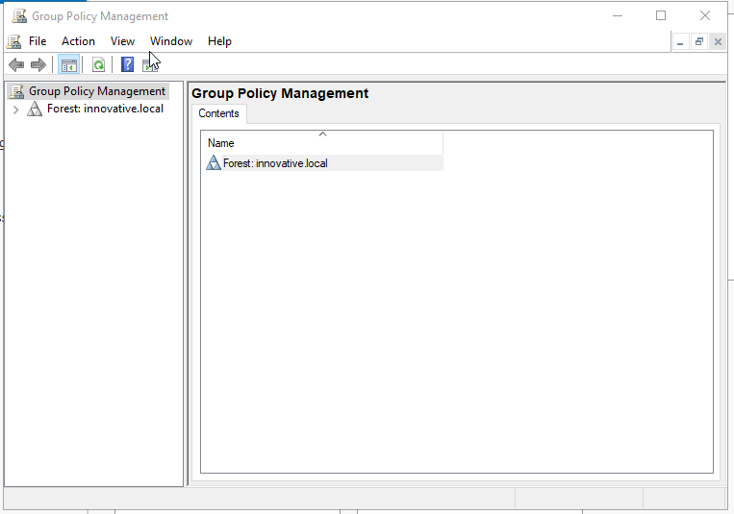

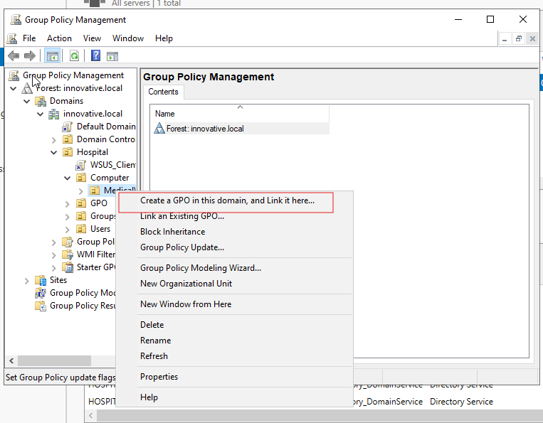

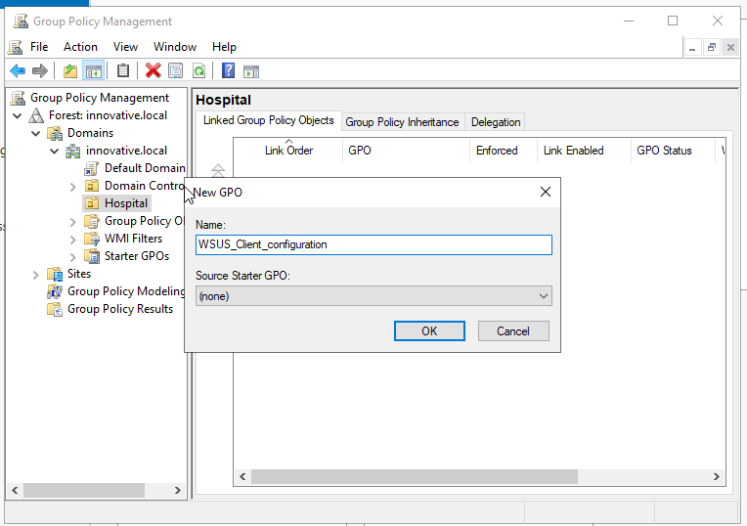

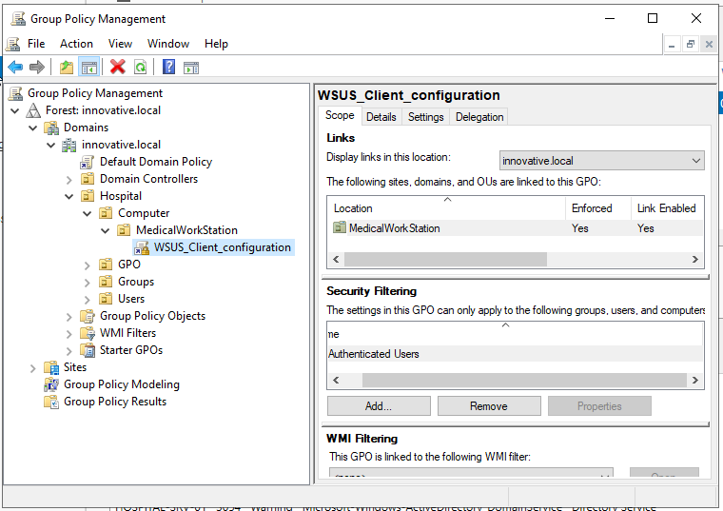

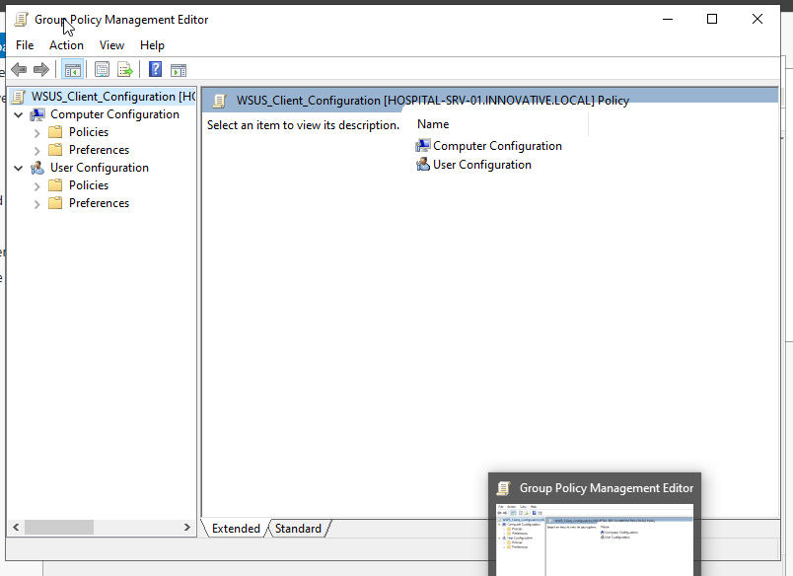

1. **Configure WSUS Settings in the GPO:**
   * **In the Group Policy Management Editor (or Local Group Policy Editor), navigate through the tree:  
     Computer Configuration -> Policies -> Administrative Templates -> Windows Components -> Windows Update**
   * **You will see a list of policies in the right-hand pane. Double-click on each of the following policies and configure them as described:**
     + **Policy 1: "Specify intranet Microsoft update service location"**
       - **Description: This is the most crucial setting. It tells the client *where* to look for updates.**
       - **Action: Double-click this policy.**
       - **Select Enabled.**
       - **In the "Set the intranet update service for detecting updates" field, enter your WSUS server's URL. The default port for WSUS over HTTP is 8530.**
         * **Example: http://HOSPITAL-SRV-01:8530**
       - **In the "Set the intranet statistics server" field, enter the *same* URL.**
         * **Example: http://HOSPITAL-SRV-01:8530**
       - **Click Apply, then OK.**

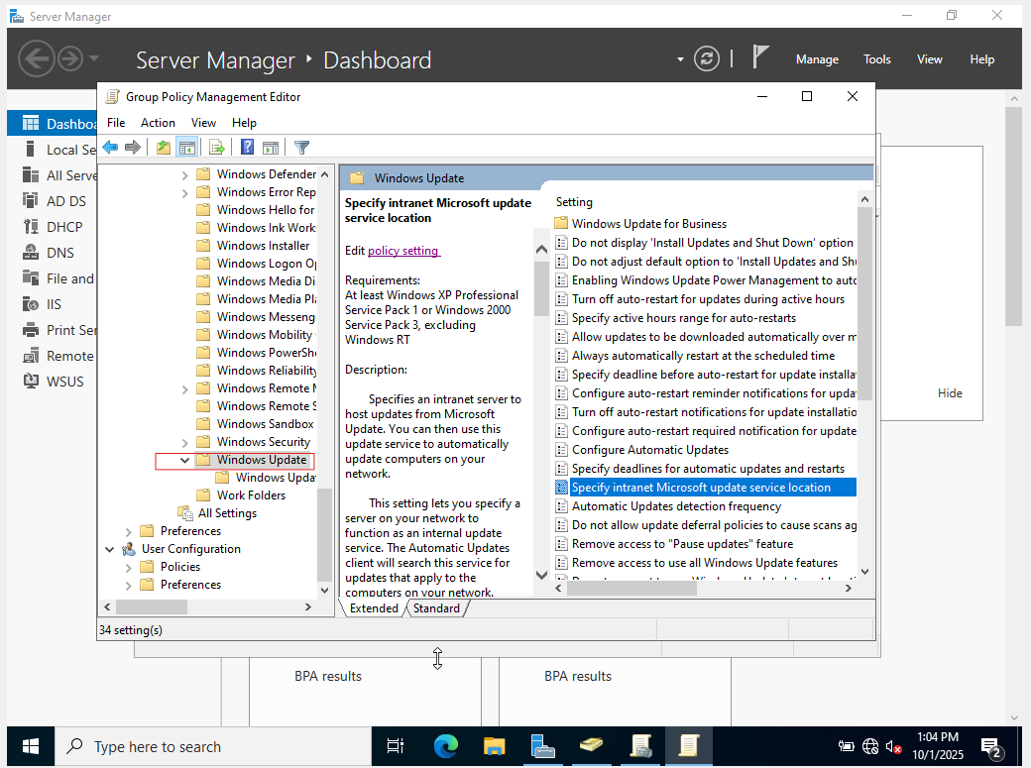

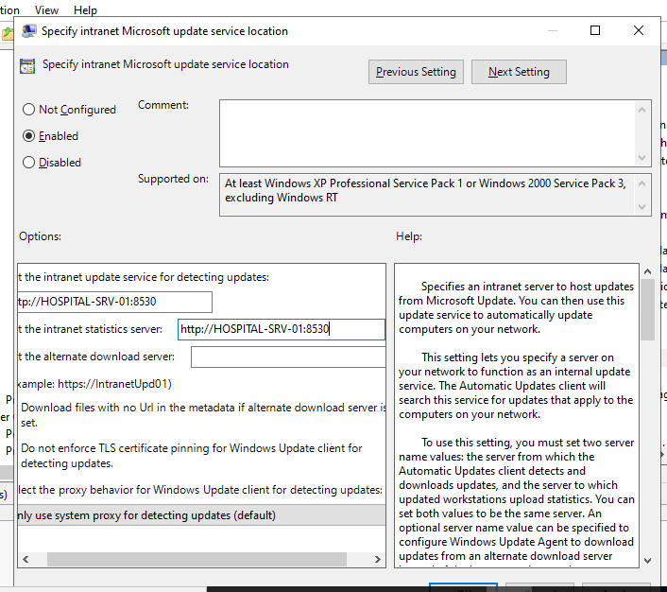

* **Policy 2: "Configure Automatic Updates"**

* **Description:** This policy controls how and when the client will download and install updates.

* **Action:** Double-click this policy.

* Select `Enabled`.

* Under "Configure automatic updating:", choose `4 - Auto download and schedule the install`.

* Under "Scheduled install day:", you can select `Every day` or a specific day.

* Under "Scheduled install time:", choose a time (e.g., `03:00` for 3:00 AM) when the client is likely to be on but not heavily used.

* Check the box for "Install during automatic maintenance" if desired (Windows 10/11 only).

* Check "Include Microsoft product updates" to get updates for other Microsoft software (like Office) if you enabled those products in WSUS.

* Click `Apply`, then `OK`.

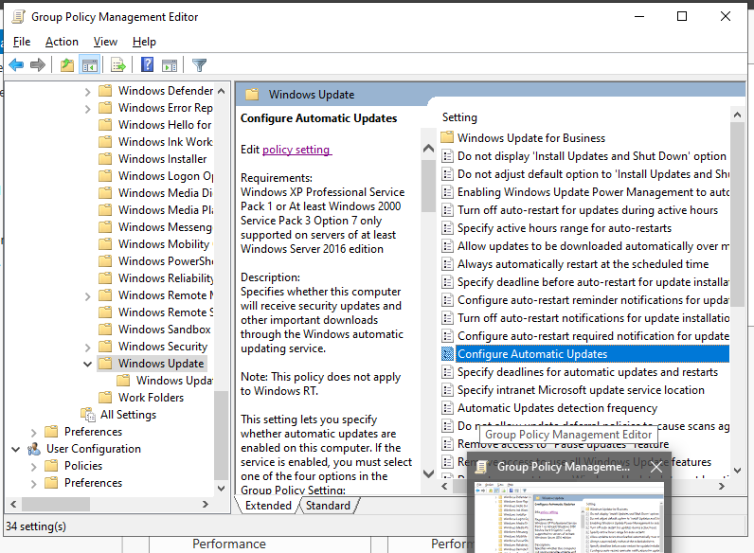

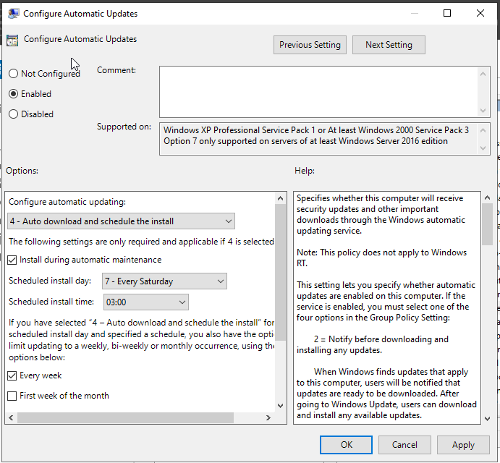

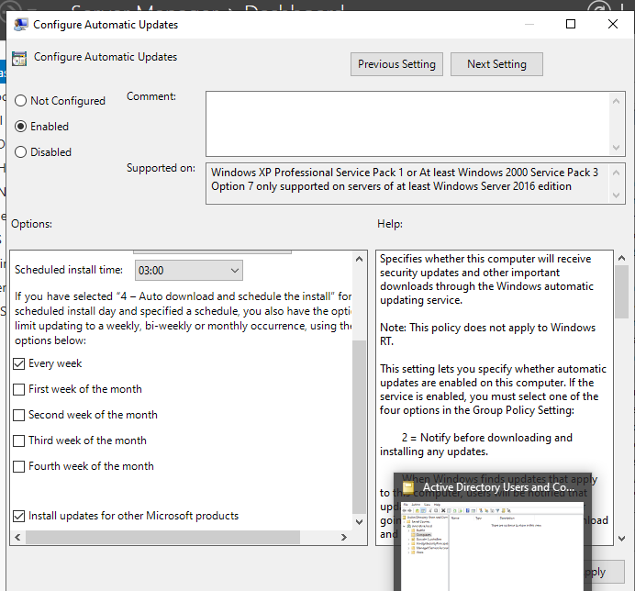

* **Linking:** Link to Hospital/Computers/MedicalWorkstations.
* **Security Filtering:** Add SG_GPO_MedicalWorkstations. Ensure Domain Computers has Read permissions on the Delegation tab.

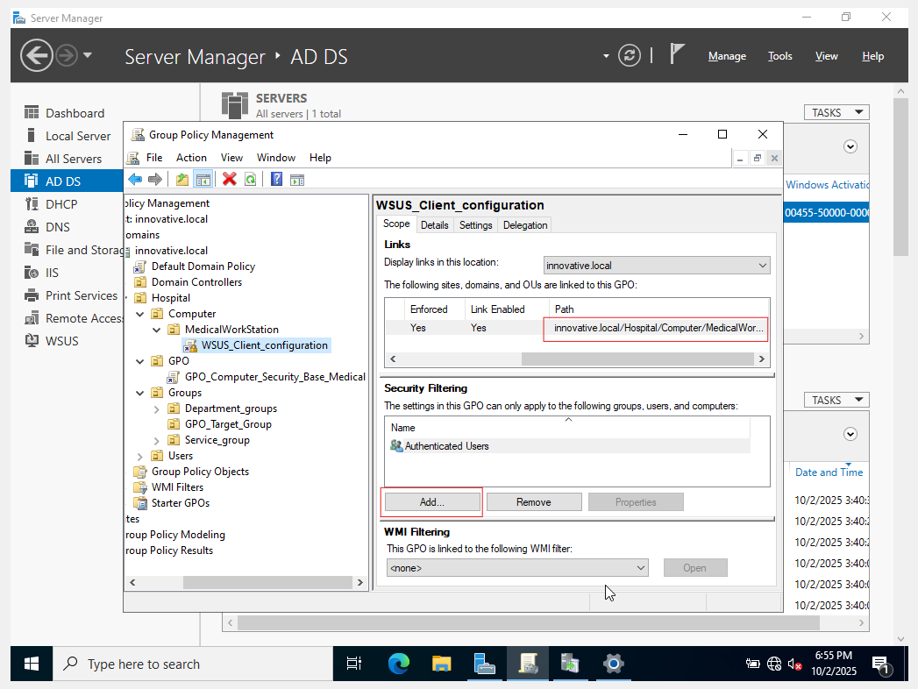

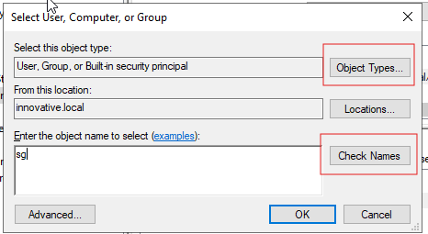

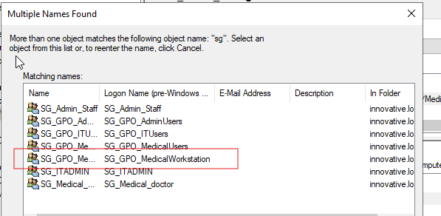

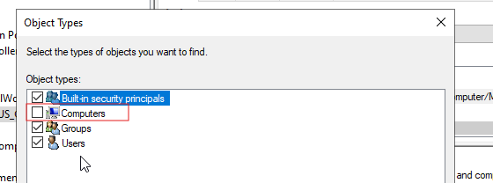

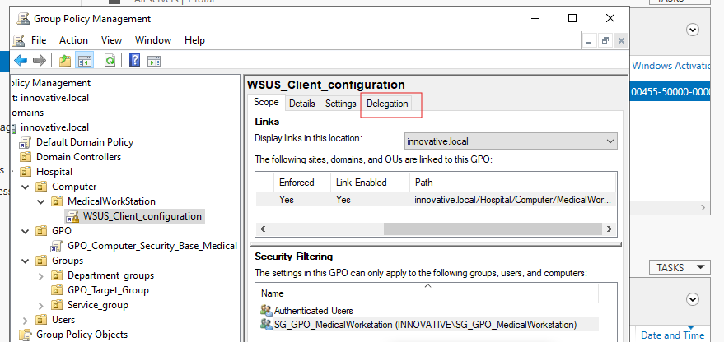

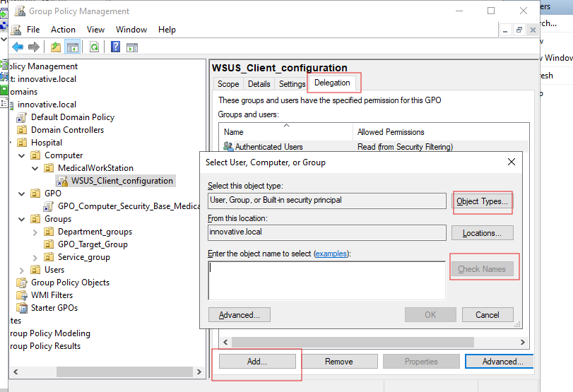

Follow the same steps as before to get the below screen

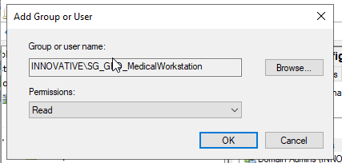

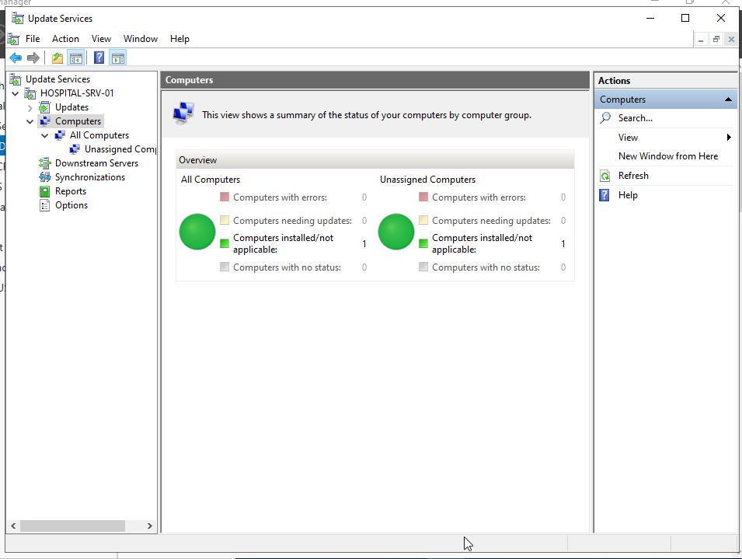

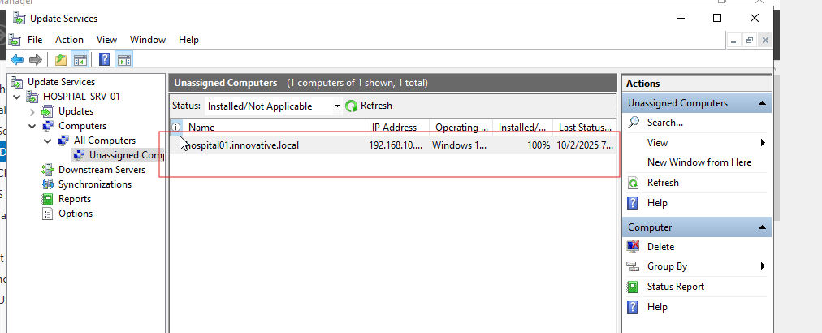

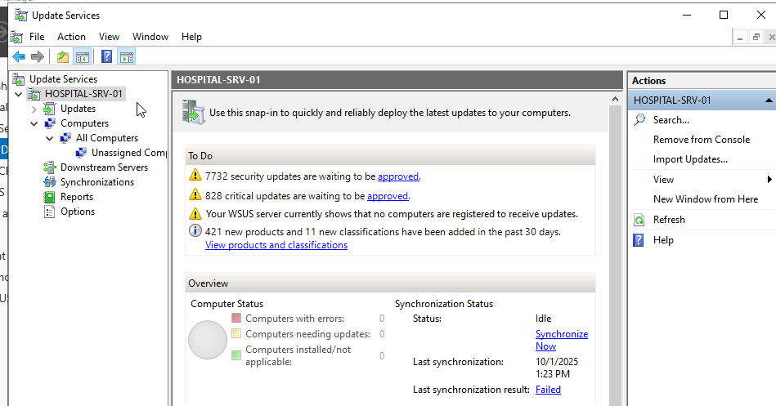

This shows that we have WSUS server configured and connected with windows client

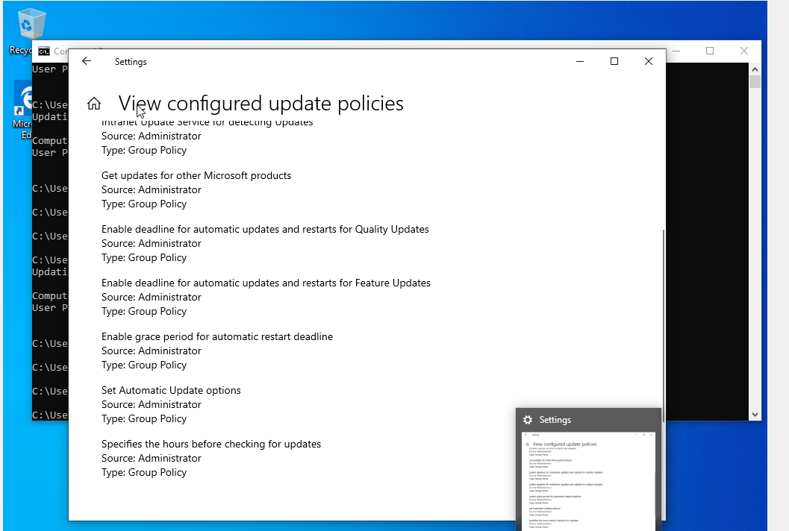

**Step 2: Force Group Policy Update on the Client**

On your Windows client machine:

1. Open an elevated Command Prompt or PowerShell.
2. Run gpupdate /force. This will immediately apply the new Group Policy settings.
3. You might need to restart the client for some settings to take full effect.

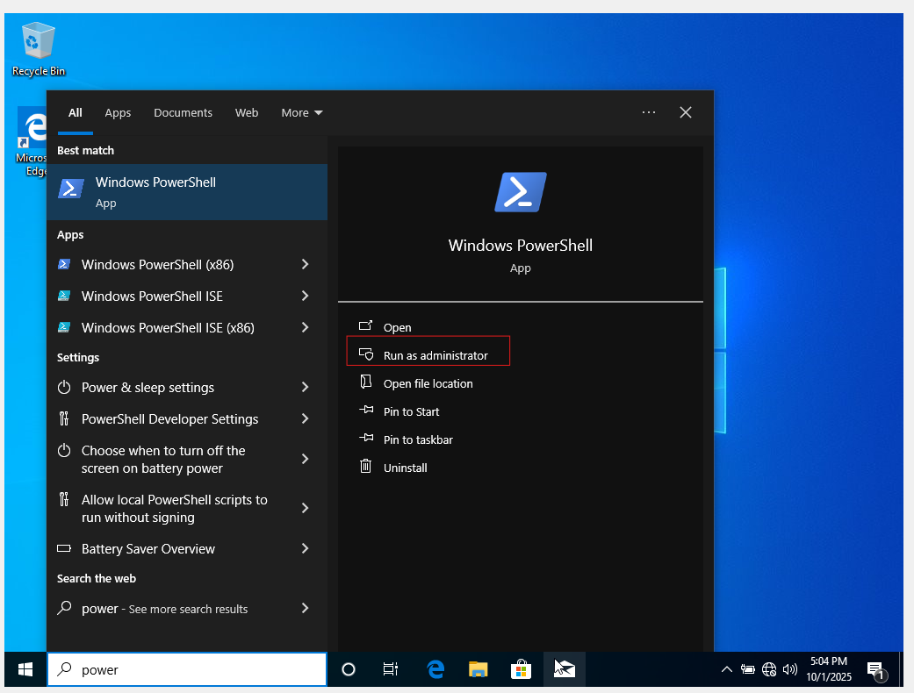

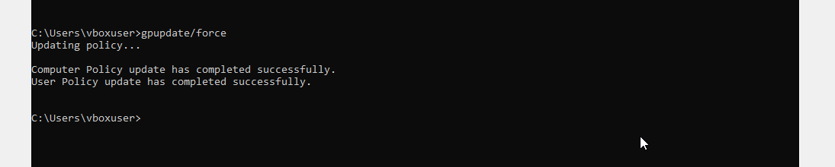

**Step 3: Initiate Update Detection on the Client**

1. Open an elevated Command Prompt or PowerShell.
2. Run wuauclt /detectnow /reportnow. This command forces the client to immediately check in with the WSUS server and report its status.

**Step 4: Verify on the WSUS Server**

1. Go back to your WSUS console (HOSPITAL-SRV-01).
2. In the left-hand pane, navigate to Computers > All Computers.
3. Your Windows client machine should now appear in the list. It might initially show "Not yet reported" or "Unknown status," but after a few minutes and another wuauclt /detectnow /reportnow on the client, it should report its status and the updates it needs.
4. If you enabled client-side targeting, you should also see your client appear in the group you specified (e.g., "Test Clients") under Computers.

# 2. Database Server (Microsoft SQL Server) Installation

1. This will be the backend for applications like EHR systems. We will install SQL Server Express, which is free and sufficient for this lab.
2. **Step 3.6: Download SQL Server and Management Studio**
3. On your server, open a browser and search for "SQL Server Express 2022 Download". Download the installer from the official Microsoft site.
4. On the same page, or by searching for it, find and download **SQL Server Management Studio (SSMS)**.
5. **Step 3.7: Install SQL Server Express**
6. Run the downloaded SQL Server Express installer.
7. Select the **Custom** installation type.
8. Choose a location and click **Install**. The installer will download the full package.
9. The SQL Server Installation Center will open. Click on **New SQL Server stand-alone installation...**.
10. Accept the license terms and proceed.
11. On the **Feature Selection** page, ensure **Database Engine Services** is checked. You can leave the rest as default. Click **Next**.
12. On the **Instance Configuration** page, leave **Default instance** selected and click **Next**.
13. On the **Server Configuration** page, click **Next**.
14. On the **Database Engine Configuration** page:
15. For **Authentication Mode**, select **Mixed Mode (SQL Server authentication and Windows authentication)**.
16. Enter a strong password for the SQL Server system administrator (sa) account. Remember this password.
17. Click the **Add Current User** button. This will add your domain administrator account (HOSPITAL\Administrator) as a SQL administrator.
18. Click **Next**.
19. The installation will proceed. Click **Close** when it's finished.
20. **Step 3.8: Install SQL Server Management Studio (SSMS)**
21. Run the SSMS installer you downloaded.
22. The process is a simple one-click installation. Click **Install** and wait for it to complete.
23. **Step 3.9: Connect and Create a Test Database**
24. Open SSMS from the Start Menu.
25. The "Connect to Server" window will appear. The Server name should default to your server's name (HOSPITAL-SRV-01). Windows authentication should be selected. Click **Connect**.
26. In the **Object Explorer** on the left, right-click on the **Databases** folder and select **New Database**.
27. **Database name:** HospitalDB.
28. Click **OK**. You have successfully installed and configured a database server.

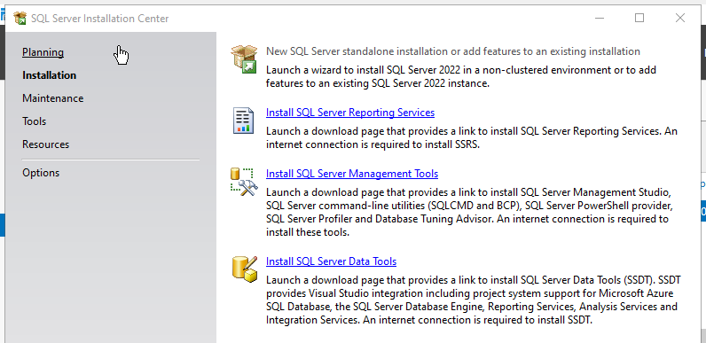

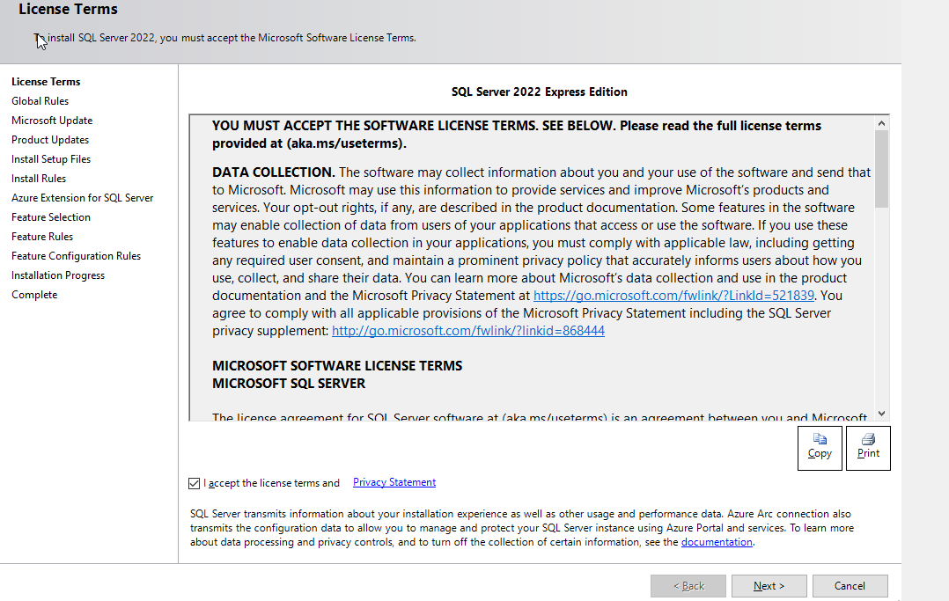

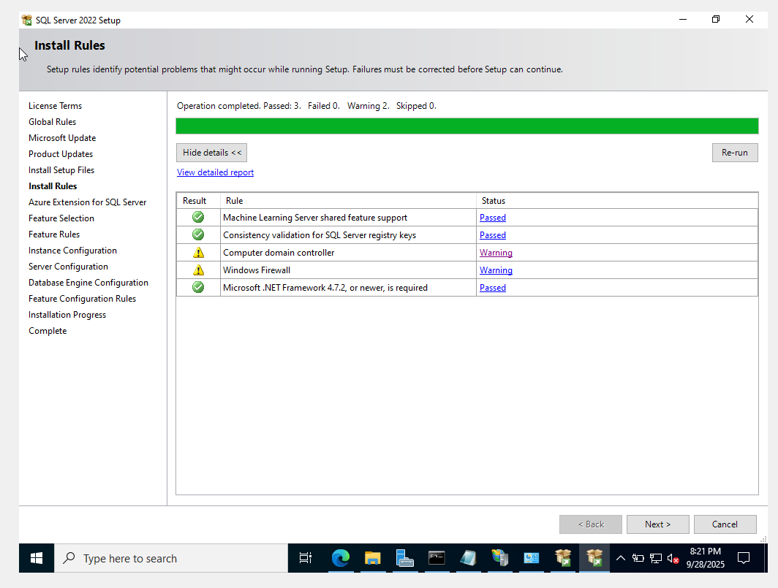

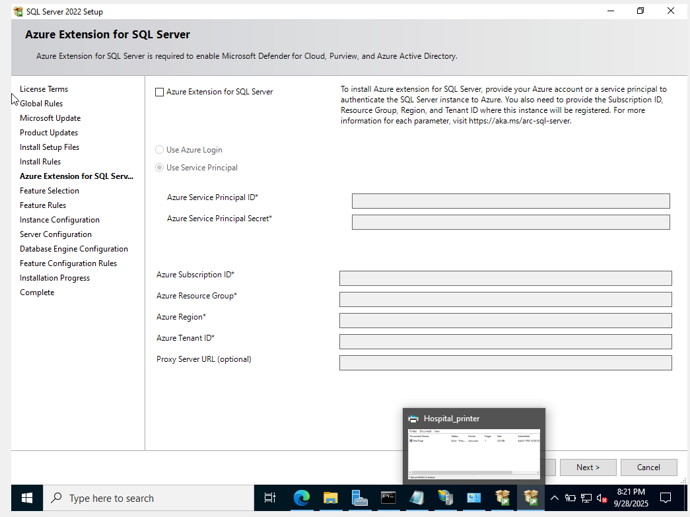

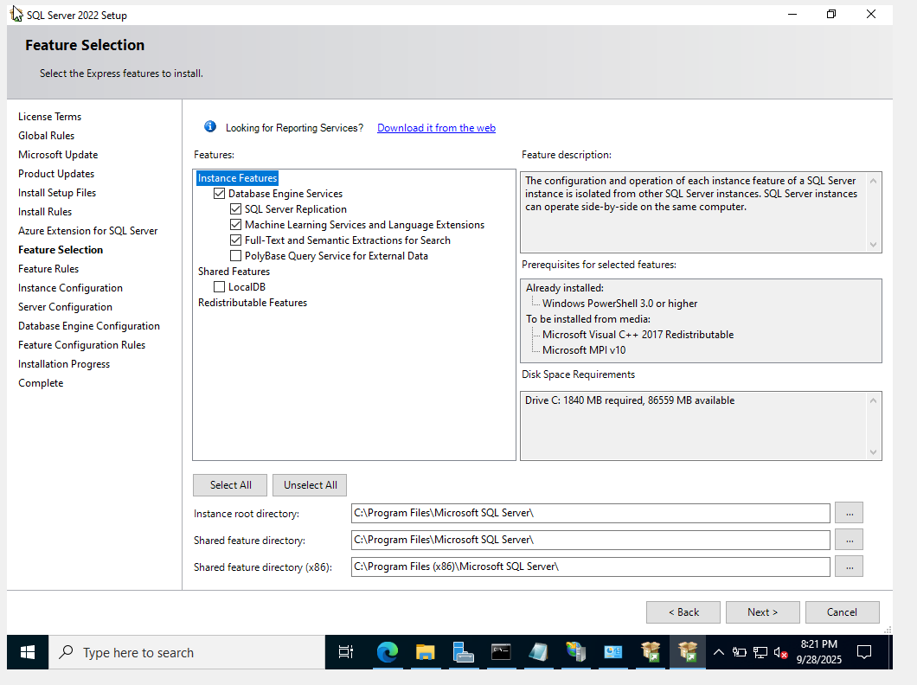

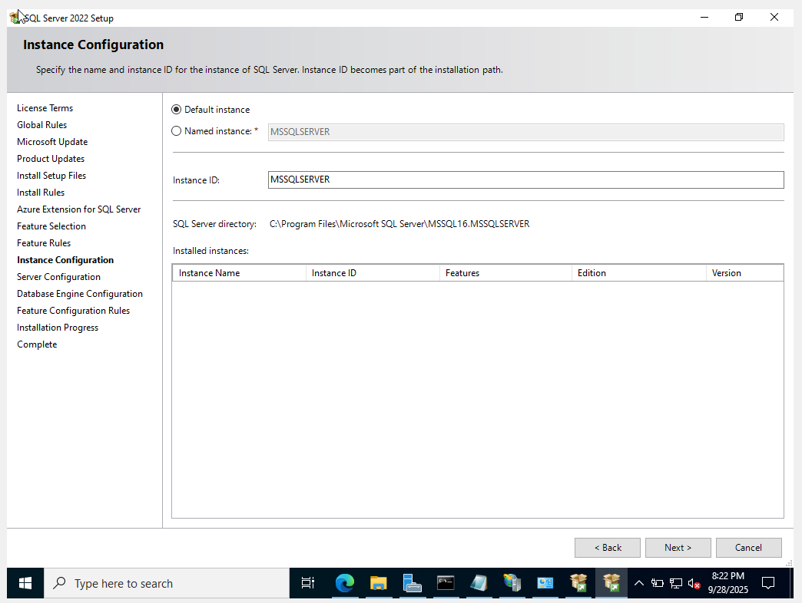

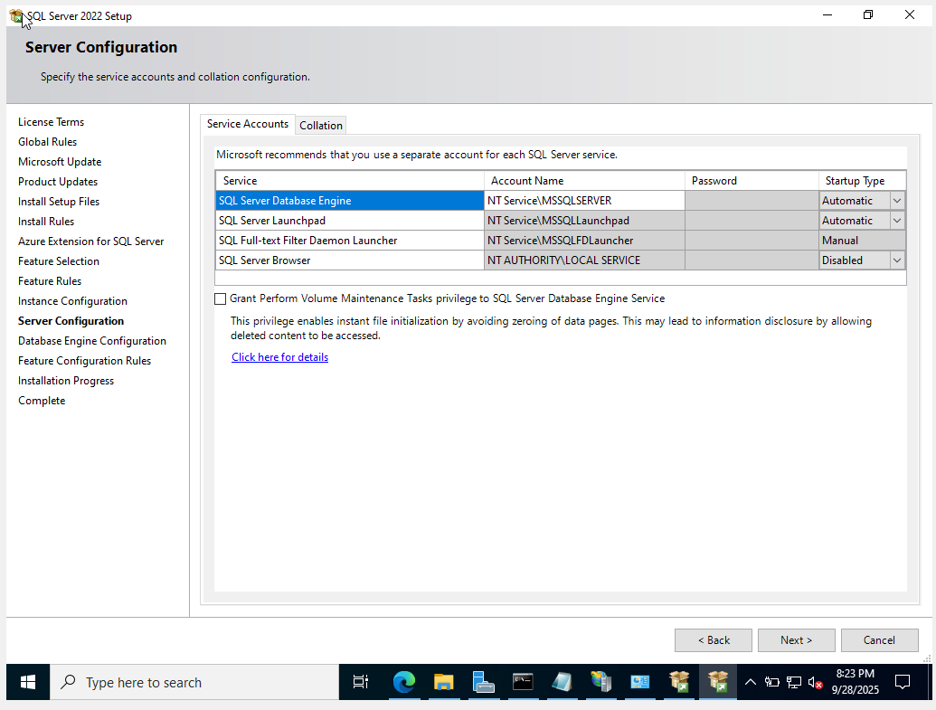

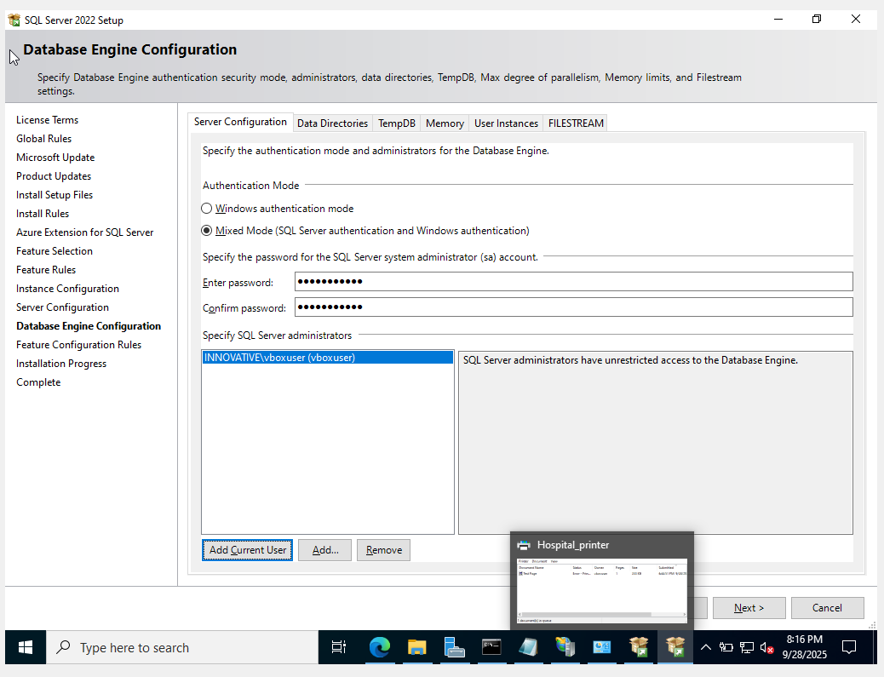

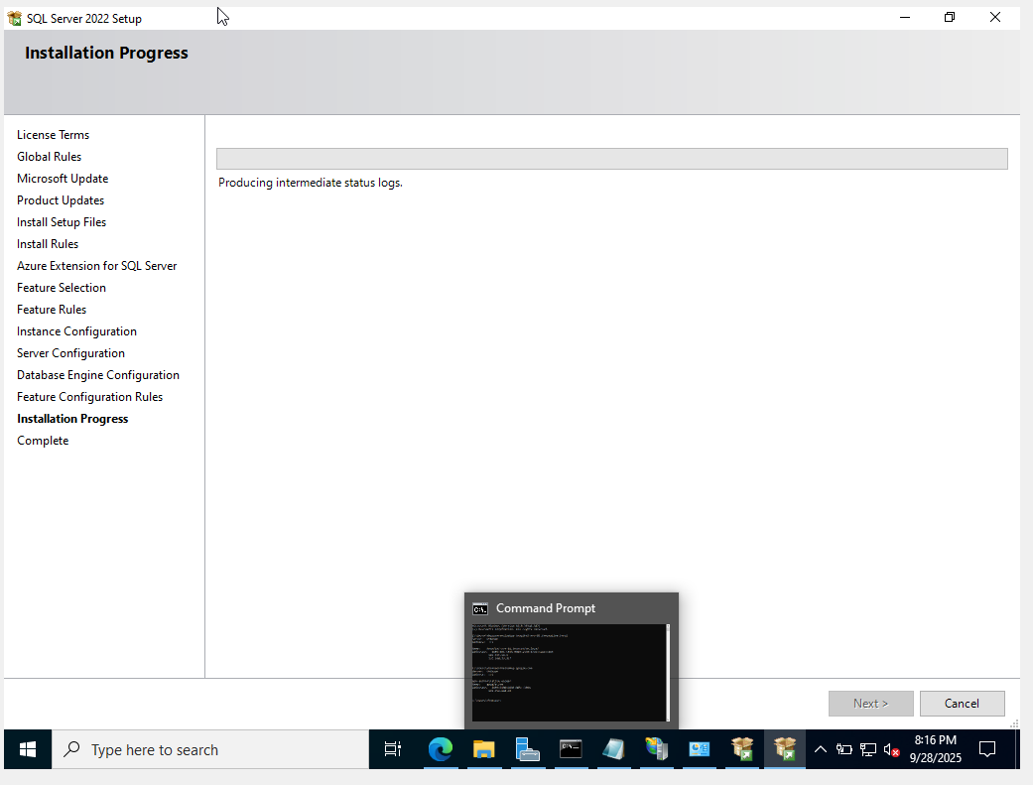

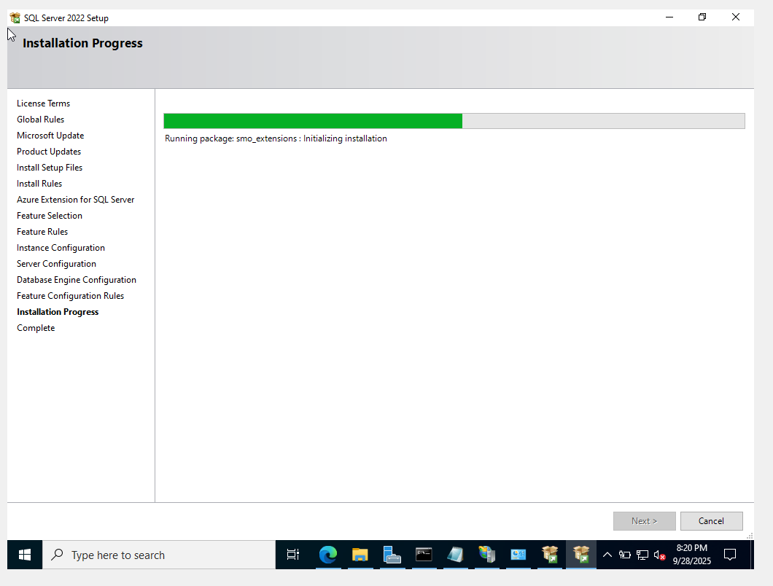

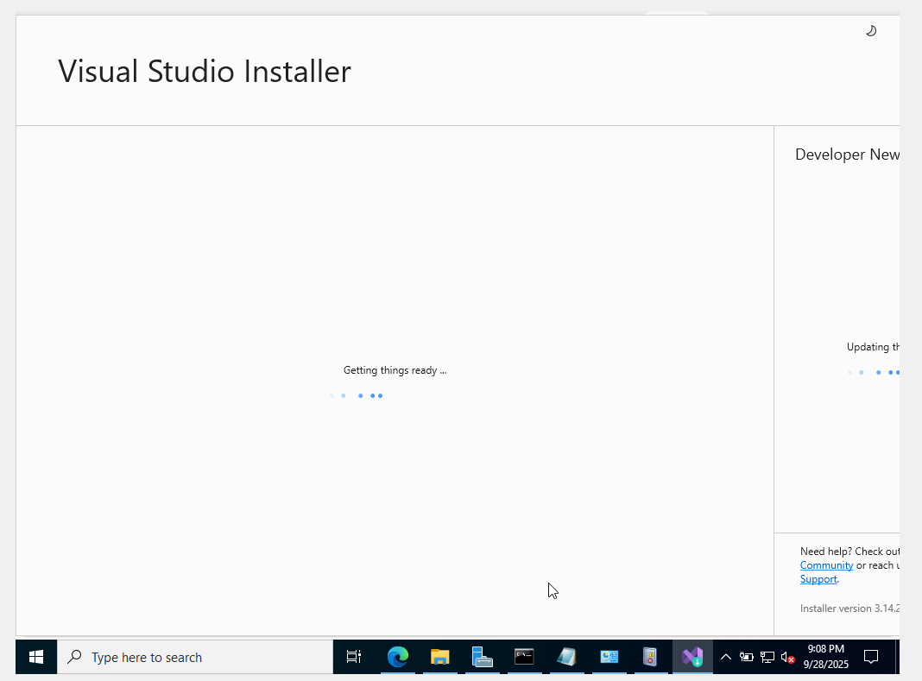



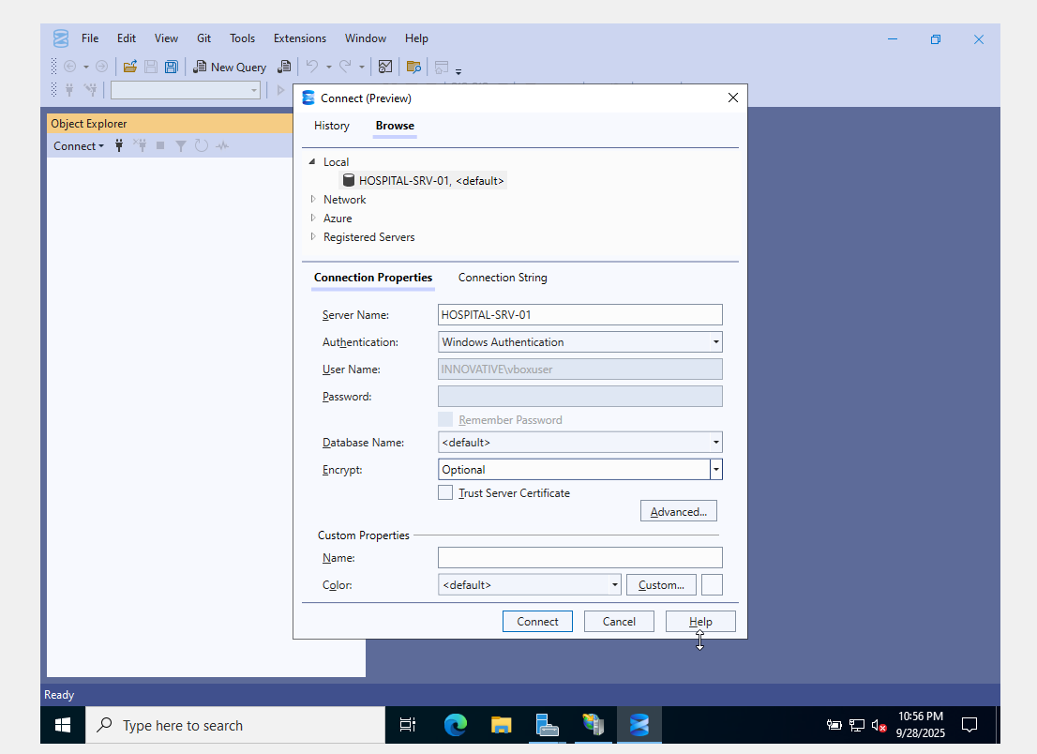

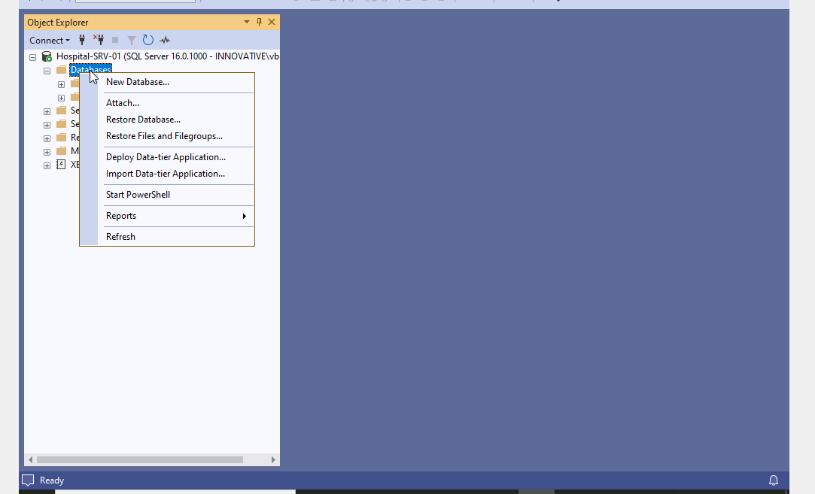

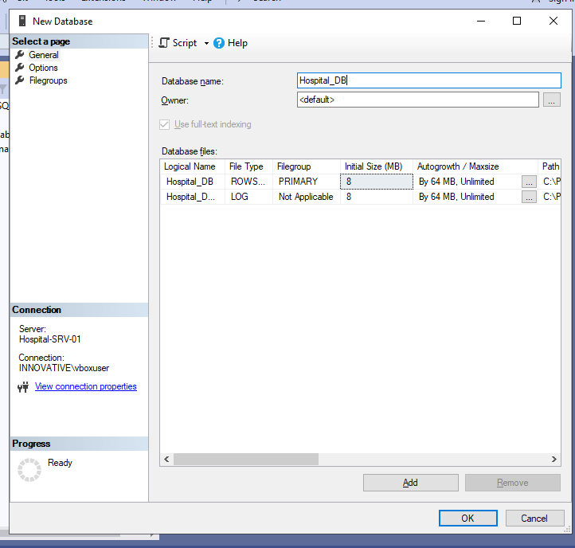

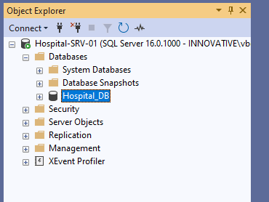

**Phase 6: Remote Access (VPN Server) Configuration**

This service will allow authorized staff (like doctors on call) to securely connect to the internal hospital network from anywhere with an internet connection.

**Step 6.1: Install the Remote Access Role**

1. On your server HOSPITAL-SRV-01, open **Server Manager**.
2. Go to **Manage > Add Roles and Features**.
3. Click **Next** until you reach the **Server Roles** page.
4. Select the **Remote Access** role.
5. Click **Next**. One features just continue and On the **Role Services** page, check the box for **DirectAccess and VPN (RAS)**.
6. Click **Add Features** in the pop-up window.
7. Click **Next** through the rest of the wizard and then click **Install**.

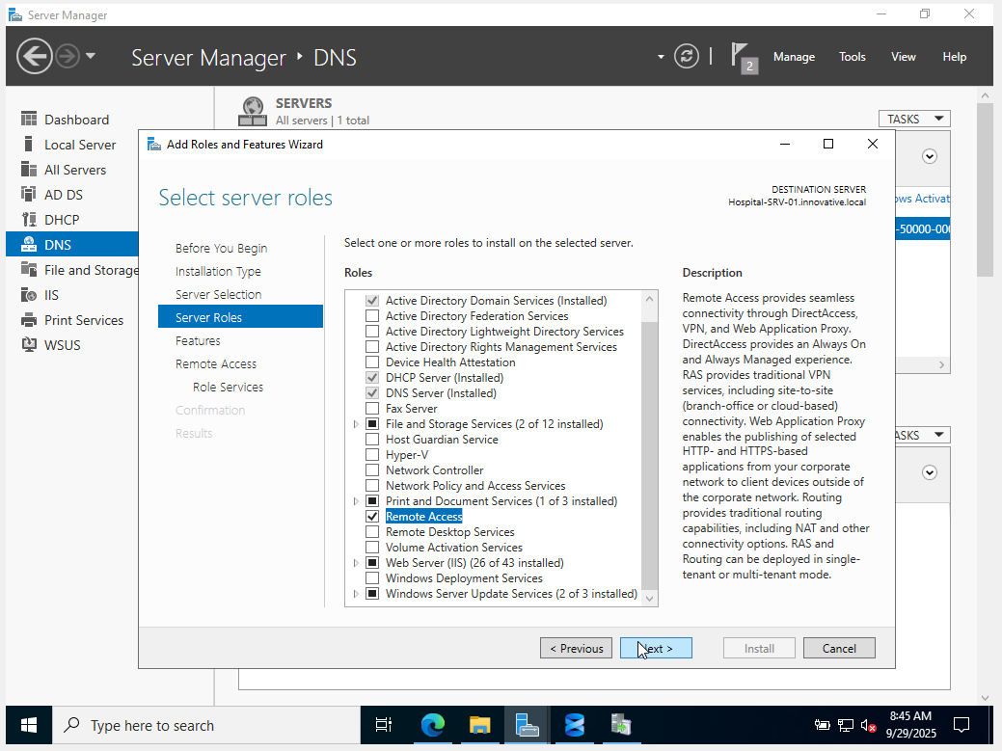

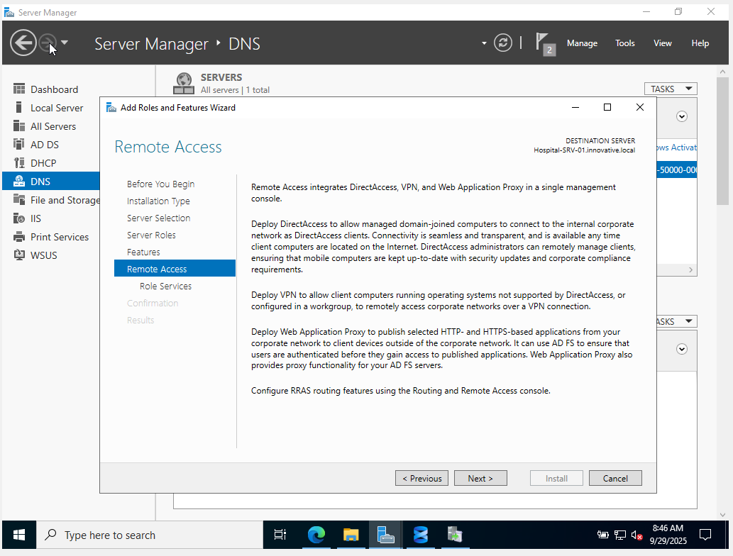

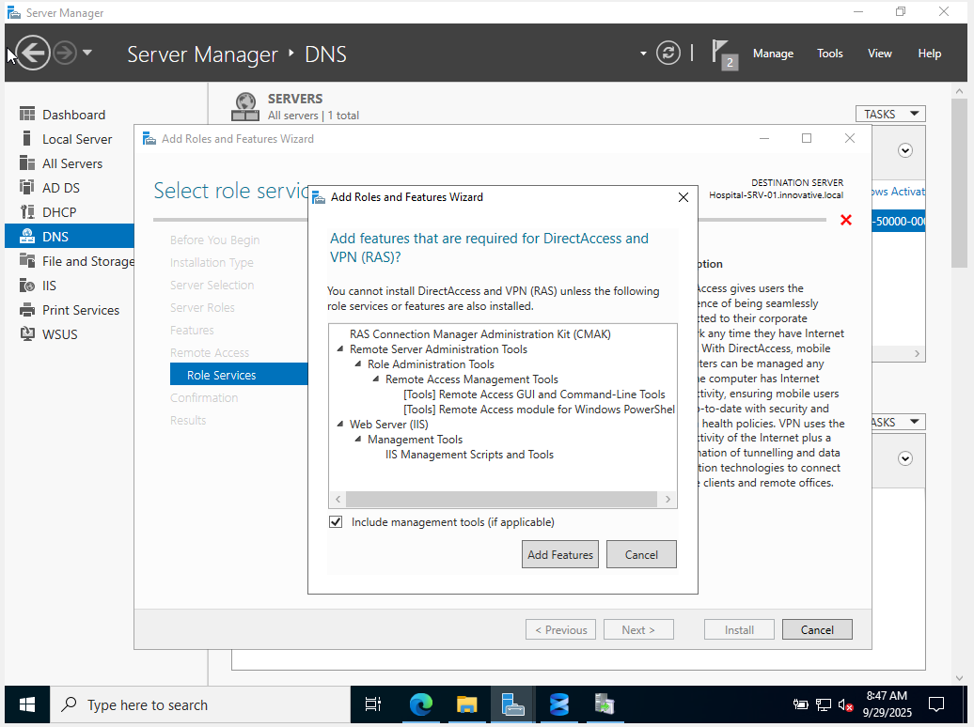

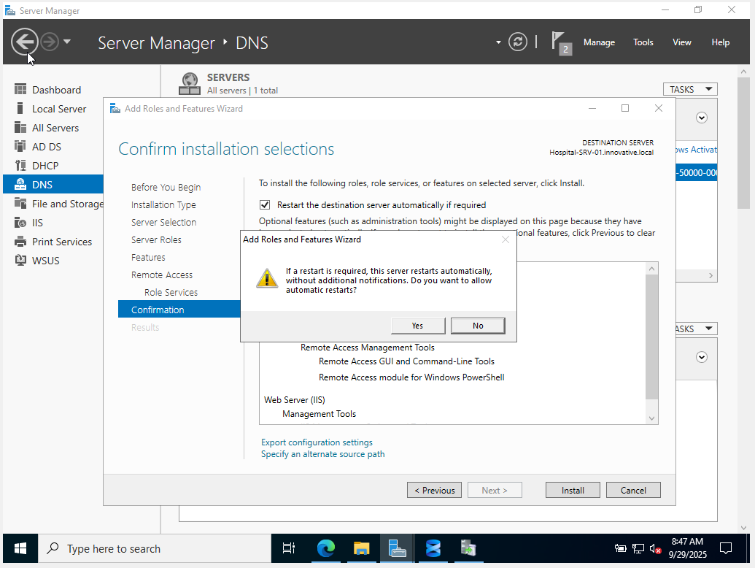

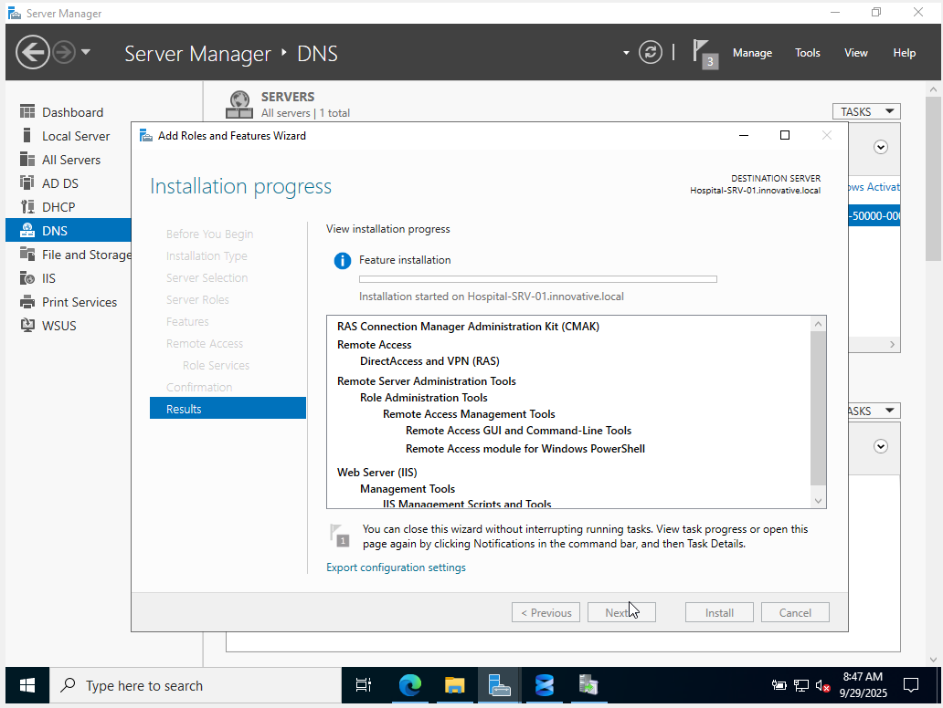

**Step 6.2: Configure the VPN Server**

1. Once the installation is complete, you will see a notification flag in Server Manager. Click it and select **Open the Getting Started Wizard**.
2. In the wizard that appears, select **Deploy VPN only**.
3. This will open the **Routing and Remote Access** console. You will see your server name with a red "down" icon.
4. Right-click on your server name (e.g., HOSPITAL-SRV-01) and select **Configure and Enable Routing and Remote Access**.
5. The setup wizard will start. Click **Next**.
6. On the **Configuration** page, select **Remote access (dial-up or VPN)**. Click **Next**.
7. On the **Remote Access** page, check the **VPN** box. Click **Next**.
8. **Network Selection:** This is a critical step. You need to tell the server which network card faces the internet.
   * In the list, select your **WAN_Internet adapter** (the one connected to the Bridged network).
   * Click **Next**.
9. **IP Address Assignment:** This determines what IP address a connecting user will get.
   * Select **From a specified range of addresses**. Click **Next**.
   * Click **New...**.
   * Enter a range of IP addresses that is on your internal network but **outside** of your DHCP scope. For example:
     + Start IP address: 192.168.10.50
     + End IP address: 192.168.10.60
   * This creates a pool of 11 addresses for VPN clients. Click **OK**, then **Next**.
10. **Managing Multiple Remote Access Servers:** Select **No, use Routing and Remote Access to authenticate connection requests**. Click **Next**.
11. Click **Finish**. You will be prompted that a firewall rule will be created. Click **OK**. The service will start, and the icon next to your server name will turn green.

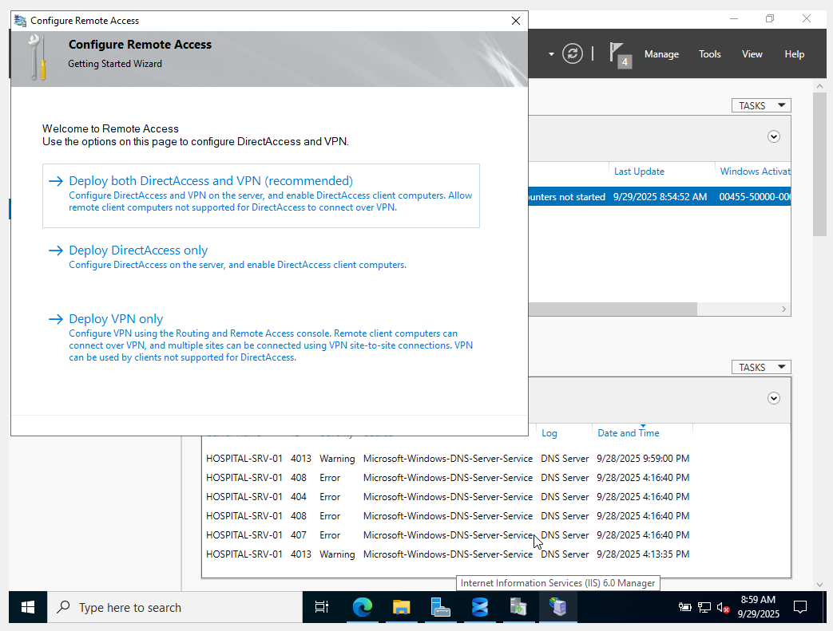

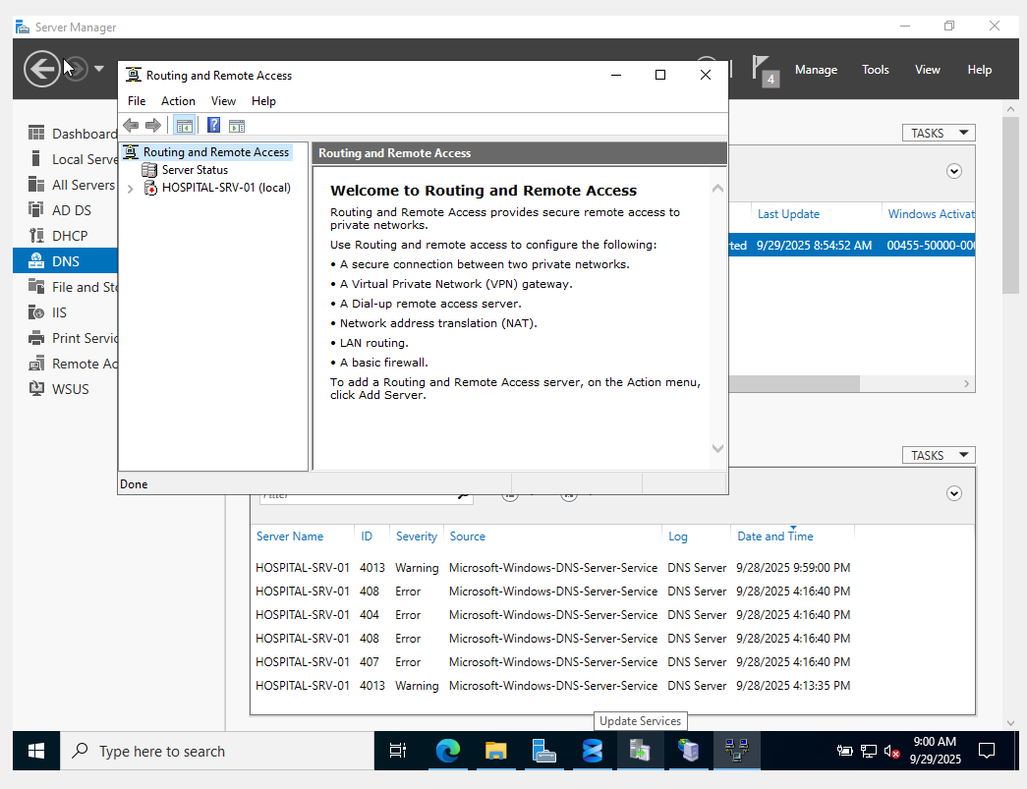

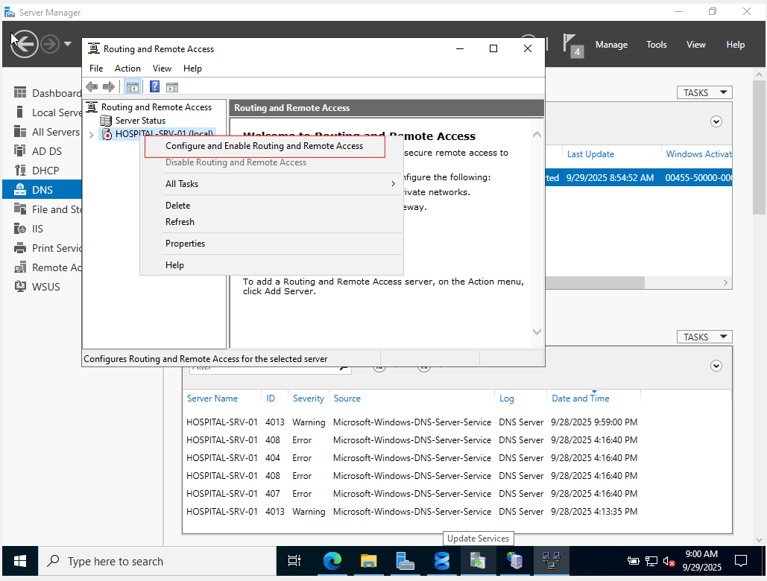

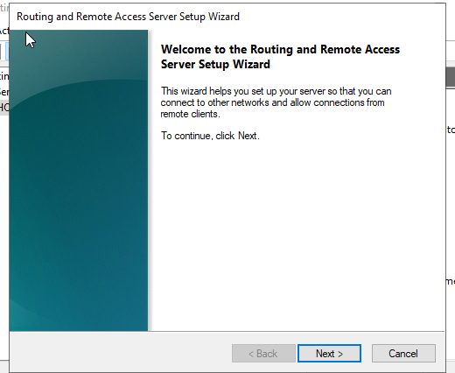

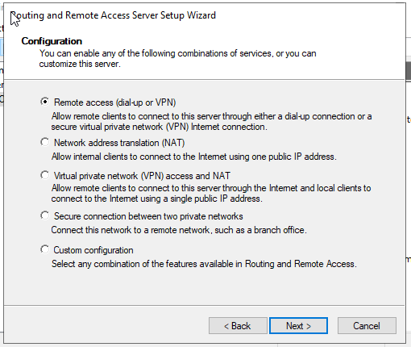

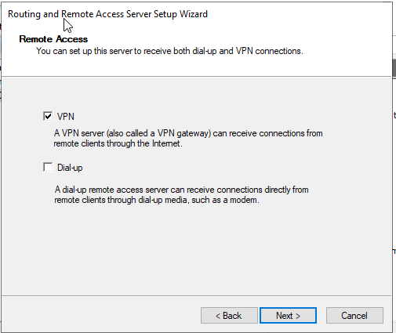

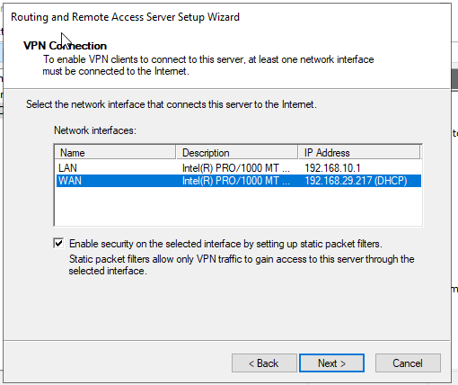

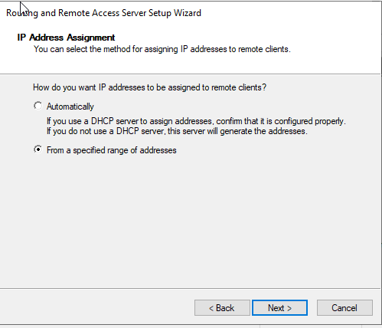

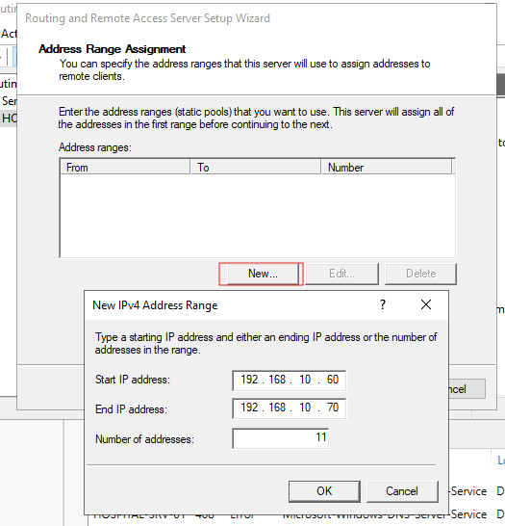

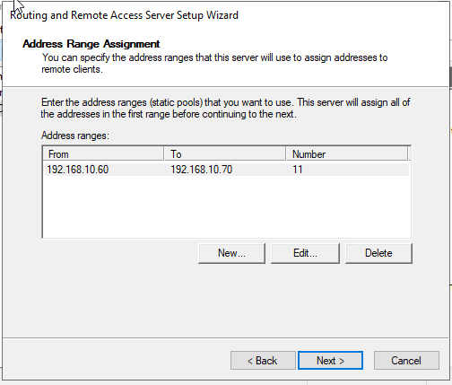

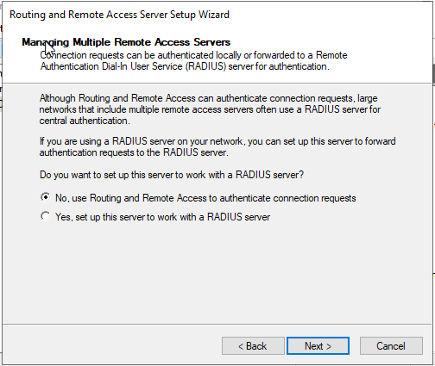

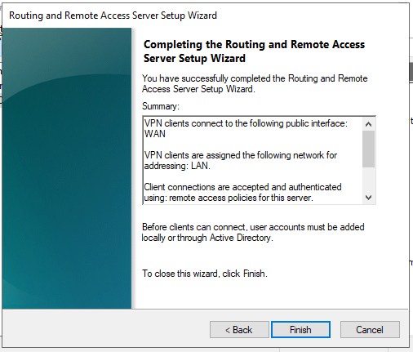

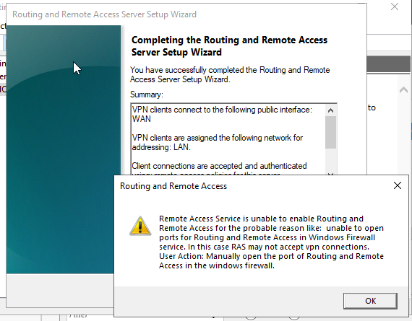

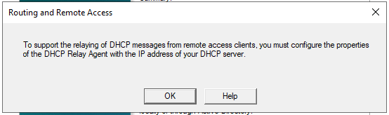

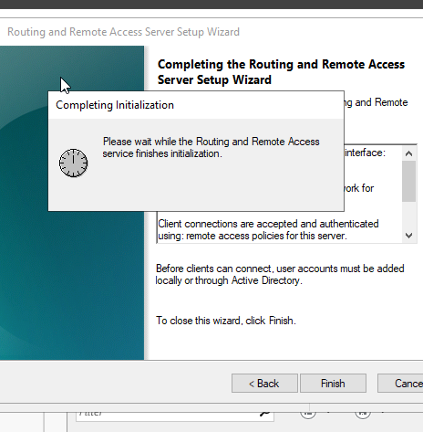

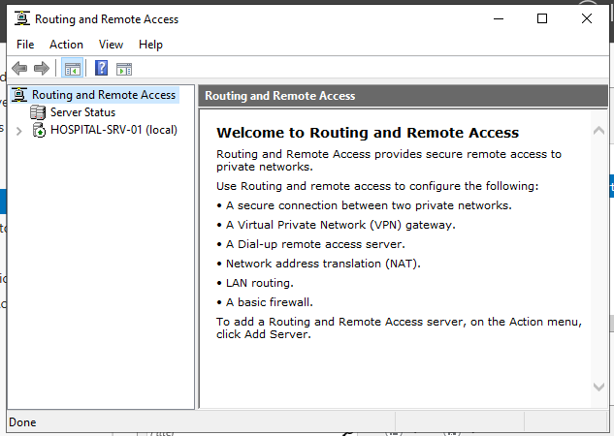

**Step 6.3: Grant User Permissions for VPN Access**

By default, users are not allowed to connect via VPN. You must grant permission on a per-user basis.

1. Open **Active Directory Users and Computers** from the Tools menu in Server Manager.
2. Navigate to the OU containing your users (e.g., Hospital_Staff > Doctors).
3. Right-click on a user you want to grant access to (e.g., John Doe) and select **Properties**.
4. Go to the **Dial-in** tab.
5. Under **Network Access Permission**, select **Allow access**.
6. Click **Apply** and **OK**.

**Step 6.4: Testing the VPN (Requires a Test Client)**

To test this, you need a computer *outside* your internal hospital-net. The easiest way to simulate this is with a new Windows 10/11 VM in VirtualBox with its network adapter set to **NAT** or **Bridged**. Once you have that client:

1. On the external test client, go to **Settings > Network & Internet > VPN**.
2. Click **Add a VPN connection**.
   * **VPN provider:** Windows (built-in)
   * **Connection name:** Hospital VPN
   * **Server name or address:** Enter the IP address of your server's **WAN_Internet adapter**. (On the server, open Command Prompt and type ipconfig to find this IP).
   * **VPN type:** Automatic
   * **User name/Password:** Enter the credentials for the user you granted access to (e.g., jdoe and their password).
3. Save the connection, then click **Connect**.
4. Once connected, open Command Prompt on the client and type ipconfig. You should see a new "PPP adapter" with an IP address from the pool you created (e.g., 192.168.10.50). You can now access internal resources like your intranet site.

**Phase 7: SMTP Server for Application Email Relay**

This service is not for user mailboxes. It's designed for internal applications (like monitoring tools, EHR alerts, or password reset systems) to send out email notifications.

**Step 7.1: Install the SMTP Server Feature**

The SMTP server is a *feature*, not a role.

1. On your server, open the **Add Roles and Features** wizard.
2. Click **Next** until you reach the **Features** page.
3. Scroll down and check the box for **SMTP Server**.
4. A pop-up will ask to add required features, including **IIS 6 Management Console**. Click **Add Features**.
5. Click **Next**, then **Install**.

**Step 7.2: Configure the SMTP Server**

Configuration is done through a special, older management console.

1. In Server Manager, go to **Tools** and select **Internet Information Services (IIS) 6.0 Manager**.
2. In the IIS 6.0 Manager, expand your server name. You will see [SMTP Virtual Server #1].
3. Right-click [SMTP Virtual Server #1] and select **Properties**.
4. Go to the **Access** tab. This is the most important tab for security.
   * Click the **Relay...** button. This configures who is allowed to *use* this server to send email.
   * Select **Only the list below**.
   * Click **Add...**.
   * Select **Single computer** and enter the IP address of your server: 192.168.10.1. Click **OK**.
   * Click **Add...** again. Select **Group of computers** and enter:
     + Subnet address: 192.168.10.0
     + Subnet mask: 255.255.255.0
   * Click **OK**. This prevents your server from being an "open relay" that spammers could abuse.
5. Click **OK** to close the Relay Restrictions window.
6. Go to the **Delivery** tab. If you wanted to relay mail through an external provider (like Office 365 or Gmail), you would configure a "Smart host" here. For internal-only notifications, we can skip this.
7. Click **Apply** and **OK**.
8. Finally, open the **Services** console (services.msc). Find the service named **Simple Mail Transfer Protocol (SMTP)**, ensure it is **Running**, and set its Startup Type to **Automatic**.

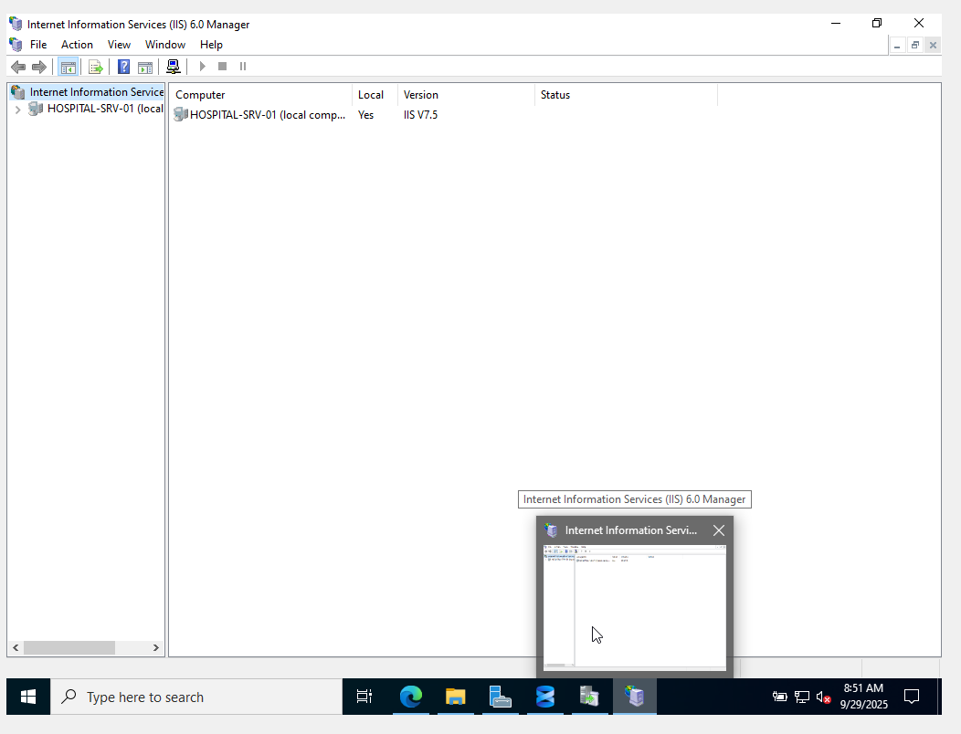

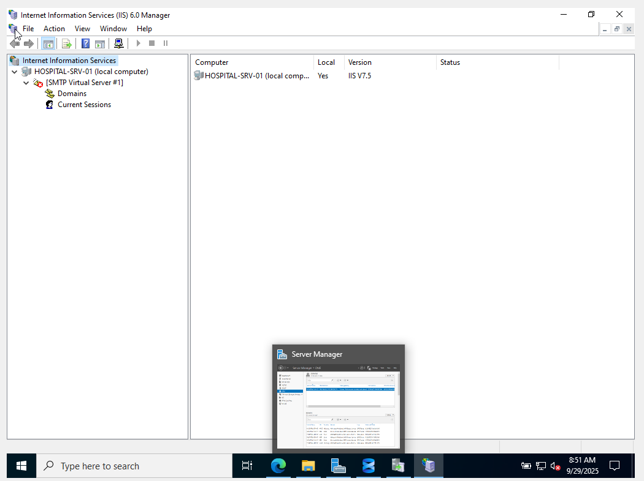

**Step 7.3: Test the SMTP Relay**

The easiest way to test is by using PowerShell on the server itself.

1. Open **Windows PowerShell** on your server.
2. Type the following command and press Enter:

code Powershell

• Send-MailMessage -From 'alerts@hospital.local' -To 'admin@hospital.local' -Subject 'Test Alert' -Body 'This is a test message from the internal SMTP relay server.' -SmtpServer 'localhost'

• **Verification:** Since this server isn't configured to deliver mail to external domains, the email won't actually go anywhere. Instead, it gets processed and stored locally. To verify it worked:

* Navigate to C:\inetpub\mailroot.
* Look inside the **Queue** folder. You will briefly see the email file appear here.
* Because the server can't deliver the email to admin@hospital.local, it will move the file to the **Badmail** folder.
* If you see your test email file inside the C:\inetpub\mailroot\Badmail folder, **your test was successful**. It means the SMTP service correctly accepted the email from your "application" (PowerShell) for delivery.